UNITED STATES
SECURITIES AND EXCHANGE COMMISSION
Washington, D.C. 20549

FORM 8-K/A
Amendment No. 1

CURRENT REPORT
Pursuant to Section 13 or 15(d) of the
Securities Exchange Act of 1934

Date of Report (Date of earliest event reported): July 24, 2026

Yarrow Bioscience, Inc.
(Exact Name of Registrant as Specified in its Charter)

Delaware |  | 001-38356 |  | 45-3757789
(State or Other Jurisdiction  of Incorporation) |  | (Commission  File Number) |  | (IRS Employer  Identification No.)

470 James Street, Suite 007, New Haven, CT |  | 06513
(Address of Principal Executive Offices) |  | (Zip Code)

Registrant’s telephone number, including area code: (203) 433-7577

N/A
(Former name or former address, if changed since last report)

Check the appropriate box below if the Form 8-K filing is intended to simultaneously satisfy the filing obligation of the registrant under any of the following provisions:

☐ | Written communications pursuant to Rule 425 under the Securities Act (17 CFR 230.425)
☐ | Soliciting material pursuant to Rule 14a-12 under the Exchange Act (17 CFR 240.14a-12)
☐ | Pre-commencement communications pursuant to Rule 14d-2(b) under the Exchange Act (17 CFR 240.14d-2(b))
☐ | Pre-commencement communications pursuant to Rule 13e-4(c) under the Exchange Act (17 CFR 240.13e-4(c))

Securities registered pursuant to Section 12(b) of the Act:

Title of each class |  | Trading  Symbol(s) |  | Name of each exchange  on which registered
Common Stock, $0.0001 par value |  | YARW |  | The Nasdaq Capital Market

Indicate by check mark whether the registrant is an emerging growth company as defined in Rule 405 of the Securities Act of 1933 (§230.405 of this chapter) or Rule 12b-2 of the Securities Exchange Act of 1934 (§240.12b-2 of this chapter).

Emerging growth company ☐

If an emerging growth company, indicate by check mark if the registrant has elected not to use the extended transition period for complying with any new or revised financial accounting standards provided pursuant to Section 13(a) of the Exchange Act. ☐

INTRODUCTORY NOTE

This Amendment No. 1 on Form 8-K/A (“Amendment No. 1”) amends the Current Report on Form 8-K of Yarrow Bioscience, Inc., a Delaware corporation formerly known as VYNE Therapeutics Inc. (the “Company” or “Yarrow”), filed on July 28, 2026 (the “Original Report”), in which the Company reported, among other events, the closing of the Merger (as defined in the Original Report) with Yarrow Bioscience, Inc., a Delaware corporation now known as Yarrow Bioscience Operating Company Corp. (“Pre-Merger Yarrow”), on July 27, 2026 (the “Closing Date”).

This Amendment No. 1 includes (i) the financial statements of Pre-Merger Yarrow as of and for the three and six months ended June 30, 2026, (ii) the financial statements of Pre-Merger Yarrow as of December 31, 2025 and October 3, 2025, and for the period from October 3, 2025 (inception) to December 31, 2025, which have been recast to give retroactive effect to the exchange ratio of 0.7171 (the “Exchange Ratio”) applied in the Merger, (iii) Pre-Merger Yarrow’s Management’s Discussion and Analysis of Financial Condition and Results of Operations as of and for the three and six months ended June 30, 2026, and (iv) the unaudited pro forma condensed combined balance sheet of the Company and Pre-Merger Yarrow as of June 30, 2026 and the unaudited pro forma condensed combined statements of operations of the Company and Pre-Merger Yarrow for the six months ended June 30, 2026 and the year ended December 31, 2025 and the related notes. In addition, a press release announcing the Company’s financial results for the quarter ended June 30, 2026 and an updated corporate presentation for the Company are being furnished with this Amendment No. 1.

This Amendment No. 1 does not amend any other item of the Original Report or purport to provide an update or a discussion of any developments at the Company or its subsidiaries, including Pre-Merger Yarrow, subsequent to the filing date of the Original Report. The information previously reported in or filed with the Original Report is hereby incorporated by reference to this Amendment No. 1.

Item 2.02. | Results of Operations and Financial Condition.

This Amendment No. 1 includes (i) the financial statements of Pre-Merger Yarrow as of and for the three and six months ended June 30, 2026, (ii) the financial statements of Pre-Merger Yarrow as of December 31, 2025 and October 3, 2025, and for the period from October 3, 2025 (inception) to December 31, 2025, which have been recast to give retroactive effect to the Exchange Ratio, (iii) Pre-Merger Yarrow’s Management’s Discussion and Analysis of Financial Condition and Results of Operations as of and for the three and six months ended June 30, 2026, and (iv) the unaudited pro forma condensed combined balance sheet of the Company and Pre-Merger Yarrow as of June 30, 2026 and the unaudited pro forma condensed combined statements of operations of the Company and Pre-Merger Yarrow for the six months ended June 30, 2026 and the year ended December 31, 2025 and the related notes.

Pre-Merger Yarrow’s Management’s Discussion and Analysis of Financial Condition and Results of Operations as of and for the three and six months ended June 30, 2026 is attached as Exhibit 99.5 and is incorporated herein by reference.

The information set forth under Item 9.01 of this Amendment No. 1 is incorporated herein by reference.

On August 13, 2026, the Company issued a press release announcing the Company’s financial results for the quarter ended June 30, 2026. A copy of the press release is furnished as Exhibit 99.7 to this Amendment No. 1.

The information set forth in this Item 2.02 with respect to the press release, and Exhibit 99.7 to this Amendment No. 1, are being furnished to the U.S. Securities and Exchange Commission (the “SEC”) and shall not be deemed to be “filed” for purposes of Section 18 of the Securities Exchange Act of 1934, as amended (the “Exchange Act”), or otherwise subject to the liabilities of that section, nor shall they be deemed incorporated by reference in any filing under the Exchange Act or the Securities Act of 1933, as amended (the “Securities Act”), regardless of any general incorporation language in such filing.

Item 7.01. | Regulation FD Disclosure.

On August 13, 2026, the Company made available an updated corporate presentation on the Company’s website.

A copy of the corporate presentation is furnished as Exhibit 99.8 to this Amendment No. 1 and is incorporated herein by reference. This Item 7.01 and Exhibit 99.8 to this Amendment No. 1 are being furnished to the SEC and shall not be deemed to be “filed” for purposes of Section 18 of the Exchange Act or otherwise subject to the liabilities of that section, nor shall they be deemed incorporated by reference in any filing under the Exchange Act or the Securities Act, regardless of any general incorporation language in such filing.

Item 9.01. | Financial Statements and Exhibits.

(a) Financial Statements of Business Acquired

The financial statements of Pre-Merger Yarrow as of December 31, 2025 and October 3, 2025, and for the period from October 3, 2025 (inception) through December 31, 2025, and the related notes thereto, which have been recast to give retroactive effect to the Exchange Ratio, are attached as Exhibit 99.3 and are incorporated herein by reference.

The financial statements of Pre-Merger Yarrow as of June 30, 2026 and for the three and six months ended June 30, 2026, and the related notes thereto, are attached as Exhibit 99.4 and are incorporated herein by reference.

(b) Pro Forma Financial Information

The unaudited pro forma condensed combined balance sheet of the Company and Pre-Merger Yarrow as of June 30, 2026 and the unaudited pro forma condensed combined statements of operations of the Company and Pre-Merger Yarrow for the six months ended June 30, 2026 and the year ended December 31, 2025 and the related notes are attached as Exhibit 99.6 and are incorporated herein by reference.

(d) | Exhibits.

EXHIBIT INDEX

Exhibit  Number | Description
23.1 | Consent of Baker Tilly US, LLP, independent registered public accounting firm of Yarrow Bioscience Operating Company Corp. (f/k/a Yarrow Bioscience, Inc.).
99.3 | Financial statements of Yarrow Bioscience Operating Company Corp. (f/k/a Yarrow Bioscience, Inc.) as of December 31, 2025 and October 3, 2025 and for the period from October 3, 2025 (inception) through December 31, 2025.
99.4 | Financial statements of Yarrow Bioscience Operating Company Corp. (f/k/a Yarrow Bioscience, Inc.) as of June 30, 2026 and for the three and six months ended June 30, 2026.
99.5 | Management’s Discussion and Analysis of Financial Condition and Results of Operations of Yarrow Bioscience Operating Company Corp. (f/k/a Yarrow Bioscience, Inc.) as of and for the three and six months ended June 30, 2026.
99.6 | Unaudited pro forma condensed combined balance sheet of Yarrow Bioscience, Inc. and Yarrow Bioscience Operating Company Corp. (f/k/a Yarrow Bioscience, Inc.) as of June 30, 2026, and the unaudited pro forma condensed combined statements of operations for the six months ended June 30, 2026 and the year ended December 31, 2025.
99.7 | Press release issued by Yarrow Bioscience, Inc. on August 13, 2026 announcing financial results for the quarter ended June 30, 2026.
99.8 | Corporate presentation of Yarrow Bioscience, Inc., dated August 2026.
104 | Cover Page Interactive Data File (formatted as Inline XBRL).

SIGNATURES

Pursuant to the requirements of the Securities Exchange Act of 1934, the registrant has duly caused this report to be signed on its behalf by the undersigned hereunto duly authorized.

 | YARROW BIOSCIENCE, INC.
Date: August 13, 2026 | By: | /s/ Rebecca Frey
 |  | Rebecca Frey
 |  | Chief Executive Officer

Exhibit 23.1

Consent of Independent Registered Public Accounting Firm

We consent to the incorporation by reference in the Registration Statements on Form S-3 (No. 333-277609 and No. 333-275507) and Form S-8 (No. 333-277608, No. 333-283940, No. 333-276027, No. 333-263654, No. 333-253883, No. 333-237041, No. 333-229975, and No. 333-222758) of Vyne Therapeutics Inc. of our report dated March 31, 2026, except for the effects of the exchange ratio discussed in Note 1, as to which the date is August 13, 2026, relating to the financial statements of Yarrow Bioscience, Inc. appearing in this Current Report on Form 8-K/A dated August 13, 2026.

/s/ Baker Tilly US, LLP

Irvine, California
August 13, 2026

Exhibit 99.3

INDEX TO FINANCIAL STATEMENTS

In connection with the closing of the Merger (as defined below in Note 1), Yarrow Bioscience, Inc. changed its name to Yarrow Bioscience Operating Company Corp. on July 27, 2026. For the purposes of these financial statements, references to Yarrow Bioscience, Inc. refer to the company prior to the Merger.

YARROW BIOSCIENCE, INC.
Audited Financial Statements:

 | Page
Report of Independent Registered Public Accounting Firm (Baker Tilly US, LLP, Irvine, CA, PCAOB ID 23) | F-49
Balance Sheets | F-50
Statement of Operations | F-51
Statement of Convertible Preferred Stock and Stockholders’ Deficit | F-52
Statement of Cash Flows | F-53
Notes to Financial Statements | F-54

Report of Independent Registered Public Accounting Firm

To the Shareholders and the Board of Directors of Yarrow Bioscience, Inc.

Opinion on the Financial Statements

We have audited the accompanying balance sheets of Yarrow Bioscience, Inc. (the Company) as of December 31, 2025 and October 3, 2025, the related statements of operations, changes in convertible preferred stock and stockholders’ deficit and cash flows for the period from October 3, 2025 (inception) to December 31, 2025, and the related notes (collectively referred to as the “financial statements”). In our opinion, the financial statements present fairly, in all material respects, the financial position of the Company as of December 31, 2025 and October 3, 2025, and the results of its operations and its cash flows for the period from October 3, 2025 (inception) to December 31, 2025, in conformity with accounting principles generally accepted in the United States of America.

Basis for Opinion

These financial statements are the responsibility of the Company’s management. Our responsibility is to express an opinion on the Company’s financial statements based on our audits. We are a public accounting firm registered with the Public Company Accounting Oversight Board (United States) (PCAOB) and are required to be independent with respect to the Company in accordance with the U.S. federal securities laws and the applicable rules and regulations of the Securities and Exchange Commission and the PCAOB.

We conducted our audits in accordance with the standards of the PCAOB. Those standards require that we plan and perform the audits to obtain reasonable assurance about whether the financial statements are free of material misstatement, whether due to error or fraud. The Company is not required to have, nor were we engaged to perform, an audit of its internal control over financial reporting. As part of our audits, we are required to obtain an understanding of internal control over financial reporting but not for the purpose of expressing an opinion on the effectiveness of the Company’s internal control over financial reporting. Accordingly, we express no such opinion.

Our audits included performing procedures to assess the risks of material misstatement of the financial statements, whether due to error or fraud, and performing procedures that respond to those risks. Such procedures included examining, on a test basis, evidence regarding the amounts and disclosures in the financial statements. Our audits also included evaluating the accounting principles used and significant estimates made by management, as well as evaluating the overall presentation of the financial statements. We believe that our audits provide a reasonable basis for our opinion.

Critical Audit Matters

Critical audit matters are matters arising from the current period audit of the financial statements that were communicated or required to be communicated to the audit committee and that: (1) relate to accounts or disclosures that are material to the financial statements and (2) involved our especially challenging, subjective, or complex judgments. We determined that there are no critical audit matters.

/s/ Baker Tilly US, LLP

Irvine, California
March 31, 2026, except for the effects of the exchange ratio discussed in Note 1, as to which the date is August 13, 2026

We have served as the Company’s auditor since 2026.

F-49

YARROW BIOSCIENCE, INC.

BALANCE SHEETS
(in thousands, except share and per share data)

 |  | December 31,  2025 |  |  |  | October 3,  2025
Assets
Current assets:
Cash |  | $ | 99,994 |  |  | $ | &numsp;—
Prepaid and other current assets |  |  | 6 |  |  |  | —
Subscription receivable |  |  | — |  |  |  | 4
Total current assets |  |  | 100,000 |  |  |  | 4
Deferred transaction costs |  |  | 407 |  |  |  | —
Total assets |  | $ | 100,407 |  |  | $ | 4
Liabilities, Convertible Preferred Stock and Stockholders’ Deficit
Current liabilities:
Accounts payable (related party of $610) |  | $ | 1,534 |  |  | $ | —
Accrued expenses |  |  | 70,013 |  |  |  | —
Total current liabilities |  |  | 71,547 |  |  |  | —
Total liabilities |  |  | 71,547 |  |  |  | —
Commitments and contingencies (Note 4)
Series A convertible preferred stock, $0.0001 par value, 14,516,188 shares authorized, issued and outstanding at December 31, 2025; liquidation value of $100,000 |  |  | 99,850 |  |  |  | —
Stockholders’ deficit:
Common stock, $0.0001 par value, 29,672,628 shares authorized, 3,047,675 issued and outstanding at December 31, 2025 |  |  | — |  |  |  | —
Additional paid-in capital |  |  | 4 |  |  |  | 4
Accumulated deficit |  |  | (70,994 | ) |  |  | —
Total stockholders’ deficit |  |  | (70,990 | ) |  |  | 4
Total liabilities, convertible preferred stock and stockholders’ deficit |  | $ | 100,407 |  |  | $ | 4

See accompanying notes to financial statements.

F-50

YARROW BIOSCIENCE, INC.

STATEMENT OF OPERATIONS
(in thousands, except share and per share data)

October 3, 2025
(Inception) through
December 31, 2025
Operating expenses:
Research and development |  | $ | 604
Acquired in-process research and development |  |  | 70,000
General and administrative |  |  | 390
Total operating expenses |  |  | 70,994
Net loss |  | $ | (70,994 | )
Share information:
Net loss per share of common stock, basic and diluted |  | $ | (23.29 | )
Weighted-average shares of common stock outstanding, basic and diluted |  |  | 3,047,675

See accompanying notes to financial statements.

F-51

YARROW BIOSCIENCE, INC.

STATEMENT OF CONVERTIBLE PREFERRED STOCK AND STOCKHOLDERS’ DEFICIT
(in thousands, except share and per share data)

 |  |  |  |  |  |  |  |  | Stockholders’ Deficit
 |  | Series A convertible  preferred stock |  |  |  |  |  |  | Common stock |  |  |  |  |  |  | Additional  paid-in |  |  |  | Accumulated
 |  | Shares |  |  | Amount |  |  |  | Shares |  |  | Amount |  |  |  | capital |  |  |  | deficit |  |  |  | Total
Balance, October 3, 2025 (Inception) |  | — |  |  | $ | — |  |  | 3,047,675 |  |  | $ | — |  |  | $ | 4 |  |  | $ | — |  |  | $ | 4
Issuance of Series A convertible preferred stock at $6.89 per share, net of issuance costs of $150 |  | 14,516,188 |  |  |  | 99,850 |  |  | — |  |  |  | — |  |  |  | — |  |  |  | — |  |  |  | —
Net loss |  | — |  |  |  | — |  |  | — |  |  |  | — |  |  |  | — |  |  |  | (70,994 | ) |  |  | (70,994 | )
Balance, December 31, 2025 |  | 14,516,188 |  |  | $ | 99,850 |  |  | 3,047,675 |  |  | $ | — |  |  | $ | 4 |  |  | $ | (70,994 | ) |  | $ | (70,990 | )

See accompanying notes to financial statements.

F-52

YARROW BIOSCIENCE, INC.

STATEMENT OF CASH FLOWS
(in thousands)

October 3, 2025
(Inception)
through
December 31,
2025
Cash flows from operating activities:
Net loss |  | $ | (70,994 | )
Adjustment to reconcile net loss to net cash used in operating activities:
Changes in operating assets and liabilities:
Prepaid and other current assets |  |  | (6 | )
Accounts payable |  |  | 1,127
Accrued expenses |  |  | 70,013
Net cash provided by operating activities |  |  | 140
Cash flows from financing activities:
Proceeds from sale of Series A convertible preferred stock, net of issuance costs |  |  | 99,850
Proceeds from the issuance of common stock |  |  | 4
Net cash provided by financing activities |  |  | 99,854
Net increase in cash and cash equivalents |  |  | 99,994
Cash and cash equivalents at inception |  |  | —
Cash and cash equivalents at end of the year |  | $ | 99,994

See accompanying notes to financial statements.

F-53

YARROW BIOSCIENCE, INC.

NOTES TO FINANCIAL STATEMENTS

1. Organization and Description of Business

Yarrow Bioscience, Inc. (“Yarrow” or the “Company”) is a clinical-stage biopharmaceutical company focused on developing novel biotherapeutics to treat autoimmune diseases affecting the thyroid. Yarrow’s lead product candidate, YB-101 (also known as GenSci098), is a humanized, monoclonal antibody targeting the thyroid stimulating hormone receptor (“TSHR”), which Yarrow plans to develop for the treatment of Graves’ disease (“GD”) and potentially thyroid eye disease (“TED”). Both GD and TED are serious and poorly treated autoimmune diseases in which autoantibodies against TSHR attack and overstimulate the receptor, leading to a wide spectrum of thyroidal and extra-thyroidal clinical sequelae.

YB-101 was designed to selectively bind to TSHR and block autoantibody-induced receptor activation, thereby directly inhibiting the pathogenic activity of thyroid-stimulating autoantibodies that drive disease progression in GD and TED as well as the biological pathway responsible for hyperthyroidism and orbitopathy. Yarrow believes that this novel and targeted approach represents a potential breakthrough for patients with GD and TED and has the potential to address an important unmet need for therapies with differentiated risk-benefit profiles.

In December 2025, Yarrow in-licensed from Changchun Genescience Pharmaceutical Company, Ltd. (“GenSci”) the exclusive rights to develop YB-101 for the treatment of GD and TED outside of China. Yarrow’s development strategy is to advance YB-101 in GD and explore a clinical development plan for TED with the goal of becoming the first company to commercialize an anti-TSHR antibody in the United States and other territories outside of China. YB-101 is currently being evaluated by GenSci in an ongoing Phase 1 single ascending dose (“SAD”) and multiple ascending dose (“MAD”) trial in patients with TED in China. Yarrow submitted the GenSci SAD clinical data to the U.S. Food and Drug Administration (“FDA”) as part of a new IND to support the initiation of a GD trial by Yarrow in the United States, which was cleared by the FDA in March 2026. In addition, third-party clinical data from two SAD trials of another anti-TSHR antibody, K1-70, further support the therapeutic potential of targeting TSHR in patients with GD and TED. Yarrow expects to initiate a combined Phase 2a/Phase 2b trial of YB-101 in patients with GD in the first half of 2026.

In December 2025 the Company entered into an Agreement and Plan of Merger and Reorganization with VYNE Therapeutics Inc., a Delaware corporation (“VYNE”), which was amended on January 30, 2026 (as amended, the “Merger Agreement”), pursuant to which, among other matters, Yellow Merger Sub Corp., a direct, wholly owned subsidiary of VYNE, will merge with and into the Company, with the Company surviving as a wholly owned subsidiary of VYNE and the surviving corporation of the merger (the “Merger”).

At the effective time of the Merger (the “Effective Time”), (i) each then-outstanding share of the Company’s common stock and the Company’s Convertible Preferred Stock (together the “Company’s Capital Stock”) (including any shares of the Company’s common stock issued in the Company’s Pre-Closing Financing described below), excluding any shares of the Company’s Capital Stock held as treasury stock immediately prior to the Effective Time and any dissenting shares, will be converted into the right to receive a number of shares of VYNE common stock, par value $0.0001 per share (the “VYNE Common Stock”) and/or VYNE Pre-Funded Warrants (as defined below) equal to the exchange ratio 35.8667, (ii) each then outstanding option to purchase shares of the Company’s common stock will be converted into and become an option to purchase shares of VYNE Common Stock on the existing terms and conditions (including with respect to vesting and accelerated vesting), subject to adjustment as set forth in the Merger Agreement, and (iii) each then-outstanding and unexercised pre-funded warrant to purchase shares of the Company’s common stock (each, a “Company Pre-Funded Warrant”) will be converted into a pre-funded warrant to purchase shares of VYNE Common Stock on the existing terms and conditions (each, a “VYNE Pre-Funded Warrant”), subject to adjustment as set forth in the Merger Agreement and the form of pre-funded warrant. If any shares of the Company’s common stock are unvested or subject to a repurchase option or risk of forfeiture at the Effective Time, then the shares of VYNE Common Stock issued in exchange for such shares will to the same extent be unvested and subject to the same repurchase option or risk of forfeiture.

Each share of VYNE Common Stock that is issued and outstanding at the Effective Time will remain issued and outstanding and such shares, subject to a proposed reverse stock split, will be unaffected by the Merger. Prior to the Effective Time, the VYNE board of directors will accelerate the vesting of all options to purchase shares of VYNE Common Stock (“VYNE Options”) and all restricted stock units (“VYNE RSUs”). Each outstanding VYNE Option with an exercise price per share equal to or less than the volume weighted average closing trading price of a share of VYNE Common Stock on The Nasdaq Stock Market LLC for the five consecutive trading days ending three trading days prior to the calculation date set forth in the Merger Agreement, as reported by Bloomberg L.P. (the “VYNE Closing Price”), will be cancelled at the Effective Time and such holder thereof will receive an amount in cash, without interest, less any applicable tax withholding, equal to the product obtained by multiplying the excess of the VYNE Closing Price over the exercise price per share of the VYNE Common Stock underlying such VYNE Option by the number of shares of the VYNE Common Stock underlying such VYNE Option. Each VYNE Option with an exercise price greater than the VYNE Closing Price will be cancelled for no consideration. Immediately prior to the Effective Time, each holder of an accelerated VYNE RSU will be entitled to receive a number of shares of VYNE Common Stock equal to the number of vested and unsettled shares underlying such VYNE RSU.

F-54

Based on the Company and VYNE’s capitalization as of December 17, 2025 and taking into account VYNE’s current cash position, each share of the Company’s Capital Stock is currently estimated to be entitled to receive approximately 35.8667 shares of VYNE Common Stock. This estimated exchange ratio does not give effect to the proposed VYNE reverse stock split and is subject to adjustment based on VYNE’s estimated net cash calculated in accordance with the Merger Agreement at the closing of the Merger.

Completed Merger and Exchange Ratio

On July 27, 2026 (the “Closing Date”), VYNE issued an aggregate of 2,130,731 shares of its common stock to the Company’s stockholders (after giving effect to the 1-for-50 reverse stock split of VYNE common stock in connection with the Merger), based on the exchange ratio of 0.7171 shares of VYNE common stock for each share of the Company’s common stock, including those shares of the Company’s common stock issued upon the conversion of the Company’s preferred stock and those shares of the Company’s common stock issued in the Company Pre-Closing Financing. In addition, the Company’s outstanding and unexercised pre-funded warrants to purchase shares of the Company’s common stock and certain shares of the Company’s common stock (including shares issued upon the conversion of the Company’s preferred stock and shares issued in the Company Pre-Closing Financing) were converted into 25,590,346 pre-funded warrants to purchase shares of VYNE common stock on the existing terms and conditions and outstanding options to purchase shares of the Company’s common stock were converted into 2,002,282 options to purchase shares of VYNE common stock on the existing terms and conditions (including with respect to vesting and accelerated vesting).

The Merger has been accounted for as a reverse recapitalization in accordance with generally accepted accounting principles in the United States of America (“U.S. GAAP”). Under this method of accounting, the Company is deemed to be the accounting acquirer for financial reporting purposes. This determination is primarily based on the fact that, immediately following the Merger: (i) the Company’s stockholders owned a substantial majority of the voting rights in the Combined Company; (ii) the Company’s largest stockholder retained the largest interest in the Combined Company; (iii) the Company designated the initial members of the board of directors of the Combined Company; and (iv) the Company’s executive management team and certain of VYNE’s current management team became the management team of the Combined Company. Historical share and per share amounts of the Company have been retroactively restated to reflect the exchange ratio of 0.7171.

Liquidity and Capital Resources

The Company has incurred losses since inception and has an accumulated deficit of $71.0 million as of December 31, 2025. The Company anticipates incurring additional losses until such time, if ever, that it can generate significant sales from its product candidates currently in development. Management believes that cash of $100.0 million as of December 31, 2025 ($30.0 million after the payment of the upfront license fee of $70.0 million (see Note 4)) is sufficient to sustain planned operations through at least twelve months from the issuance date of these financial statements.

In connection with the execution and delivery of the Merger Agreement, certain investors entered into a securities purchase agreement, pursuant to which such persons have agreed to purchase shares of the Company’s common stock or Company pre-funded warrants for an aggregate purchase price of approximately $100 million (the “Company Pre-Closing Financing”). However, the completion of the closing of the Company Pre-Closing Financing is subject to the satisfaction of customary closing conditions, and there are no assurances that such conditions will be achieved nor that such financing or other strategic transactions will be available on acceptable terms, or at all.

F-55

The Company is subject to those risks associated with any specialty biotechnology company that has substantial expenditures for research and development. There can be no assurance that the Company’s research and development projects will be successful, that products developed will obtain necessary regulatory approval, or that any approved product will be commercially viable. In addition, the Company operates in an environment of rapid technological change and is largely dependent on the services of its employees and consultants.

2. Summary of Significant Accounting Policies

Basis of Presentation

The accompanying financial statements have been prepared in accordance with U.S. generally accepted accounting principles (“GAAP”). Any references in these notes to applicable guidance are meant to refer to GAAP as found in Accounting Standards Codifications and Accounting Standards Updates (“ASU”) of the Financial Accounting Standards Board (“FASB”).

Use of Estimates

The preparation of financial statements in conformity with GAAP requires management to make estimates and assumptions that affect the reported amounts of assets and liabilities and disclosure of contingent assets and liabilities at the date of the financial statements and the reported amounts of expenses during the reporting period. Significant estimates and assumptions made in the accompanying financial statements include the fair value of the Company’s common stock and valuation allowance relating to the Company’s deferred tax assets. Due to the uncertainty of factors surrounding the estimates or judgments used in the preparation of the financial statements, actual results may vary from these estimates. Estimates and assumptions are periodically reviewed, and the effects of revisions are reflected in the financial statements in the period they are determined to be necessary.

Segment Information

The Company operates and manages its business as a single segment for the purposes of assessing performance and making operating decisions. The Company’s chief executive officer, who is the chief operating decision maker (“CODM”), reviews the Company’s financial information for purposes of evaluating financial performance and allocating resources.

Fair Value of Financial Instruments

Management believes that the carrying amounts of financial instruments, which include accounts payable and accrued expenses, approximate fair value due to the short-term nature of those instruments.

Concentration of Credit Risk

Financial instruments that potentially subject the Company to significant concentrations of credit risk consist primarily of cash, which is held in checking account deposits in federally insured financial institutions in excess of federally insured limits. The Company has not experienced any losses in such accounts and believes it is not exposed to significant risk on its cash.

Deferred Transaction Costs

Specific incremental legal, accounting and other fees and costs directly attributable to a proposed or actual offering of securities may properly be deferred and charged against the gross proceeds of such an offering. In the event the Company’s planned Merger does not occur or is significantly delayed, all of the costs will be expensed. As of December 31, 2025, there were $0.4 million of transaction costs, primarily consisting of legal fees, that were capitalized in assets on the balance sheet.

F-56

Classification of Convertible Preferred Stock

The Company has classified the Series A Convertible Preferred Stock (the “Convertible Preferred Stock”) outside of stockholders’ deficit on the Company’s balance sheet because the holders of such stock have certain liquidation rights in the event of a Deemed Liquidation Event that, in certain situations, is not solely within the control of the Company and would require the redemption of the then-outstanding Convertible Preferred Stock.

The Convertible Preferred Stock is not redeemable, except in the event of deemed liquidation (see Note 5). Because the occurrence of a Deemed Liquidation Event is not currently probable, the carrying values of the Convertible Preferred Stock are not being accreted to their redemption values. Subsequent adjustments to the carrying values of the Convertible Preferred Stock would be made only when a Deemed Liquidation Event becomes probable.

Research and Development Costs

Research and development costs are expensed as incurred and principally consist of personnel costs as well as amounts paid to third parties for the provision of services for product candidate discovery and development and related supply costs. Upfront and milestone payments made to third parties in connection with agreements with third parties to license their technologies are generally expensed as incurred as acquired in-process research and development, up to the point of regulatory approval.

Stock-Based Compensation Expense

The Company measures stock-based awards, including stock options, at their grant-date fair value and records compensation expense over the requisite service period, which is the vesting period of the awards. The Company accounts for forfeitures as they occur.

Estimating the fair value of stock options requires the use of subjective assumptions, including the fair value of the Company’s common stock, the expected term of the option and expected stock price volatility. The Company uses the Black-Scholes option-pricing model to value its stock option awards. The assumptions used in calculating the fair value of stock options represent management’s best estimates and involve inherent uncertainties and the application of management’s judgment. As a result, if factors change and management uses different assumptions, stock-based compensation expense could be materially different for future awards.

The fair value of the Company’s common stock is estimated by the Company’s board of directors, with input from management considering the most recently available third-party valuation of the Company’s common stock. The expected term of stock options for employees is estimated using the “simplified method,” as the Company has limited historical information to develop reasonable expectations about future exercise patterns and post-vesting employment termination behavior for its stock option grants. The simplified method is the midpoint between the vesting date and the contractual term of the option. The contractual term is used as the expected term for stock options granted to non-employees. For stock price volatility, the Company uses comparable public companies as a basis for the expected volatility to calculate the fair value of option grants. The risk-free rate is based on the U.S. Treasury yield curve commensurate with the expected term of the option. The expected dividend yield is zero given the Company does not expect to pay dividends for the foreseeable future.

On December 17, 2025, the Company adopted the 2025 Equity Incentive Plan (the “Plan”). Awards may be made under the Plan covering up to 1,951,541 shares of common stock of the Company.

Net Loss per Share

Basic net loss per share of common stock is computed by dividing net loss by the weighted-average number of shares of common stock outstanding during each period. Diluted net loss per share of common stock includes the effect, if any, from the potential exercise or conversion of securities, such as convertible preferred stock, which would result in the issuance of incremental shares of common stock. For diluted net loss per share, the weighted-average number of shares of common stock is the same as for basic net loss per share since when a net loss exists, potentially dilutive securities are not included in the calculation as their impact is anti-dilutive. The Company’s Convertible Preferred Stock entitles the holder to participate in dividends and earnings of the Company, and, if the Company were to recognize net income, it would have to use the two-class method to calculate earnings per share. The two-class method is not applicable during periods with a net loss, as the holders of the Convertible Preferred Stock have no obligation to fund losses.

F-57

As of December 31, 2025, 14,516,188 of Convertible Preferred Stock, on an as converted basis, have been excluded from the computation of diluted weighted-average shares of common stock outstanding, as they would be anti-dilutive.

Income Taxes

Income taxes are accounted for under the asset and liability method. The Company recognizes deferred tax assets and liabilities for temporary differences between the financial reporting basis and the tax basis of the Company’s assets and liabilities and the expected benefits of net operating loss carryforwards. The impact of changes in tax rates and laws on deferred taxes, if any, applied during the period in which temporary differences are expected to be settled, is reflected in the Company’s financial statements in the period of enactment. The measurement of deferred tax assets is reduced, if necessary, based on weight of the evidence, it is more likely than not that some, or all, of the deferred tax assets will not be realized. As of December 31, 2025, the Company has concluded that a full valuation allowance was necessary for all of its deferred tax assets. The Company’s policy is to include interest and penalties related to unrecognized income tax benefits as a component of income tax expense. The Company has no accruals for interest or penalties in the balance sheets as of December 31, 2025, and has not recognized interest or penalties in the statements of operations for the year ended December 31, 2025.

Accounting Pronouncements Recently Adopted

In December 2023, the FASB issued ASU No. 2023-09, “Income Taxes (Topic 740) — Improvements to Income Tax Disclosures”, which is intended to enhance the transparency and decision usefulness of income tax disclosures. Public business entities are required to adopt this standard for annual fiscal periods beginning after December 31, 2024 and early adoption is permitted. The Company adopted the standard as of December 31, 2025.

Accounting Pronouncements Not Yet Adopted

In November 2024, the FASB issued ASU No. 2024-03, Income Statement — Reporting Comprehensive Income — Expense Disaggregation Disclosures (Subtopic 220-40): Disaggregation of Income Statement Expenses (“ASU 2024-03”). This standard requires additional expense breakdowns in the footnotes for items such as inventory purchases, employee compensation, depreciation, and intangible asset amortization. Public companies must also provide a qualitative description of remaining expense amounts not separately disclosed, as well as the definition and total amount of selling expenses. ASU 2024-03 is effective for the Company’s fiscal year beginning after December 15, 2026, and for interim periods within the Company’s fiscal year beginning after December 15, 2027. The amendments are to be applied either prospectively to financial statements issued for reporting periods after the effective date of the update, or retrospectively to all prior periods presented in the financial statements. The Company is currently evaluating the effects the adoption of ASU 2024-03 will have on its financial statements and related disclosures.

There were no other new accounting pronouncements that were issued or became effective during the year ended December 31, 2025 that had, or are expected to have, a material impact on the Company’s financial position, results of operations, cash flows or financial statement disclosures.

3. Accrued Expenses

Accrued expenses consisted of the following (in thousands):

December 31,
2025
Accrued research and development licensing fee |  | $ | 70,000
Professional fees |  |  | 13
 |  | $ | 70,013

F-58

4. Commitments and Contingencies

GenSci Agreement

On December 15, 2025, GenSci and Yarrow entered into an exclusive license agreement (the “GenSci License Agreement”), pursuant to which Yarrow obtained from GenSci an exclusive, royalty-bearing license to develop, manufacture, and commercialize YB-101 (also known as GS-098), an antibody targeting the TSHR, outside Greater China for all fields of use, including the treatment of GD and TED. GenSci retained rights to exploit these assets in Greater China. Under the GenSci License Agreement, and subject to limited exceptions in which GenSci will perform certain development activities outside Greater China, Yarrow is responsible for all development and commercialization activities for YB-101 outside Greater China. GenSci is obligated to provide Yarrow with clinical data relating to YB-101 that exists as of the effective date in connection with the initial know-how transfer. Additionally, each party is obligated to provide the other party with certain clinical data generated by that party during the development of YB-101 as part of the ongoing know-how transfer.

More specifically, clinical data generated by GenSci will be shared with Yarrow for inclusion in global safety reports and regulatory submissions by Yarrow to global health authorities including the FDA. Yarrow will become the manager of the YB-101 global safety database; as a result, data sharing between Yarrow and GenSci will continue during the term of the GenSci License Agreement. Yarrow does not currently anticipate outsourcing preclinical or clinical research to GenSci, but could consider doing so in the future. Manufacturing data generated by GenSci related to the manufacturing and testing of YB-101 will be shared with Yarrow on an ongoing basis to support global regulatory filings related to manufacturing.

Subject to customary exceptions, during the term of the GenSci License Agreement, neither Yarrow (with respect to activities outside Greater China) nor GenSci (with respect to activities in Greater China), nor their respective affiliates, may directly or indirectly clinically develop or commercialize specified categories of antibodies directed to TSHR.

Upon execution of the GenSci License Agreement, the Company was required to pay GenSci a non-refundable upfront cash payment of $70 million. The upfront payment was recorded as acquired in-process research and development in the Company’s statement of operations since further development and regulatory approval of the licensed product candidates is necessary and there is no alternative use that the Company could benefit from.

GenSci is also eligible to receive up to approximately $1.295 billion in additional contingent payments based on GenSci’s completion of the manufacturing technology transfer, GenSci’s achievement of a development milestone, as well as Yarrow’s achievement of development, regulatory approval, and commercial sales-based milestones. Specifically, GenSci is eligible to receive up to approximately $100 million in contingent payments based on the achievement of specified clinical development milestones by Yarrow or GenSci, as applicable, and up to $150 million in contingent payments based on Yarrow’s achievement of specified regulatory approval milestones. In addition, GenSci is eligible to receive tiered royalties ranging from the low teens to the low-mid teens on annual net product sales outside Greater China during the applicable royalty term. The royalty term for a licensed product in a given country commences upon the first commercial sale of the licensed product in that country and continues until the latest of: (a) the expiration of the last royalty-bearing valid claim of the licensed patents covering the licensed product in that country; (b) the tenth anniversary of the first commercial sale of the licensed product in that country; and (c) the expiration of all regulatory exclusivity for the licensed product in that country. The expected expiry of the last-to-expire royalty payment obligation is January 20, 2046.

The GenSci License Agreement will remain in effect until the expiration of all royalty terms. Either party may terminate the GenSci License Agreement for an uncured material breach or insolvency of the other party. GenSci may terminate the GenSci License Agreement in the event of a specified patent challenge by Yarrow or its affiliates or if Yarrow ceases all development activities outside Greater China for a substantial period of time prior to achieving a specified regulatory approval milestone. Following a specified near-term triggering event, Yarrow may terminate the GenSci License Agreement for convenience upon providing the required notice.

Purchase Commitments

The Company enters into contracts in the normal course of business with contract research organizations, contract manufacturing organizations, universities, and other third parties for preclinical research studies, clinical trials and testing and manufacturing services. These contracts generally do not contain minimum purchase commitments and are cancellable by the Company upon prior written notice although, purchase orders for clinical materials are generally non-cancellable. Payments due upon cancellation consist only of payments for services provided or expenses incurred, including non-cancellable obligations of the Company’s service providers, up to the date of cancellation or upon completion of a manufacturing run.

F-59

Contingencies

Liabilities for loss contingencies, arising from claims, assessments, litigation, fines, penalties, and other sources are recorded when it is probable that a liability has been incurred and the amount of the assessment and/or remediation can be reasonably estimated.

5. Convertible Preferred Stock and Common Stock

Convertible Preferred Stock

In December 2025, the Company sold 14,516,188 shares of Convertible Preferred Stock at an original issuance price of $6.89 per share.

The following is a summary of the rights, preferences, and terms of the Convertible Preferred Stock:

Dividends

The holders of the Convertible Preferred Stock are entitled to receive dividends payable when, as and if declared by the board of directors of the Company, with the holders of common stock, paid out of any assets or on the common stock of the Company, on an as-converted to common stock basis. The Company may not declare or pay dividends on common stock or other junior securities unless the holders of Convertible Preferred Stock receive, on a pro rata, as-converted basis, dividends at least equal to those payable on the common stock. No dividends on common stock were declared or paid from inception through December 31, 2025.

Voting

The holders of Convertible Preferred Stock are entitled to vote on any matter presented to the stockholders of the Company. Each holder of outstanding shares of Convertible Preferred Stock is entitled to the number of votes equal to the number of shares of common stock into which the shares of Convertible Preferred Stock are convertible. For as long as at least 3,629,048 shares of Convertible Preferred Stock remain outstanding, holders of Convertible Preferred Stock are entitled to elect two directors. The holders of common stock and Convertible Preferred Stock, together as a single class, are entitled to elect the balance of the total directors of the corporation and on an as-converted basis. As of December 31, 2025, the Company had three directors and two vacancies.

Liquidation Preference

In the event of any voluntary or involuntary liquidation, dissolution or winding up of the Company, including a Deemed Liquidation Event (as described below), the holders of Convertible Preferred Stock shall be entitled to be paid out of the consideration payable to stockholders before any payment shall be made to the holders of common stock, an amount equal to the greater of (i) the original issue price, plus any dividends declared but unpaid, or (ii) such amount per share as would have been payable had all shares of Convertible Preferred Stock been converted into common stock immediately prior to liquidation, dissolution or winding up. As of December 31, 2025, the liquidation amount is $6.89 per share for Convertible Preferred Stock.

A Deemed Liquidation Event shall include a merger or consolidation in which the Company is a constituent party (other than one in which the current stockholders of the Company own a majority of the voting power of the outstanding shares of the surviving company) or the sale, lease, transfer, exclusive license or other disposition of all or substantially all of the business or assets of the Company.

Conversion

Each share of Convertible Preferred Stock is convertible into a number of shares of common stock equal to the original issue price divided by the conversion price, subject to adjustment for stock splits, stock dividends, combinations and similar recapitalizations, as well as certain anti-dilution adjustments in the event of issuances of equity securities at a price below the then-effective conversion price, as set forth in the Company’s Amended and Restated Certificate of Incorporation. The Conversion Price is $6.89 per share for Convertible Preferred Stock. As a result, as of December 31, 2025, each outstanding share of Convertible Preferred Stock is convertible into one share of common stock. The Convertible Preferred Stock automatically converts to common stock upon (1) an initial public offering resulting in a pre-money valuation of the Company of at least $125 million and at least $50 million in gross proceeds to the Company; or (2) upon a closing of a business combination between the Company and a public company pursuant to the public company acquiring 100% of the Company’s outstanding equity (including a reverse merger).

F-60

Redemption

The Convertible Preferred Stock does not have redemption rights, except for the contingent redemption upon the occurrence of a Deemed Liquidation Event.

Common Stock

The holders of the common stock are entitled to one vote for each share of common stock held at all meetings of stockholders. Unless required by law, there shall be no cumulative voting. In the event of any voluntary or involuntary liquidation, dissolution or winding up of the Company, after the payment of all preferential amounts required to be paid to the holders of shares of Convertible Preferred Stock, the remaining funds and assets available for distribution to the stockholders of the Company will be distributed among the holders of shares of common stock, pro rata based on the number of shares of common stock held by each such holder.

6. Related-Party Transactions

In December 2025, the Company’s sole common stockholder participated in the Convertible Preferred Stock financing for $25 million. Additionally, the Company owes the investor $0.6 million for reimbursement of expenses incurred prior to the Company’s financing.

7. Income Taxes

The Company has incurred losses, all in domestic jurisdictions, since inception and has not recorded current or deferred income taxes.

The following is a reconciliation of the difference between the effective income tax rate and the federal statutory tax rate (in thousands):

October 3, 2025
(Inception) through
December 31, 2025
Federal income tax provision at statutory rate |  |  | (14,909 | ) |  |  | 21 | %
Change in valuation allowances |  |  | 14,909 |  |  |  | (21 | )%
Effective tax rate |  |  | — |  |  |  | — | %

A reconciliation of income tax benefit at the U.S. federal statutory rate to the provision for income taxes as reflected in the financial statements is as follows:

October 3, 2025
(Inception) through
December 31, 2025
Tax at U.S. federal rate |  |  | 21 | %
Valuation allowance |  |  | (21 | )%
Total provision |  |  | — | %

Deferred tax assets and liabilities are determined based on the differences between the financial statement carrying amounts and tax bases of assets and liabilities using enacted tax rates in effect for years in which differences are expected to reverse.

F-61

Significant components of the Company’s deferred tax assets and liabilities for federal income taxes consisted of the following (in thousands):

December 31,
2025
Deferred tax assets
Net operating losses |  | $ | 268
Intangible asset |  |  | 18,743
Other |  |  | 105
Gross deferred tax assets |  |  | 19,115
Valuation allowance |  |  | (19,115 | )
Total deferred tax assets |  | $ | —

The Company records a valuation allowance against its deferred tax assets when it is more likely than not that realization will not occur. The realization of deferred tax assets depends upon the Company’s ability to generate future taxable income or other tax planning strategies available in the relevant taxing jurisdiction. In evaluating the realizability of its deferred tax assets, management must determine whether there will be sufficient taxable income to allow for the realization of deferred tax assets. Based upon the historical and anticipated future losses, management has determined that the deferred tax assets do not meet the more-likely-than-not threshold for realizability. As a result, the Company recorded a valuation allowance against its deferred tax assets as of December 31, 2025. The valuation allowance increased by $19.1 million during the period October 3, 2025 (inception) through December 31, 2025.

As of December 31, 2025, the Company had federal net operating loss (“NOL”) carryforwards of $1.0 million, which will be carried forward indefinitely to offset future taxable income, subject to an 80% limitation of taxable income annually. In addition, the Company had state NOL’s of $1.0 million, which also carry forward indefinitely.

As of December 31, 2025, the Company had no accrued interest or penalties related to uncertain tax positions and no amounts have been recognized in the Company’s financial statements. The Company is generally subject to three-year statute of limitations for federal and state jurisdictions.

8. Segment Reporting

The Company has one reportable segment relating to the research and development of its research programs, GD and TED.

The Company’s CODM, its Chief Executive Officer, manages the Company’s operations on a total basis and uses net loss for the allocation of resources and the assessment of performance. Although the Company’s financial reporting package that is reviewed and approved by the CODM disaggregates significant expenses, such as program-level expenses, decisions made by the CODM are based upon reviewing operating metrics and performance indications at the Company-wide level and net loss. The CODM uses net loss to evaluate loss generated from the Company’s business activities in deciding how to allocate company resources and in monitoring budget versus actual results.

The table below is a summary of significant expenses categories regularly provided to the CODM (in thousands):

October 3, 2025
(Inception) through
December 31, 2025
Operating Expenses
Research and development:
GD external research and development costs |  | $ | 604
Acquired in-process research and development |  |  | 70,000
General and administrative costs |  |  | 390
Total operating expenses |  | $ | 70,994

F-62

9. Subsequent Events

The Company has evaluated subsequent events from the balance sheet date through March 31, 2026, the issuance date of these financial statements and has not identified any events requiring disclosure except as noted below.

In January 2026, the Company issued 1,299,727 options to purchase the Company’s common stock at $6.19 per share to its executives and employees. The options vest over a 4-year period.

F-63

Exhibit 99.4

YARROW BIOSCIENCE, INC.

In connection with the closing of the Merger (as defined below in Note 1), Yarrow Bioscience, Inc. changed its name to Yarrow Bioscience Operating Company Corp. on July 27, 2026. For the purposes of these financial statements, references to Yarrow Bioscience, Inc. refer to the company prior to the Merger.

INDEX TO FINANCIAL STATEMENTS

 | Page
Unaudited Interim Financial Statements
Balance Sheets | F-2
Statements of Operations | F-3
Statement of Convertible Preferred Stock and Stockholders’ Deficit | F-4
Statement of Cash Flows | F-5
Notes to Financial Statements | F-6

F-1

YARROW BIOSCIENCE, INC.

Balance SheetS
(in thousands, except share and per share data)

 |  | June 30, 2026 |  |  |  | December 31, 2025
 |  | (Unaudited)
Assets
Current assets:
Cash and cash equivalents |  | $ | 18,670 |  |  | $ | 99,994
Restricted cash |  |  | 105 |  |  |  | —
Prepaid and other current assets |  |  | 4,509 |  |  |  | 6
Total current assets |  |  | 23,284 |  |  |  | 100,000
Deferred transaction costs |  |  | 2,282 |  |  |  | 407
Total assets |  | $ | 25,566 |  |  | $ | 100,407
Liabilities, Convertible Preferred Stock and Stockholders’ Deficit
Current liabilities:
Accounts payable (related party of $610 at December 31, 2025) |  | $ | 2,206 |  |  | $ | 1,534
Accrued expenses |  |  | 2,944 |  |  |  | 70,013
Total current liabilities |  |  | 5,150 |  |  |  | 71,547
Total liabilities |  |  | 5,150 |  |  |  | 71,547
Commitments and contingencies (Note 4)
Series A convertible preferred stock, $0.0001 par value, 14,516,188 shares authorized, issued and outstanding at June 30, 2026 and December 31, 2025; liquidation value of $100,000 |  |  | 99,850 |  |  |  | 99,850
Stockholders’ deficit:
Common stock, $0.0001 par value, 29,672,628 shares authorized, 3,047,675 issued and outstanding at June 30, 2026 and December 31, 2025 |  |  | — |  |  |  | —
Additional paid-in capital |  |  | 817 |  |  |  | 4
Accumulated deficit |  |  | (80,251 | ) |  |  | (70,994 | )
Total stockholders’ deficit |  |  | (79,434 | ) |  |  | (70,990 | )
Total liabilities, convertible preferred stock and stockholders’ deficit |  | $ | 25,566 |  |  | $ | 100,407

See accompanying notes to the unaudited interim financial statements.

F-2

YARROW BIOSCIENCE, INC.

StatementS of Operations
(in thousands, except share and per share data)
(Unaudited)

 |  | For the Three  Months Ended  June 30, 2026 |  |  |  | For the Six  Months Ended  June 30, 2026
Operating expenses:
Research and development |  | $ | 4,939 |  |  | $ | 6,185
General and administrative |  |  | 1,757 |  |  |  | 3,373
Total operating expenses |  |  | 6,696 |  |  |  | 9,558
Net loss from operations |  |  | (6,696 | ) |  |  | (9,558 | )
Other income
Interest income |  |  | 184 |  |  |  | 301
Net loss |  | $ | (6,512 | ) |  | $ | (9,257 | )
Share information:
Net loss per share of common stock, basic and diluted |  | $ | (2.14 | ) |  | $ | (3.04 | )
Weighted-average shares of common stock outstanding, basic and diluted |  |  | 3,047,675 |  |  |  | 3,047,675

See accompanying notes to the unaudited interim financial statements.

F-3

YARROW BIOSCIENCE, INC.

Statement of CONVERTIBLE PREFERRED STOCK AND Stockholders’ Deficit
(in thousands, except share and per share data)
(Unaudited)

 |  |  |  |  |  |  |  |  | Stockholders’ Deficit
 |  | Series A convertible |  |  |  |  |  |  |  |  |  |  |  |  |  | Additional
 |  | preferred stock |  |  |  |  |  |  | Common stock |  |  |  |  |  |  | paid-in |  |  |  | Accumulated
 |  | Shares |  |  | Amount |  |  |  | Shares |  |  | Amount |  |  |  | capital |  |  |  | deficit |  |  |  | Total
Balance, December 31, 2025 |  | 14,516,188 |  |  | $ | 99,850 |  |  | 3,047,675 |  |  | $ | — |  |  | $ | 4 |  |  | $ | (70,994 | ) |  | $ | (70,990 | )
Stock-based compensation |  | — |  |  |  | — |  |  | — |  |  |  | — |  |  |  | 308 |  |  |  | — |  |  |  | 308
Net loss |  | — |  |  |  | — |  |  | — |  |  |  | — |  |  |  | — |  |  |  | (2,745 | ) |  |  | (2,745 | )
Balance, March 31, 2026 |  | 14,516,188 |  |  | $ | 99,850 |  |  | 3,047,675 |  |  | $ | — |  |  | $ | 312 |  |  | $ | (73,739 | ) |  | $ | (73,427 | )
Stock-based compensation |  | — |  |  |  | — |  |  | — |  |  |  | — |  |  |  | 505 |  |  |  | — |  |  |  | 505
Net loss |  | — |  |  |  | — |  |  | — |  |  |  | — |  |  |  | — |  |  |  | (6,512 | ) |  |  | (6,512 | )
Balance, June 30, 2026 |  | 14,516,188 |  |  | $ | 99,850 |  |  | 3,047,675 |  |  | $ | — |  |  | $ | 817 |  |  | $ | (80,251 | ) |  | $ | (79,434 | )

See accompanying notes to the unaudited interim financial statements.

F-4

YARROW BIOSCIENCE, INC.

Statement of Cash Flows
(in thousands)
(Unaudited)

For the Six Months
Ended June 30,
2026
Cash flows from operating activities:
Net loss |  | $ | (9,257 | )
Adjustments to reconcile net loss to net cash used in operating activities:
Stock-based compensation |  |  | 813
Changes in operating assets and liabilities:
Prepaid and other current assets |  |  | (4,503 | )
Deferred transaction costs |  |  | (1,713 | )
Accounts payable |  |  | 510
Accrued expenses |  |  | (67,069 | )
Net cash used in operating activities |  |  | (81,219 | )
Net decrease in cash, cash equivalents and restricted cash |  |  | (81,219 | )
Cash, cash equivalents and restricted cash at beginning of the period |  |  | 99,994
Cash, cash equivalents and restricted cash at end of the period |  | $ | 18,775
Supplemental disclosure of non-cash financing activities:
Deferred transaction costs in accrued expenses and other current liabilities |  | $ | 162

See accompanying notes to the unaudited interim financial statements.

F-5

YARROW BIOSCIENCE, INC.
NOTES TO THE UNAUDITED FINANCIAL STATEMENTS

 | 1. | Organization and Description of Business

Yarrow Bioscience, Inc. (“Yarrow” or the “Company”), incorporated on October 3, 2025, is a clinical-stage biotechnology company focused on developing transformative therapies for autoimmune thyroid diseases. Yarrow’s lead product candidate, YB-101 (also known as GenSci098), is a humanized, monoclonal antibody targeting the thyroid stimulating hormone receptor (“TSHR”). Yarrow intends to develop YB-101 for the treatment of Graves’ disease (“GD”) and thyroid eye disease (“TED”). Both GD and TED are serious and poorly treated autoimmune diseases in which autoantibodies against TSHR attack and overstimulate the receptor, leading to a wide spectrum of thyroidal and extra-thyroidal clinical sequelae.

YB-101 was designed to selectively bind to TSHR and block autoantibody-induced receptor activation, thereby directly inhibiting the pathogenic activity of thyroid-stimulating autoantibodies that drive disease progression in GD and TED as well as the biological pathway responsible for hyperthyroidism and orbitopathy. Yarrow believes that this novel and targeted approach represents a potential breakthrough for patients with GD and TED and has the potential to address an important unmet need for therapies with differentiated risk-benefit profiles.

In December 2025, Yarrow in-licensed from Changchun Genescience Pharmaceutical Company, Ltd. (“GenSci”) the exclusive rights to develop YB-101 for the treatment of GD and TED outside of China. Yarrow’s development strategy is to advance YB-101 in GD and explore a clinical development plan for TED with the goal of becoming the first company to commercialize an anti-TSHR antibody in the United States and other territories outside of China. YB-101 is currently being evaluated by GenSci in an ongoing Phase 1 single ascending dose (“SAD”) and multiple ascending dose trial in patients with TED in China. Yarrow submitted the GenSci SAD clinical data to the U.S. Food and Drug Administration (“FDA”) as part of the new investigational new drug application to support the initiation of a GD trial by Yarrow in the United States, which was cleared by the FDA in March 2026. In addition, third-party clinical data from two SAD trials of another anti-TSHR antibody, K1-70, further support the therapeutic potential of targeting TSHR in patients with GD and TED. In June 2026, Yarrow initiated a combined Phase 2a/Phase 2b trial of YB-101 in patients with GD. Data from the Phase 2a portion of the trial are expected in the second half of 2027.

In December 2025, the Company entered into an Agreement and Plan of Merger and Reorganization with VYNE Therapeutics Inc., a Delaware corporation (“VYNE”), which was amended on January 30, 2026 (as amended, the “Merger Agreement”), pursuant to which, among other matters, Yellow Merger Sub Corp., a direct, wholly owned subsidiary of VYNE, merged with and into the Company, with the Company surviving as a wholly owned subsidiary of VYNE and the surviving corporation of the merger (the “Merger”). Concurrently with the execution of the Merger Agreement, and in order to provide the Company with additional capital for its development programs prior to the closing of the Merger, certain existing investors entered into a Securities Purchase Agreement with the Company, pursuant to which such investors purchased, immediately prior to the Merger, shares of the Company’s common stock or, in lieu thereof, the Company’s pre-funded warrants to purchase the Company’s common stock, for gross proceeds of approximately $100.0 million (the “Company Pre-Closing Financing”).

On July 27, 2026 (the “Closing Date”), VYNE and the Company completed the Merger in accordance with the terms of the Merger Agreement. In connection with the completion of the Merger, the Company changed its name from “Yarrow Bioscience, Inc.” to “Yarrow Bioscience Operating Company Corp.,” VYNE changed its name to “Yarrow Bioscience, Inc.” and the current business of the Company became the primary business of the Combined Company. VYNE following the Merger is referred to herein as the “Combined Company.”

F-6

YARROW BIOSCIENCE, INC.
NOTES TO THE UNAUDITED FINANCIAL STATEMENTS

On the Closing Date, VYNE issued an aggregate of 2,130,731 shares of its common stock to the Company’s stockholders (after giving effect to the 1-for-50 reverse stock split of VYNE common stock in connection with the Merger), based on the exchange ratio of 0.7171 shares of VYNE common stock for each share of the Company’s common stock, including those shares of the Company’s common stock issued upon the conversion of the Company’s preferred stock and those shares of the Company’s common stock issued in the Company Pre-Closing Financing. In addition, the Company’s outstanding and unexercised pre-funded warrants to purchase shares of the Company’s common stock and certain shares of the Company’s common stock (including shares issued upon the conversion of the Company’s preferred stock and shares issued in the Company’s Pre-Closing Financing) were converted into 25,590,346 pre-funded warrants to purchase shares of VYNE common stock on the existing terms and conditions and outstanding options to purchase shares of the Company’s common stock were converted into 2,002,282 options to purchase shares of VYNE common stock on the existing terms and conditions (including with respect to vesting and accelerated vesting).

The Merger has been accounted for as a reverse recapitalization in accordance with generally accepted accounting principles in the United States of America (“U.S. GAAP”). Under this method of accounting, the Company is deemed to be the accounting acquirer for financial reporting purposes. This determination is primarily based on the fact that, immediately following the Merger: (i) the Company’s stockholders owned a substantial majority of the voting rights in the Combined Company; (ii) the Company’s largest stockholder retained the largest interest in the Combined Company; (iii) the Company designated the initial members of the board of directors of the Combined Company; and (iv) the Company’s executive management team and certain of VYNE’s current management team became the management team of the Combined Company. Historical share and per share amounts of the Company have been retroactively restated to reflect the exchange ratio of 0.7171.

Liquidity and Capital Resources

The Company has incurred losses since inception and has an accumulated deficit of $80.3 million as of June 30, 2026. The Company anticipates incurring additional losses until such time, if ever, that it can generate significant sales from its product candidates currently in development. The Company believes its existing cash of $18.7 million as of June 30, 2026, and the proceeds from the Company Pre-Closing Financing of $100.0 million, are sufficient to sustain planned operations through at least twelve months from the issuance date of these financial statements.

The Company is subject to those risks associated with any specialty biotechnology company that has substantial expenditures for research and development. There can be no assurance that the Company’s research and development projects will be successful, that products developed will obtain necessary regulatory approval, or that any approved product will be commercially viable. In addition, the Company operates in an environment of rapid technological change and is largely dependent on the services of its employees and consultants.

 | 2. | Summary of Significant Accounting Policies

The summary of significant accounting policies included in the Company’s annual financial statements for the year ended December 31, 2025, has not materially changed, except as set forth below.

Interim Financial Statements

For the three and six months ended June 30, 2026, the Company had no components of other comprehensive income or loss from non-owner sources. Accordingly, a separate Statement of Comprehensive Income (Loss) has not been presented, and net loss equals total comprehensive loss for all periods presented. The accompanying unaudited interim financial statements have been prepared in accordance with U.S. GAAP. Any references in these notes to applicable guidance are meant to refer to U.S. GAAP as found in Accounting Standards Codifications and Accounting Standards Updates of the Financial Accounting Standards Board.

F-7

YARROW BIOSCIENCE, INC.
NOTES TO THE UNAUDITED FINANCIAL STATEMENTS

In the opinion of management, the accompanying interim financial statements include all the normal and recurring adjustments, which consist primarily of accruals, estimates, and assumptions that impact financial statements, considered necessary to present fairly the Company’s financial position as of June 30, 2026 and its results of operations for the three and six months ended June 30, 2026. Certain information and disclosures normally included in the annual financial statements prepared in accordance with U.S. GAAP, but that are not required for interim reporting purposes, have been condensed or omitted.

These interim financial statements should be read in conjunction with the Company’s audited financial statements and related notes as of and for the year ended December 31, 2025 included in the Combined Company’s Current Report on Form 8-K filed with the SEC on August 13, 2026.

The results of operations for the interim period are not necessarily indicative of the results to be expected for the full year, any other interim periods or any future year or period.

Use of Estimates

The preparation of financial statements in conformity with U.S. GAAP requires management to make estimates and assumptions that affect the reported amounts of assets and liabilities and disclosure of contingent assets and liabilities at the date of the financial statements and the reported amounts of expenses during the reporting period. Significant estimates and assumptions made in the accompanying financial statements include the fair value of the Company’s common stock, stock-based compensation expense assumptions and accrued research and development expenses. Due to the uncertainty of factors surrounding the estimates or judgments used in the preparation of the financial statements, actual results may vary from these estimates. Estimates and assumptions are periodically reviewed, and the effects of revisions are reflected in the financial statements in the period they are determined to be necessary.

Restricted Cash

Restricted cash relates to the amount required as collateral to secure the Company’s operating lease for its corporate offices. As of June 30, 2026, the balance was in a commercial money market account.

Statements of Cash Flows

The table below reconciles the cash, cash equivalents and restricted cash balances from the Company’s balance sheets to the amounts reported on the statement of cash flows (in thousands):

 |  | June 30, 2026 |  |  |  | December 31, 2025
Cash and cash equivalents |  | $ | 18,670 |  |  | $ | 99,994
Restricted cash |  |  | 105 |  |  |  | —
Total cash, cash equivalents and restricted cash shown in the statements of cash flows |  | $ | 18,775 |  |  | $ | 99,994

Deferred Transaction Costs

Specific incremental legal, accounting and other fees and costs directly attributable to a proposed or actual offering of securities may properly be deferred and charged against the gross proceeds of such an offering. As of June 30, 2026, there were $2.3 million of transaction costs, primarily consisting of legal and accounting fees for services directly attributable to the planned securities issuance, including comfort letters and consents, that were capitalized in assets on the balance sheet.

F-8

YARROW BIOSCIENCE, INC.
NOTES TO THE UNAUDITED FINANCIAL STATEMENTS

Classification of Convertible Preferred Stock

The Company has classified the Company’s Series A Convertible Preferred Stock (the “Convertible Preferred Stock”) outside of stockholders’ deficit on the Company’s balance sheet because the holders of such stock have certain liquidation rights in the event of a Deemed Liquidation Event (as defined in the Company’s Amended and Restated Certificate of Incorporation) that, in certain situations, is not solely within the control of the Company and would require the redemption of the then-outstanding Convertible Preferred Stock.

The Convertible Preferred Stock is not redeemable, except in the event of a Deemed Liquidation Event (see Note 5). Because the occurrence of a Deemed Liquidation Event is not currently probable, the carrying values of the Convertible Preferred Stock are not being accreted to their redemption values. Subsequent adjustments to the carrying values of the Convertible Preferred Stock would be made only when a Deemed Liquidation Event becomes probable.

Research and Development Costs

Research and development costs are expensed as incurred and principally consist of personnel costs as well as amounts paid to third parties for the provision of services for product candidate development and related supply costs. Upfront and milestone payments made to third parties in connection with agreements with third parties to license their technologies are generally expensed as incurred as acquired in-process research and development, up to the point of regulatory approval.

Stock-Based Compensation Expense

The Company measures stock-based awards, including stock options, at their grant-date fair value and records compensation expense over the requisite service period, which is the vesting period of the awards. The Company accounts for forfeitures as they occur.

Estimating the fair value of stock options requires the use of subjective assumptions, including the fair value of the Company’s common stock, the expected term of the option and expected stock price volatility. The Company uses the Black-Scholes option-pricing model to value its stock option awards. The assumptions used in calculating the fair value of stock options represent management’s best estimates and involve inherent uncertainties and the application of management’s judgment. As a result, if factors change and management uses different assumptions, stock-based compensation expense could be materially different for future awards.

The fair value of the Company’s common stock is estimated by the Company’s board of directors, with input from management considering the most recently available third-party valuation of the Company’s common stock. The expected term of stock options for employees is estimated using the “simplified method,” as the Company has limited historical information to develop reasonable expectations about future exercise patterns and post-vesting employment termination behavior for its stock option grants. The simplified method is the midpoint between the vesting date and the contractual term of the option. The contractual term is used as the expected term for stock options granted to non-employees. For stock price volatility, the Company uses comparable public companies as a basis for the expected volatility to calculate the fair value of option grants. The risk-free rate is based on the U.S. Treasury yield curve commensurate with the expected term of the option. The expected dividend yield is zero given the Company does not expect to pay dividends for the foreseeable future.

Net Loss per Share

Basic net loss per share of common stock is computed by dividing net loss by the weighted-average number of shares of common stock outstanding during each period. Diluted net loss per share of common stock includes the effect, if any, from the potential exercise or conversion of securities, such as convertible preferred stock, which would result in the issuance of incremental shares of common stock. For diluted net loss per share, the weighted-average number of shares of common stock is the same as for basic net loss per share since when a net loss exists, potentially dilutive securities are not included in the calculation as their impact is anti-dilutive. The Company’s Convertible Preferred Stock entitles the holder to participate in dividends and earnings of the Company, and, if the Company were to recognize net income, it would have to use the two-class method to calculate earnings per share. The two-class method is not applicable during periods with a net loss, as the holders of the Convertible Preferred Stock have no obligation to fund losses.

F-9

YARROW BIOSCIENCE, INC.
NOTES TO THE UNAUDITED FINANCIAL STATEMENTS

As of June 30, 2026, 14,516,188 shares of common stock issuable upon conversion of Convertible Preferred Stock, on an as converted basis, have been excluded from the computation of diluted weighted-average shares of common stock outstanding, as they would be anti-dilutive.

Accounting Pronouncements Not Yet Adopted

There were no new accounting pronouncements that were issued or became effective during the three and six months ended June 30, 2026 that had, or are expected to have, a material impact on the Company’s financial position, results of operations, cash flows or financial statement disclosures.

3. Accrued Expenses

Accrued expenses consisted of the following (in thousands):

 |  | June 30, 2026 |  |  |  | December 31,  2025
Accrued research and development |  | $ | 2,160 |  |  | $ | 70,000
Professional fees |  |  | 397 |  |  |  | 13
Payroll related expenses |  |  | 382 |  |  |  | —
Other |  |  | 5 |  |  |  | —
 |  | $ | 2,944 |  |  | $ | 70,013

4. Commitments and Contingencies

GenSci Agreement

On December 15, 2025, GenSci and Yarrow entered into an exclusive license agreement (the “GenSci License Agreement”), pursuant to which Yarrow obtained from GenSci an exclusive, royalty-bearing license to develop, manufacture, and commercialize YB-101 (also known as GenSci098), an antibody targeting the TSHR, outside Greater China for all fields of use, including the treatment of GD and TED. GenSci retained rights to exploit these assets in Greater China. Under the GenSci License Agreement, and subject to limited exceptions in which GenSci will perform certain development activities outside Greater China, Yarrow is responsible for all development and commercialization activities for YB-101 outside Greater China. GenSci is obligated to provide Yarrow with clinical data relating to YB-101 that exists as of the effective date in connection with the initial know-how transfer. Additionally, each party is obligated to provide the other party with clinical data generated by that party during the development of YB-101 as part of the ongoing knowledge sharing.

More specifically, clinical data generated by GenSci will be shared with Yarrow for inclusion in global safety reports and regulatory submissions by Yarrow to global health authorities including the FDA. Yarrow will become the manager of the YB-101 global safety database; as a result, data sharing between Yarrow and GenSci will continue during the term of the GenSci License Agreement. Yarrow does not currently anticipate outsourcing preclinical or clinical research to GenSci, but could consider doing so in the future. Manufacturing data generated by GenSci related to the manufacturing and testing of YB-101 will be shared with Yarrow on an ongoing basis to support global regulatory filings related to manufacturing.

Subject to customary exceptions, during the term of the GenSci License Agreement, neither Yarrow (with respect to activities outside Greater China) nor GenSci (with respect to activities in Greater China), nor their respective affiliates, may directly or indirectly clinically develop or commercialize specified categories of antibodies directed to TSHR.

Upon execution of the GenSci License Agreement, the Company was required to pay GenSci a non-refundable upfront cash payment of $70 million. The upfront payment was recorded as acquired in-process research and development in the Company’s statements of operations since further development and regulatory approval of the licensed product candidates is necessary and there is no alternative use that the Company could benefit from.

F-10

YARROW BIOSCIENCE, INC.
NOTES TO THE UNAUDITED FINANCIAL STATEMENTS

GenSci is also eligible to receive up to approximately $1.295 billion in additional contingent payments based on GenSci’s completion of the manufacturing technology transfer, GenSci’s achievement of a development milestone, as well as Yarrow’s achievement of development, regulatory approval, and commercial sales-based milestones. Specifically, GenSci is eligible to receive up to approximately $100 million in contingent payments based on the achievement of specified clinical development milestones by Yarrow or GenSci, including a $50 million near-term development milestone, as applicable, and up to $150 million in contingent payments based on Yarrow’s achievement of specified regulatory approval milestones. In addition, GenSci is eligible to receive tiered royalties ranging from the low teens to the low-mid teens on annual net product sales outside Greater China during the applicable royalty term. The royalty term for a licensed product in a given country commences upon the first commercial sale of the licensed product in that country and continues until the latest of: (a) the expiration of the last royalty-bearing valid claim of the licensed patents covering the licensed product in that country; (b) the tenth anniversary of the first commercial sale of the licensed product in that country; and (c) the expiration of all regulatory exclusivity for the licensed product in that country. The expected expiry of the last-to-expire royalty payment obligation is January 20, 2046.

The GenSci License Agreement will remain in effect until the expiration of all royalty terms. Either party may terminate the GenSci License Agreement for an uncured material breach or insolvency of the other party. GenSci may terminate the GenSci License Agreement in the event of a specified patent challenge by Yarrow or its affiliates or if Yarrow ceases all development activities outside Greater China for a substantial period of time prior to achieving a specified regulatory approval milestone. Following a specified near-term triggering event, Yarrow may terminate the GenSci License Agreement for convenience upon providing the required notice.

Purchase Commitments

The Company enters into contracts in the normal course of business with contract research organizations, contract manufacturing organizations, universities, and other third parties for preclinical research studies, clinical trials and testing and manufacturing services. These contracts generally do not contain minimum purchase commitments and are cancellable by the Company upon prior written notice although purchase orders for clinical materials are generally non-cancellable. Payments due upon cancellation consist only of payments for services provided or expenses incurred, including non-cancellable obligations of the Company’s service providers, up to the date of cancellation or upon completion of a manufacturing run.

Contingencies

Liabilities for loss contingencies, arising from claims, assessments, litigation, fines, penalties, and other sources are recorded when it is probable that a liability has been incurred and the amount of the assessment and/or remediation can be reasonably estimated.

 | 5. | Convertible Preferred Stock and Common Stock

Convertible Preferred Stock

In December 2025, the Company sold 14,516,188 shares of Convertible Preferred Stock at an original issue price of $6.89 per share.

The following is a summary of the rights, preferences, and terms of the Convertible Preferred Stock:

Dividends

The holders of the Convertible Preferred Stock are entitled to receive dividends payable when, as and if declared by the board of directors of the Company, with the holders of common stock, paid out of any assets or on the common stock of the Company, on an as-converted to common stock basis. The Company may not declare or pay dividends on common stock or other junior securities unless the holders of Convertible Preferred Stock receive, on a pro rata, as-converted basis, dividends at least equal to those payable on the common stock. No dividends on common stock were declared or paid from inception through June 30, 2026.

F-11

YARROW BIOSCIENCE, INC.
NOTES TO THE UNAUDITED FINANCIAL STATEMENTS

Voting

The holders of Convertible Preferred Stock are entitled to vote on any matter presented to the stockholders of the Company. Each holder of outstanding shares of Convertible Preferred Stock is entitled to the number of votes equal to the number of shares of common stock into which the shares of Convertible Preferred Stock are convertible. For as long as at least 3,629,048 shares of Convertible Preferred Stock remain outstanding, holders of Convertible Preferred Stock are entitled to elect two directors. The holders of common stock and Convertible Preferred Stock, together as a single class, are entitled to elect the balance of the total directors of the corporation and on an as-converted basis. As of June 30, 2026, the Company had five directors.

Liquidation Preference

In the event of any voluntary or involuntary liquidation, dissolution or winding up of the Company, including a Deemed Liquidation Event, the holders of Convertible Preferred Stock shall be entitled to be paid out of the consideration payable to stockholders before any payment shall be made to the holders of common stock, an amount equal to the greater of (i) the original issue price, plus any dividends declared but unpaid, or (ii) such amount per share as would have been payable had all shares of Convertible Preferred Stock been converted into common stock immediately prior to liquidation, dissolution or winding up. As of June 30, 2026, the liquidation amount is $6.89 per share for Convertible Preferred Stock.

A Deemed Liquidation Event shall include a merger or consolidation in which the Company is a constituent party (other than one in which the current stockholders of the Company own a majority of the voting power of the outstanding shares of the surviving company) or the sale, lease, transfer, exclusive license or other disposition of all or substantially all of the business or assets of the Company.

Conversion

Each share of Convertible Preferred Stock is convertible into a number of shares of common stock equal to the original issue price divided by the conversion price, subject to adjustment for stock splits, stock dividends, combinations and similar recapitalizations, as well as certain anti-dilution adjustments in the event of issuances of equity securities at a price below the then-effective conversion price, as set forth in the Company’s Amended and Restated Certificate of Incorporation. The conversion price is $6.89 per share for Convertible Preferred Stock. As a result, as of June 30, 2026, each outstanding share of Convertible Preferred Stock is convertible into one share of common stock. The Convertible Preferred Stock automatically converts to common stock upon (1) an initial public offering resulting in a pre-money valuation of the Company of at least $125 million and at least $50 million in gross proceeds to the Company; or (2) upon a closing of a business combination between the Company and a public company pursuant to the public company acquiring 100% of the Company’s outstanding equity (including a reverse merger).

Redemption

The Convertible Preferred Stock does not have redemption rights, except for the contingent redemption upon the occurrence of a Deemed Liquidation Event.

Common Stock

The holders of the common stock are entitled to one vote for each share of common stock held at all meetings of stockholders. Unless required by law, there shall be no cumulative voting. In the event of any voluntary or involuntary liquidation, dissolution or winding up of the Company, after the payment of all preferential amounts required to be paid to the holders of shares of Convertible Preferred Stock, the remaining funds and assets available for distribution to the stockholders of the Company will be distributed among the holders of shares of common stock, pro rata based on the number of shares of common stock held by each such holder.

6. Related-Party Transactions

In December 2025, the Company’s sole common stockholder participated in the Convertible Preferred Stock financing for $25 million. Additionally, as of December 31, 2025, the Company owed the investor $0.6 million for reimbursement of expenses incurred prior to the Company’s financing. At June 30, 2026, the Company does not owe the stockholder any further reimbursements.

F-12

YARROW BIOSCIENCE, INC.
NOTES TO THE UNAUDITED FINANCIAL STATEMENTS

7. Stock-Based Compensation

In December 2025, the Company adopted the 2025 Equity Incentive Plan, which was amended in May 2026 (as amended, the “Plan”). Awards may be made under the Plan covering up to 2,090,100 shares of common stock of the Company. As of June 30, 2026, there were 17,562 shares available to be granted under the Plan.

In January 2026, the Company issued 1,299,727 options to purchase the Company’s common stock at $6.19 per share to its executives and employees. The options vest over a 4-year period.

In April 2026, the Company issued 667,428 options to purchase the Company’s common stock at $6.19 per share to its executives and independent board directors. The options vest over a 4-year period and the independent board director options are immediately exercisable.

In June 2026, the Company issued 105,384 options to purchase the Company’s common stock at $6.19 per share to its executives. The options vest over a 4-year period.

The Company’s stock options vest based on the terms in the awards agreements and generally vest over four years. The Company recorded stock-based compensation expense in the following expense categories in its accompanying statements of operations (in thousands):

 |  | For The Three  Months Ended  June 30, 2026 |  |  |  | For The Six  Months Ended  June 30, 2026
Research and development |  | $ | 122 |  |  | $ | 189
General and administrative |  |  | 383 |  |  |  | 624
 |  | $ | 505 |  |  | $ | 813

The following is a summary of stock options activity under the Plan:

 |  | Options |  |  |  | Weighted  average  exercise  price |  |  |  | Weighted  average  remaining  contractual  term (years) |  |  |  | Aggregate  Intrinsic  Value
Outstanding as of December 31, 2025 |  |  | —
Granted |  |  | 2,072,538 |  |  | $ | 6.19
Exercised |  |  | — |  |  |  |  |  |  |  |  |  |  | $ | —
Forfeited |  |  | —
Outstanding as of June 30, 2026 |  |  | 2,072,538 |  |  | $ | 6.19 |  |  |  | 9.68 |  |  | $ | —
Exercisable as of June 30, 2026 |  |  | 439,098 |  |  | $ | 6.19 |  |  |  | 9.80 |  |  | $ | —
Vested and expected to vest at June 30, 2026 |  |  | 2,072,538 |  |  | $ | 6.19 |  |  |  | 9.68 |  |  | $ | —

The weighted-average grant-date fair value of the options granted in the three and six months ended June 30, 2026 was $4.23 and $4.34 per share, respectively. The estimated fair value using the Black-Scholes option-pricing model was based on the following assumptions:

 |  | For The Three  Months Ended  June 30, 2026 |  |  |  | For The Six  Months Ended  June 30, 2026
Risk-free interest rate |  |  | 3.94 – 4.21% |  |  |  | 3.90 – 4.21%
Expected term |  |  | 6.02 – 6.08 years |  |  |  | 6.02 – 6.08 years
Expected volatility |  |  | 74.17 – 76.08% |  |  |  | 74.17 – 79.73%
Expected dividend yield |  |  | — |  |  |  | —
Estimated fair value of the Company’s common stock per share |  |  | $6.19 |  |  |  | $6.19

Unrecognized compensation expense for awards not vested as of June 30, 2026 was $8.2 million and will be expensed over a weighted-average period of 3.65 years.

F-13

YARROW BIOSCIENCE, INC.
NOTES TO THE UNAUDITED FINANCIAL STATEMENTS

8. Segment Reporting

The Company has one reportable segment relating to the research and development of its research programs, GD and TED.

The Company’s Chief Operating Decision Maker (“CODM”), its Chief Executive Officer, manages the Company’s operations on a total basis and uses net loss for the allocation of resources and the assessment of performance. Although the Company’s financial reporting package that is reviewed and approved by the CODM disaggregates significant expenses, such as program-level expenses, decisions made by the CODM are based upon reviewing operating metrics and performance indications at the Company-wide level and net loss. The CODM uses net loss to evaluate loss generated from the Company’s business activities in deciding how to allocate company resources and in monitoring budget versus actual results.

The table below is a summary of significant expense categories regularly provided to the CODM (in thousands):

 |  | For the Three  Months  Ended June  30, 2026 |  |  |  | For the Six  Months Ended  June 30, 2026
Operating Expenses
Research and development:
Clinical and external research and development costs |  | $ | 4,197 |  |  | $ | 5,105
Personnel related |  |  | 732 |  |  |  | 1,068
Other |  |  | 10 |  |  |  | 12
General and administrative costs |  |  | 1,757 |  |  |  | 3,373
Total operating expenses |  | $ | 6,696 |  |  | $ | 9,558

9. Subsequent Events

The Company has evaluated subsequent events from the balance sheet date through August 13, 2026, the issuance date of these financial statements and has not identified any events requiring disclosure except as noted below.

On July 27, 2026, the Company consummated the Merger. See Note 1 for further information.

F-14

Exhibit 99.5

YARROW MANAGEMENT’S DISCUSSION and ANALYSIS OF FINANCIAL CONDITION and RESULTS of OPERATIONS

You should read the following discussion and analysis of Yarrow’s financial condition and results of operations in conjunction with the financial statements and the related notes thereto and other financial information included elsewhere in the Combined Company’s (as defined below) Current Report on Form 8-K filed with the U.S. Securities and Exchange Commission (the “SEC”) on August 13, 2026 (the “Form 8-K”) and our audited financial statements and notes thereto included in the Form 8-K. This discussion contains forward-looking statements based upon Yarrow’s current plans, estimates and beliefs related to future events and Yarrow’s future financial performance that involve risks, uncertainties and assumptions. Yarrow’s actual results and the timing of events could differ materially from those discussed in these forward-looking statements as a result of various factors. Factors that could cause or contribute to these differences include, but are not limited to, those discussed below and elsewhere in the definitive proxy statement/prospectus filed on Form S-4 with the SEC, most recently amended on June 3, 2026, and declared effective on June 15, 2026 (the “proxy statement/prospectus”), particularly in the section titled “Risk Factors.”

Overview

Yarrow is a clinical-stage biotechnology company focused on developing transformative therapies for autoimmune thyroid diseases. Yarrow’s lead product candidate, YB-101 (also known as GenSci098), is a humanized, monoclonal antibody targeting the thyroid stimulating hormone receptor (“TSHR”), which Yarrow plans to develop for the treatment of Graves’ disease (“GD”) and potentially thyroid eye disease (“TED”). Both GD and TED are serious and poorly treated autoimmune diseases in which autoantibodies against TSHR attack and overstimulate the receptor, leading to a wide spectrum of thyroidal and extra-thyroidal clinical sequelae. YB-101 was designed to selectively bind to TSHR and block autoantibody-induced receptor activation, thereby directly inhibiting the pathogenic activity of thyroid-stimulating autoantibodies that drive disease progression in GD and TED as well as the biological pathway responsible for hyperthyroidism and orbitopathy. In December 2025, Yarrow in-licensed from Changchun GeneScience Pharmaceutical Co., Ltd. and its affiliates (collectively, “GenSci”) the exclusive rights to develop YB-101 for the treatment of GD and TED outside of China.

From its inception in October 2025 until it in-licensed the exclusive rights to develop YB-101 for GD and TED outside of China from GenSci, Yarrow devoted substantially all of its resources to raising capital, organizing and staffing Yarrow, business and scientific planning, establishing arrangements with third parties, and providing general and administrative support for these operations. Since December 2025, Yarrow has continued its focus on these activities and has also initiated clinical development of YB-101 in GD, including filing an investigational new drug application (“IND”) with U.S. Food and Drug Administration (“FDA”), which has been cleared, and the initiation of a combined Phase 2a/ Phase 2b trial of YB-101 in patients with GD in June 2026.

As of June 30, 2026, Yarrow has seven employees and does not intend to use any of the workforce of VYNE Therapeutics Inc., a Delaware corporation (“VYNE”), or GenSci going forward, except for the appointment of VYNE’s Chief Financial Officer, Tyler Zeronda, as Chief Financial Officer of the Combined Company as of the closing of the Merger (as defined below), and potential continued employment of certain finance personnel from VYNE’s finance department. Yarrow does not have any products approved for sale and has not generated any revenue from product sales. To date, Yarrow has funded its operations primarily with proceeds from the issuance of Yarrow’s Series A Convertible Preferred Stock, par value $0.0001 per share (the “Yarrow Preferred Stock”), from which Yarrow received gross proceeds of $100.0 million in December 2025.

Yarrow has incurred operating losses since inception. Yarrow’s ability to generate product revenue sufficient to achieve profitability will depend heavily on the successful development and eventual commercialization of YB-101 and any future product candidates Yarrow may develop. Yarrow generated net losses of $6.5 million and $9.3 million for the three and six months ended June 30, 2026, respectively. As of June 30, 2026, Yarrow had an accumulated deficit of $80.3 million. Yarrow expects to continue to incur significantly increased expenses for the foreseeable future if and as Yarrow:

 | • | continues the clinical development of YB-101 in the United States and territories outside of China and initiates and advances preclinical studies and clinical trials of future product candidates;

 | • | seeks and identifies additional product candidates and initiates discovery-related activities and preclinical studies for those product candidates;

 | • | pursues INDs or comparable foreign applications that allow commencement of its planned clinical trials or future clinical trials;

 | • | initiates enrollment in and successfully completes clinical trials;

 | • | hires research and development, clinical, manufacturing and commercial personnel;

 | • | adds operational, financial and management information systems and personnel;

 | • | experiences any delays, challenges, or other issues associated with the preclinical and clinical development of its product candidates, including with respect to its regulatory strategies;

 | • | develops, maintains and enhances a sustainable, scalable, reproducible and transferable clinical and commercial-scale current good manufacturing practices (“cGMP”) capabilities through a third-party or Yarrow’s own manufacturing facility for Yarrow’s current and any future product candidates;

 | • | seeks, obtains and maintains regulatory approvals for any product candidates for which Yarrow successfully completes clinical trials;

 | • | ultimately establishes a sales, marketing and distribution infrastructure to commercialize any product candidates for which Yarrow may obtain regulatory approval;

 | • | generates revenue from commercial sales of product candidates for which Yarrow receives regulatory approval, if any;

 | • | pursues positive results from future clinical trials that support the safety, tolerability and efficacy profile of any product candidates Yarrow may develop;

 | • | maintains, expands, enforces, defends and protects its intellectual property portfolio and other intellectual property protection or regulatory exclusivity for any products Yarrow may develop and defend any intellectual property-related claims;

 | • | further acquires or in-licenses product candidates or programs, intellectual property and technologies;

 | • | maintains Yarrow’s current collaborations and establishes and maintains any future collaborations, including making royalty, milestone or other payments thereunder; and

 | • | incurs additional costs of operating as a public company, including increased costs of audit, legal, regulatory and tax-related services associated with maintaining compliance with an exchange listing and SEC requirements, director and officer insurance premiums and investor and public relations costs.

Any changes in the outcome of any of these variables with respect to the development of Yarrow’s current and any future product candidates could mean a significant change in the costs and timing associated with the development of such product candidates. For example, if the FDA or another comparable regulatory authority were to require Yarrow to conduct clinical trials beyond those that Yarrow currently anticipates, or if Yarrow experiences significant delays in its future preclinical studies or clinical trials, Yarrow would be required to expend significant additional financial resources and time to advance and complete clinical development. Yarrow may never obtain regulatory approval for any of its product candidates.

Yarrow will not generate revenue from product sales unless and until Yarrow successfully initiates and completes clinical development and obtains regulatory approval for any product candidates. If Yarrow obtains regulatory approval for any of its product candidates and does not enter into a commercialization partnership, Yarrow expects to incur significant expenses related to developing its commercialization capability to support product sales, manufacturing, marketing, and distribution.

As a result of all the foregoing, Yarrow expects to need substantial additional funding to support its continued operations and growth strategy. Until such a time as Yarrow can generate significant revenue from product sales, if ever, Yarrow expects to finance its operations through the sale of equity, debt financings or other capital sources, including collaborations with other companies or other strategic transactions. Yarrow may be unable to raise additional funds or enter into such other agreements on favorable terms, or at all. If Yarrow fails to raise capital or enter into such agreements as, and when, needed, Yarrow may have to significantly delay, scale back or discontinue the development and commercialization of one or more of its product candidates.

Because of the numerous risks associated with product development, Yarrow is unable to accurately predict the timing or amount of increased expenses or when or if Yarrow will be able to achieve or maintain profitability. Even if Yarrow is able to generate product sales, Yarrow may not become profitable. If Yarrow fails to become profitable or is unable to sustain profitability on a continuing basis, then Yarrow may be unable to continue its operations at planned levels and be forced to reduce or terminate its operations.

As of June 30, 2026, Yarrow had cash and cash equivalents of $18.7 million.

VYNE and Yarrow entered into an Agreement and Plan of Merger on December 17, 2025, as amended on January 30, 2026 (the “Merger Agreement”), pursuant to which, among other matters, Yellow Merger Sub Corp., a direct, wholly owned subsidiary of VYNE, merged with and into Yarrow, with Yarrow surviving as a wholly owned subsidiary of VYNE and the surviving corporation of the merger (the “Merger”). In connection with the Merger, VYNE changed its name to “Yarrow Bioscience, Inc.” VYNE following the Merger is referred to herein as the “Combined Company.” The Combined Company is led by Yarrow’s management team and is focused on developing transformative therapies for autoimmune thyroid diseases.

Concurrent with the execution of the Merger Agreement, Yarrow entered into a Series A stock purchase agreement (the “Series A Preferred Stock Purchase Agreement”) with certain institutional and accredited investors pursuant to which such persons invested in and purchased an aggregate of 14,516,188 shares of Yarrow Preferred Stock at a purchase price of $6.89 per share for aggregate gross proceeds to Yarrow of $100.0 million.

Concurrent with the execution of the Merger Agreement, Yarrow also entered into a Securities Purchase Agreement (the “Securities Purchase Agreement”) with certain investors pursuant to which Yarrow issued and sold to investors, immediately prior to the Merger, shares of Yarrow common stock, par value $0.0001 per share (the “Yarrow Common Stock”), or in lieu thereof, pre-funded warrants to purchase shares of Yarrow Common Stock (each, a “Yarrow Pre-Funded Warrant”) for gross proceeds of approximately $100.0 million (the “Yarrow Pre-Closing Financing”). At the effective time of the Merger, (i) shares of Yarrow Common Stock issued in the Yarrow Pre-Closing Financing converted into shares of VYNE common stock in accordance with the Exchange Ratio (as defined below) and (ii) Yarrow Pre-Funded Warrants converted into a pre-funded warrant to purchase shares of VYNE common stock, subject to adjustment as set forth in the Merger Agreement and the form of pre-funded warrant. The proceeds from the Yarrow Pre-Closing Financing are expected to advance the Combined Company’s pipeline and will be used for research and development, business development, working capital, and other general corporate purposes.

On July 27, 2026 (the “Closing Date”), the Company completed the Merger. In connection with the completion of the Merger, the Company changed its name from “Yarrow Bioscience, Inc.” to “Yarrow Bioscience Operating Company Corp.,” VYNE changed its name to “Yarrow Bioscience, Inc.” and the current business of the Company became the primary business of the Combined Company.

On the Closing Date, VYNE issued an aggregate of 2,130,731 shares of its common stock to the Company’s stockholders (after giving effect to the 1-for-50 reverse stock split of VYNE common stock in connection with the Merger), based on the exchange ratio of 0.7171 shares of VYNE common stock for each share of Yarrow Common Stock (the “Exchange Ratio”), including those shares of Yarrow Common Stock issued upon the conversion of the Company’s preferred stock and those shares of Yarrow Common Stock issued in the Yarrow Pre-Closing Financing . In addition, the outstanding and unexercised Yarrow Pre-Funded Warrants were converted into 25,590,346 pre-funded warrants to purchase shares of VYNE common stock on the existing terms and conditions and outstanding options to purchase shares of the Company’s common stock were converted into 2,002,282 options to purchase shares of VYNE common stock on the existing terms and conditions (including with respect to vesting and accelerated vesting).

The Merger has been accounted for as a reverse recapitalization in accordance with generally accepted accounting principles in the United States of America (“U.S. GAAP”). Under this method of accounting, the Company is deemed to be the accounting acquirer for financial reporting purposes. This determination is primarily based on the fact that, immediately following the Merger: (i) the Company’s stockholders own a substantial majority of the voting rights in the Combined Company; (ii) the Company’s largest stockholders retained the largest interest in the Combined Company; (iii) the Company designated the initial members of the board of directors of the Combined Company; and (iv) the Company’s executive management team became the management team of the Combined Company. Historical common stock figures of the Company have been retroactively restated based on the exchange ratio of approximately 0.7171.

Yarrow estimates that the net proceeds from the Yarrow Pre-Closing Financing, together with its existing cash and cash equivalents as of June 30, 2026 will be sufficient to enable Yarrow to fund its operating expenses and capital expenditure requirements into 2028. Yarrow has based this estimate on assumptions that may prove to be wrong, Yarrow’s operating plan may change as a result of many factors currently unknown to Yarrow and Yarrow could exhaust its available capital resources sooner than Yarrow expects. See the sections titled “— Liquidity and Capital Resources” and “Risk Factors — Risks Related to Yarrow — Risks Related to Yarrow’s Limited Operating History, Financial Position and Capital Requirements” in the proxy statement/prospectus.

Impact of General Economic Risk Factors on Yarrow’s Operations

Uncertainty in the global economy presents significant risks to Yarrow’s business. Yarrow is subject to continuing risks and uncertainties in connection with the current macroeconomic environment, including increases in inflation, fluctuating interest rates, new or increased tariffs and other barriers to trade, changes to fiscal and monetary policy or government budget dynamics (particularly in the pharmaceutical and biotech areas), bank failures, geopolitical factors, including the ongoing conflicts between Russia and Ukraine and in the Middle East and the responses thereto and rising tensions with China, and supply chain disruptions. While Yarrow is closely monitoring the impact of the current macroeconomic and geopolitical conditions on all aspects of its business, including the impacts on Yarrow’s access to capital, ability to manufacture drug product, ability to conduct clinical trials, and its clinical trial participants, employees, suppliers, vendors and business partners, the ultimate extent of the impact on Yarrow’s business remains highly uncertain and will depend on future developments and factors that continue to evolve. Most of these developments and factors are outside Yarrow’s control and could exist for an extended period of time. Yarrow will continue to evaluate the nature and extent of the potential impacts to its business, results of operations, liquidity and capital resources. For additional information, see the section titled “Risk Factors — Risks Related to Yarrow — Risks Related to Yarrow’s Business and Operations” in the proxy statement/prospectus.

Components of Results of Operations

Revenue

To date, Yarrow has not generated revenue from any sources, including product sales, and does not expect to generate any revenue from the sale of products in the foreseeable future. If Yarrow’s development efforts for its product candidates are successful and result in regulatory approval, Yarrow may generate revenue in the future from product sales or payments from future collaboration or license agreements that Yarrow may enter into with third parties, or any combination thereof. Yarrow cannot predict if, when, or to what extent Yarrow will generate revenue from the commercialization and sale of its product candidates. Yarrow may never succeed in obtaining regulatory approval for any of its product candidates.

Operating Expenses

Yarrow’s operating expenses consist of (i) research and development expenses and (ii) general and administrative expenses.

Research and Development

Research and development expenses consist primarily of costs incurred in connection with the development and research of Yarrow’s product candidates. These expenses include:

 | • | expenses incurred in connection with the clinical development of YB-101 and discovery-phase and clinical development of any future product candidates Yarrow may identify, including under future agreements with third parties, such as consultants and contractors; and

 | • | personnel-related expenses, including recruiting costs, salaries, bonuses, benefits and equity-based compensation expense.

Yarrow expenses research and development costs as incurred. For the period from October 3, 2025 (inception) to December 31, 2025, Yarrow recognized $70.0 million of expenses in connection with the upfront payment to GenSci for entry into the GenSci License Agreement (as defined below), in Yarrow’s statement of operations. See the section titled “Contractual Obligations and Other Commitments” below for further details on the research plan.

Yarrow’s primary focus since inception has been the identification and development of its pipeline product candidates. Yarrow’s research and development expenses primarily consist of external costs, such as the upfront payment made to GenSci under the GenSci License Agreement. See the section titled “Contractual Obligations and Other Commitments” below for further details on the GenSci License Agreement.

General and Administrative

General and administrative expenses consist primarily of personnel-related expenses, including recruiting costs, salaries, bonuses, benefits, and equity-based compensation, for individuals in Yarrow’s executive, finance, operations, human resources, legal, business development and other administrative functions. Other significant general and administrative expenses include legal fees relating to corporate matters and patent-related activities, insurance costs, information technology, and professional and consulting fees associated with accounting, audit, tax and investor and public relations.

Yarrow expects that its general and administrative expenses will increase substantially for the foreseeable future as Yarrow increases its headcount to support the expected growth. Yarrow also expects to incur increased expenses associated with the Merger, the Yarrow Pre-Closing Financing and becoming a public company, including increased costs of accounting, audit, legal, regulatory and tax related services associated with maintaining compliance with SEC requirements, additional director and officer insurance costs, and investor and public relations costs. Yarrow also expects to incur additional intellectual property-related expenses as Yarrow files patent applications to protect innovations arising from its research and development activities.

Results of Operations for the Three and Six Months ended June 30, 2026

The following table summarizes Yarrow’s statement of operations for the period presented (in thousands):

 |  | Three Months Ended  June 30, 2026 |  |  |  | Six Months Ended  June 30, 2026
Operating expenses:
Research and development |  | $ | 4,939 |  |  | $ | 6,185
General and administrative |  |  | 1,757 |  |  |  | 3,373
Total operating expenses |  |  | 6,696 |  |  |  | 9,558
Net loss from operations |  |  | (6,696 | ) |  |  | (9,558 | )
Interest income |  |  | 184 |  |  |  | 301
Net loss |  | $ | (6,512 | ) |  | $ | (9,257 | )

Research and Development Expenses

The following table summarizes Yarrow’s research and development expenses incurred for the period presented (in thousands):

 |  | Three Months Ended  June 30, 2026 |  |  |  | Six Months Ended  June 30, 2026
Research and development costs for YB-101:
Clinical and external research and development costs |  | $ | 4,197 |  |  | $ | 5,105
Personnel related |  |  | 732 |  |  |  | 1,068
Other |  |  | 10 |  |  |  | 12
Total research and development expenses |  | $ | 4,939 |  |  | $ | 6,185

Research and development expenses were $4.9 million and $6.2 million for the three and six months ended June 30, 2026, respectively, consisting of research and development expense due to third-party CROs for clinical development costs for YB-101 and personnel-related costs.

General and Administrative Expenses

The following table summarizes Yarrow’s total general and administrative expenses for the period presented (in thousands):

 |  | Three Months Ended  June 30, 2026 |  |  |  | Six Months Ended  June 30, 2026
Personnel related |  | $ | 801 |  |  | $ | 1,396
Professional and consulting fees |  |  | 877 |  |  |  | 1,851
Other |  |  | 79 |  |  |  | 126
Total general and administrative expenses |  | $ | 1,757 |  |  | $ | 3,373

General and administrative expenses were $1.8 million and $3.4 million for the three and six months ended June 30, 2026 and consisted primarily of professional and consulting fees associated with accounting, audit, investor and public relations, and legal fees due to an increase in Yarrow’s business activity as Yarrow began preparing to become a public company.

Liquidity and Capital Resources

Sources of Liquidity

Since its inception, Yarrow has incurred significant operating losses. Yarrow expects to incur significant expenses and operating losses for the foreseeable future as Yarrow commences clinical development of YB-101. Yarrow has not yet commercialized any products and Yarrow does not expect to generate revenue from sales of products for several years, if at all. To date, Yarrow has funded its operations primarily with proceeds from the sale of Yarrow Preferred Stock. In December 2025, Yarrow received $100.0 million in gross proceeds from the issuance of Yarrow Preferred Stock. As of June 30, 2026, Yarrow had cash and cash equivalents of $18.7 million.

Yarrow’s primary use of cash is to fund the development of YB-101 and advance its pipeline. This includes both the research and development costs and the general and administrative expenses required to support those operations. Since Yarrow is currently a clinical-stage biotechnology company, Yarrow has incurred significant operating losses since its inception and Yarrow anticipates such losses to increase as Yarrow continues to pursue clinical development of its product candidates, prepares for the potential commercialization of Yarrow’s product candidates, and expands Yarrow’s pipeline research and development efforts.

Yarrow has historically financed its operations through the sale of its preferred stock. However, there can be no assurance that Yarrow will be able to obtain additional liquidity through financings or in the public market or that these funds will be readily available at terms acceptable to Yarrow or in an amount sufficient to enable Yarrow to satisfy its obligations or sustain operations in the future. If Yarrow is unable to raise sufficient additional funds, it will have to develop and implement a plan to further extend payables and indebtedness, reduce overhead, or scale back its current business plan until sufficient additional capital is raised to support further operations or force Yarrow to grant rights to develop and commercialize product candidates that it would otherwise prefer to develop and commercialize on its own. There can be no assurance that such a plan will be successful.

Yarrow estimates that the net proceeds from the Yarrow Pre-Closing Financing of $100 million, received in July 2026, together with its existing cash and cash equivalents as of June 30, 2026 will be sufficient to enable Yarrow to fund its operating expenses and capital expenditure requirements into 2028. Yarrow will need to secure additional financing in the future to fund additional research and development, and before a commercial drug can be produced, marketed, and sold. If Yarrow is unable to obtain additional financing or generate license or product revenue, the lack of liquidity could have a material adverse effect on Yarrow.

Cash Flows

The following table summarizes Yarrow’s cash flows for the period presented (in thousands):

Six Months Ended
June 30, 2026
Net cash used in operating activities |  | $ | (81,219 | )
Net decrease in cash |  | $ | (81,219 | )

Net Cash Used in Operating Activities

For the six months ended June 30, 2026, net cash used in operating activities was $81.2 million, which was primarily attributable to the payment of the acquired research and development that was included in the accrued expenses at December 31, 2025 and the net loss of $9.2 million.

Future Funding Requirements

To date, Yarrow has not generated any revenue from product sales. Yarrow does not expect to generate revenue from product sales unless and until Yarrow successfully completes preclinical and clinical development of, receives regulatory approval for, and commercializes a product candidate, and Yarrow does not know when, or if at all, that will occur. Yarrow expects its expenses to increase substantially in connection with its ongoing activities, particularly as Yarrow initiates clinical trials and advances future preclinical activities and studies. In addition, if Yarrow obtains regulatory approval for any product candidates, Yarrow expects to incur significant expenses related to product sales, marketing, and distribution to the extent that such sales, marketing and distribution are not the responsibility of potential collaborators. The timing and amount of Yarrow’s operating expenditures will depend largely on the factors set out above. For more information, see the section titled “Risk Factors — Risks Related to Yarrow — Risks Related To Yarrow’s Limited Operating History, Financial Position and Capital Requirements” in the proxy statement/prospectus.

Yarrow’s funding requirements and timing and amount of its operating expenditures will depend on many factors, including, but not limited to:

 | • | the rate of progress in Yarrow’s clinical development of YB-101 and future research and development and discovery-related development of future product candidates;

 | • | the scope, progress, results and costs of product candidates and discovery-related activities and preclinical studies for those product candidates;

 | • | Yarrow’s ability to successfully file INDs or comparable foreign applications and obtain authorization to commence Yarrow’s planned clinical trials or future clinical trials;

 | • | the costs of enrollment and successful completion of clinical trials;

 | • | the costs necessary to pursue positive results from Yarrow’s future clinical trials that support a finding of safety and effectiveness and an acceptable risk-benefit profile in the intended populations;

 | • | the costs of hiring research and development, clinical, manufacturing and commercial personnel;

 | • | the costs of adding operational, financial and management information systems and personnel;

 | • | the costs necessary to obtain regulatory approvals, if any, for any approved products in the United States and other jurisdictions, and the costs of post-marketing studies that could be required by regulatory authorities in jurisdictions where approval is obtained;

 | • | the costs of developing, maintaining and enhancing sustainable, scalable, reproducible and transferable clinical and commercial-scale cGMP capabilities through a third-party or Yarrow’s own manufacturing facility for its product candidates;

 | • | the costs and timing of future commercialization activities, including establishing sales, marketing and distribution infrastructure to commercialize any product candidates, for any of Yarrow’s product candidates for which Yarrow receives regulatory approval;

 | • | the revenue, if any, received from commercial sales of Yarrow’s product candidates for which Yarrow receives marketing approval;

 | • | the costs and timing of preparing, maintaining, expanding, enforcing, defending and protecting Yarrow’s intellectual property rights and protection or regulatory exclusivity for any products Yarrow may develop and defending any intellectual property-related claims;

 | • | the timing and payment of milestone, royalty or other payments Yarrow must make pursuant to Yarrow’s existing and potential future collaborations and licensing arrangements with third parties;

 | • | the costs Yarrow incurs in maintaining business operations;

 | • | the costs associated with being a public company, including costs of audit, legal, regulatory and tax-related services associated with maintaining compliance with an exchange listing and SEC requirements, director and officer insurance premiums and investor and public relations costs;

 | • | the effect of competing technological and market developments; and

 | • | the extent to which Yarrow acquires or invests in businesses, products and technologies, including entering into licensing or collaboration arrangements for product candidates.

Identifying potential programs and product candidates and conducting preclinical studies and clinical trials is a time consuming, expensive and uncertain process that takes years to complete, and Yarrow may never generate the necessary data or results required to obtain marketing approval and achieve product sales. In addition, Yarrow’s product candidates, if approved, may not achieve commercial success. Yarrow’s commercial revenues, if any, will be derived from sales of products that Yarrow does not expect to be commercially available for many years, if ever. Accordingly, Yarrow will need to obtain substantial additional funds to achieve its business objectives.

Adequate additional funds may not be available to Yarrow on acceptable terms, or at all. Yarrow does not currently have any committed external source of funds. To the extent that Yarrow raises additional capital through the sale of equity or convertible debt securities, your ownership interest will be diluted, and the terms of these securities may include liquidation or other preferences that adversely affect your rights as a common stockholder. Additional debt financing and preferred equity financing, if available, may involve agreements that include covenants limiting or restricting Yarrow’s ability to take specific actions, such as incurring debt, making capital expenditures or declaring dividends and may require the issuance of warrants, which could potentially dilute your ownership interest.

If Yarrow raises additional funds through strategic collaborations or licensing arrangements with third parties, Yarrow may have to relinquish valuable rights to its technologies, future revenue streams, research programs, or product candidates or grant licenses on terms that may not be favorable to Yarrow. If Yarrow is unable to raise additional funds through equity or debt financings when needed, Yarrow may be required to delay, limit or terminate its product development programs or any future commercialization efforts or grant rights to develop and market product candidates to third parties that Yarrow would otherwise prefer to develop and market itself.

Yarrow estimates that the net proceeds from the Yarrow Pre-Closing Financing, together with its existing cash and cash equivalents as of the June 30, 2026 will be sufficient to enable Yarrow to fund its operating expenses and capital expenditure requirements into 2028. Yarrow has based this estimate on assumptions that may prove to be wrong, Yarrow’s operating plan may change as a result of many factors currently unknown to Yarrow and Yarrow could exhaust its available capital resources sooner than Yarrow expects.

Contractual Obligations and Other Commitments

GenSci License Agreement

On December 15, 2025, GenSci and Yarrow entered into an exclusive license agreement (the “GenSci License Agreement”), pursuant to which Yarrow obtained from GenSci an exclusive, royalty-bearing license to develop, manufacture, and commercialize YB-101 (also known as GenSci098), an antibody targeting the TSHR, outside Greater China for all fields of use, including the treatment of GD and TED. GenSci retained rights to exploit these assets in Greater China. Under the GenSci License Agreement, and subject to limited exceptions in which GenSci will perform certain development activities outside Greater China, Yarrow is responsible for all development and commercialization activities for YB-101 outside Greater China. GenSci is obligated to provide Yarrow with clinical data relating to YB-101 that exists as of the effective date in connection with the initial know-how transfer. Additionally, each party is obligated to provide the other party with certain clinical data generated by that party during the development of YB-101 as part of the ongoing information exchange.

More specifically, clinical data generated by GenSci will be shared with Yarrow for inclusion in global safety reports and regulatory submissions by Yarrow to global health authorities including the FDA. Yarrow will become the manager of the YB-101 global safety database responsible for the maintenance, compilation and submission of required safety reports to global health authorities including the FDA; as a result, data sharing between Yarrow and GenSci will continue during the term of the GenSci License Agreement. Yarrow does not currently anticipate outsourcing preclinical or clinical research to GenSci, but could consider doing so in the future. Manufacturing data generated by GenSci related to the manufacturing and testing of YB-101 will be shared with Yarrow on an ongoing basis to support global regulatory filings related to manufacturing.

Exclusivity

Subject to customary exceptions, during the term of the GenSci License Agreement, neither Yarrow (with respect to activities outside Greater China) nor GenSci (with respect to activities in Greater China), nor their respective affiliates, may directly or indirectly clinically develop or commercialize specified categories of antibodies directed to TSHR.

Financial Consideration

Under the GenSci License Agreement, GenSci received an upfront payment of $70.0 million. GenSci is also eligible to receive up to approximately $1.295 billion in additional contingent payments based on GenSci’s completion of the manufacturing technology transfer, GenSci’s achievement of a development milestone, as well as Yarrow’s achievement of development, regulatory approval, and commercial sales-based milestones. Specifically, GenSci is eligible to receive up to approximately $100 million in contingent payments based on the achievement of specified clinical development milestones by Yarrow or GenSci, including a $50 million near-term development milestone, as applicable, and up to $150 million in contingent payments based on Yarrow’s achievement of specified regulatory approval milestones. In addition, GenSci is eligible to receive tiered royalties ranging from the low teens to the low-mid teens on annual net product sales outside Greater China during the applicable royalty term. The royalty term for a licensed product in a given country commences upon the first commercial sale of the licensed product in that country and continues until the latest of: (a) the expiration of the last royalty-bearing valid claim of the licensed patents covering the licensed product in that country; (b) the tenth anniversary of the first commercial sale of the licensed product in that country; and (c) the expiration of all regulatory exclusivity for the licensed product in that country. The expected expiry of the last-to-expire royalty payment obligation is January 20, 2046.

Termination

The GenSci License Agreement will remain in effect until the expiration of all royalty terms. Either party may terminate the GenSci License Agreement for an uncured material breach or insolvency of the other party. GenSci may terminate the GenSci License Agreement in the event of a specified patent challenge by Yarrow or its affiliates or if Yarrow ceases all development activities outside Greater China for a substantial period of time prior to achieving a specified regulatory approval milestone. Following a specified near-term triggering event, Yarrow may terminate the GenSci License Agreement for convenience upon providing the required notice.

Critical Accounting Policies and Significant Judgments and Estimates

Yarrow’s management’s discussion and analysis of its financial condition and results of operations is based on its financial statements, which have been prepared in accordance with U.S. GAAP. The preparation of these financial statements requires Yarrow to make estimates and assumptions that affect the reported amounts of assets and liabilities and the disclosure of contingent assets and liabilities at the date of the financial statements, as well as the reported revenues recognized and expenses incurred during the reporting periods. Yarrow’s estimates are based on its historical experience and on various other factors that Yarrow believes are reasonable under the circumstances, the results of which form the basis for making judgments about the carrying value of assets and liabilities that are not readily apparent from other sources. Actual results may differ from these estimates under different assumptions or conditions.

While Yarrow’s significant accounting policies are described in more detail in Note 2 to its financial statements for the period ended June 30, 2026 included elsewhere in the Form 8-K, Yarrow believes the following accounting policies used in the preparation of Yarrow’s financial statements require the most significant judgments and estimates.

Research and Development Contract Costs Accruals

Yarrow records the costs associated with research and development as incurred. These costs are a significant component of Yarrow’s research and development expenses, with a substantial portion of Yarrow’s ongoing research and development activities conducted by third-party service providers, including CROs and contract manufacturing organizations (“CMOs”).

Yarrow accrues for expenses resulting from payments due under the GenSci License Agreement and agreements with CROs, CMOs, and other outside service providers for which payment flows do not match the periods over which materials or services are provided to Yarrow. Accruals are recorded based on estimates of services received and efforts expended pursuant to agreements established with GenSci, CROs, CMOs, and other outside service providers. These estimates are typically based on contracted amounts applied to the proportion of work performed and determined through analysis with internal personnel and external service providers as to the progress or stage of completion of the services. Yarrow makes significant judgments and estimates in determining the accrual balance in each reporting period. In the event advance payments are made to GenSci, a CRO, a CMO, or outside service provider, the payments will be recorded as a prepaid asset which will be expensed as the contracted services are performed. Changes in these estimates that result in material changes to Yarrow’s accruals could materially affect Yarrow’s results of operations. For the periods presented, Yarrow has not experienced any material deviations between accrued and actual research and development expenses.

Stock-Based Compensation

Yarrow measures stock-based awards granted to employees, directors, and non-employees in the form of stock options to purchase shares of Yarrow Common Stock, based on their fair value on the date of grant using the Black-Scholes model. Compensation expense for those awards is recognized using the straight-line method over the requisite service period, which is generally the vesting period of the respective award for employees. Compensation expense for awards to non-employees with service-based vesting conditions is recognized in the same manner as if Yarrow had paid cash in exchange for the goods or services, which is generally over the vesting period of the award. Yarrow accounts for forfeitures as they occur. Yarrow classifies its stock-based compensation expenses in the same manner in which the award recipient’s payroll costs are classified or in which the award recipient’s service payments are classified.

The Black-Scholes model uses inputs that are determined by the Yarrow board of directors on the date of grant and assumptions Yarrow makes for the volatility of stock-based awards, the expected term of stock-based awards, the risk-free interest rate for a period that approximates the expected term of Yarrow’s stock-based awards and its expected dividend yield. Yarrow has historically been a private company and lacks company-specific historical and implied volatility information of its stock. Therefore, Yarrow estimates its expected stock volatility based on the historical volatility of a representative group of public companies in the biotechnology industry for a term equal to the remaining time of the expected term. The expected term of Yarrow’s stock options has been determined utilizing the “simplified” method for awards that qualify as “plain-vanilla” stock options. The risk-free interest rate is determined by reference to the U.S. Treasury yield curve for time periods approximately equal to the remaining contractual term of the options on the date of measurement. Yarrow has estimated a 0% dividend yield based on the expected dividend yield and the fact that Yarrow has never paid, and does not expect to pay, any cash dividends in the foreseeable future. See Note 2 to Yarrow’s financial statements for the period ended June 30, 2026 included elsewhere in the Form 8-K for information concerning certain of the specific assumptions Yarrow used in applying the Black-Scholes model to determine the estimated fair value of its stock options granted in the periods presented.

Determination of Fair Value of Common Stock

As there has been no public market for the Yarrow Common Stock from October 3, 2025 (inception) to the Closing Date, the estimated fair value of stock-based awards has been determined by the Yarrow board of directors as of the date of grant, with input from management, and with consideration of additional objective and subjective factors that Yarrow believed were relevant. All options to purchase shares of Yarrow Common Stock are intended to be granted with an exercise price per share no less than the estimated fair value per share of the common stock underlying those options on the date of grant, based on the information known to Yarrow on the date of grant. The third-party valuations of the common stock were performed using methodologies, approaches, and assumptions consistent with the American Institute of Certified Public Accountants Audit and Accounting Practice Aid Series: Valuation of Privately Held Company Equity Securities Issued as Compensation. In addition, the Yarrow board of directors considered various objective and subjective factors to determine the fair value of Yarrow’s share-based awards as of each grant date, including:

 | • | the price at which Yarrow sold shares of Yarrow Preferred Stock and the preferences of the Yarrow Preferred Stock relative to its stock-based awards at the time of each grant;

 | • | the valuations of Yarrow Common Stock;

 | • | the progress of Yarrow’s research and development programs;

 | • | Yarrow’s stage of development and business strategy;

 | • | external market conditions affecting the biotechnology industry and trends within the biotechnology industry;

 | • | Yarrow’s financial position, including cash on hand, and Yarrow’s historical and forecasted performance and operating results; and

 | • | the lack of an active public market for Yarrow Common Stock at the grant dates.

Yarrow Common Stock valuations were prepared using a hybrid method, including an option pricing method (“OPM”). The OPM treats common stock and preferred stock as call options on the total equity value of a company, with exercise prices based on the value thresholds at which the allocation among the various holders of a company’s securities changes. Under this method, the common stock has value only if the funds available for distribution to stockholders exceed the value of the preferred stock liquidation preferences at the time of the liquidity event, such as a strategic sale or a merger. The hybrid method is a probability-weighted expected return method (“PWERM”), where the equity value in one or more of the scenarios is calculated using an OPM. The PWERM is a scenario-based methodology that estimates the fair value of common stock based upon an analysis of future values for the company, assuming various outcomes. The common stock value is based on the probability-weighted present value of expected future investment returns considering each of the possible outcomes available as well as the rights of each class of stock. The future value of the common stock under each outcome is discounted back to the valuation date at an appropriate risk-adjusted discount rate and probability weighted to arrive at an indication of value for the common stock. A discount for lack of marketability of the common stock is then applied to arrive at an indication of value for the common stock.

Yarrow’s independent third-party valuation was used, in part, by Yarrow’s board of directors to determine the price per share of Yarrow Common Stock and by management to determine the estimated fair value of the Yarrow Common Stock. This valuation utilized the hybrid method described above to value the common stock as of December 17, 2025. This valuation included the merger transaction and longer term trade sale / transaction scenarios. From inception to June 30, 2026, Yarrow has issued the following stock option awards to its employees and non-employee directors:

 |  |  |  |  |  |  |  |  |  |  |  |  |  |  | (in thousands)
Grant Date |  | Award Type |  | Number  Granted |  |  | Exercise  Price |  |  |  | Grant Date  Fair Value |  |  |  | Compensation  Expense |  |  |  | Unrecognized  Compensation  Expense
1/30/2026(1) |  | Stock Options |  | 1,299,727 |  |  | $ | 6.19 |  |  | $ | 4.40 |  |  | $ | 5,718 |  |  | $ | 5,057
4/17/2026(1) |  | Stock Options |  | 667,428 |  |  | $ | 6.19 |  |  | $ | 4.22 |  |  | $ | 2,816 |  |  | $ | 2,669
6/25/2026(1) |  | Stock Options |  | 105,384 |  |  | $ | 6.19 |  |  | $ | 4.29 |  |  |  | 452 |  |  |  | 447

 | (1) | Yarrow’s independent third-party valuation (the “valuation”) was used, in part, by the Yarrow board of directors to determine the price per share of common stock and by management to determine the estimated fair value of the common stock. An independent third-party valuation of Yarrow determined that the value of Yarrow’s common stock was $6.19 per share as of December 17, 2025, which was utilized as an input to determine the exercise price and the grant date fair value of stock options granted by Yarrow on January 30, 2026, April 17, 2026 and June 25, 2026. The fair value of Yarrow’s common stock was estimated using a hybrid method as part of Yarrow’s December 17, 2025 valuation of its common stock price per share, which considered a merger transaction scenario and a longer term trade sale / transaction scenario. The probability of a merger scenario in such valuation was 80%, which was mainly driven by Yarrow’s execution of the Merger Agreement, the Series A Preferred Stock Purchase Agreement, and the Securities Purchase Agreement.

The difference between the fair value of the Yarrow Common Stock as of December 17, 2025 of $6.19 per share and the merger valuation of approximately $9.84 per share is the result of the application of (i) a present value discount reflecting the expected timing of the Merger closing and (ii) a discount for lack of marketability of the Yarrow Common Stock, which were both taken into account in Yarrow’s determination of the fair value of its common stock in the December 17, 2025 valuation. Additionally, the merger valuation is based only upon a scenario in which Yarrow completes the Merger and is not probability-weighted, in contrast to the December 17, 2025 valuation of the Yarrow Common Stock, which considered multiple potential outcomes, resulting in a lower valuation of the common stock than the merger valuation. Yarrow also signed the Series A Preferred Stock Purchase Agreement at $6.89 per share concurrently with the execution of the Merger Agreement. The $6.89 price is generally consistent with the value of common stock implied by the merger scenario in the December 17, 2025 valuation after applying the present value adjustment and discount for lack of marketability described above.

In the valuation, the probability weighting of the merger transaction scenario was 80%. If Yarrow had instead applied a weighting of 100% to the scheduled merger transaction scenario, the fair value of the common stock in the December 17, 2025 valuation would have been $8.63 per share (before giving effect to any discount for lack of marketability) as of December 17, 2025.

The assumptions underlying these valuations represented management’s best estimate, which involved inherent uncertainties and the application of management’s judgment. As a result, if Yarrow had used significantly different assumptions or estimates, the fair value of Yarrow’s incentive shares and its stock-based compensation expense could have been materially different.

Recently Issued Accounting Pronouncements

A description of recently issued accounting pronouncements that may potentially impact Yarrow’s financial position, results of operations or cash flows is disclosed in Note 2 to Yarrow’s financial statements for the period ended June 30, 2026 included elsewhere in the Form 8-K.

Off-Balance Sheet Arrangements

During the periods presented Yarrow did not have, nor does Yarrow currently have, any off-balance sheet arrangements as defined in the rules and regulations of the SEC.

Quantitative and Qualitative Disclosures About Market Risks

Yarrow is a smaller reporting company, as defined by Rule 12b-2 under the Securities Exchange Act of 1934, as amended, and in Item 10(f)(1) of Regulation S-K, and is not required to provide the information under this item.

Exhibit 99.6

UNAUDITED PRO FORMA CONDENSED COMBINED FINANCIAL INFORMATION

Defined terms included below shall have the same meaning as terms defined and included elsewhere in the Combined Company’s (as defined below) Current Report on Form 8-K filed with the U.S. Securities and Exchange Commission (the “SEC”) on August 13, 2026 (the “Form 8-K”).

On December 17, 2025, Yarrow Bioscience, Inc., a Delaware corporation (“Yarrow”), entered into an Agreement and Plan of Merger and Reorganization with VYNE Therapeutics Inc., a Delaware corporation (“VYNE”), which was amended on January 30, 2026 (as amended, the “Merger Agreement”), pursuant to which, among other matters, Yellow Merger Sub Corp., a direct, wholly owned subsidiary of VYNE (“Merger Sub”), merged with and into Yarrow, with Yarrow surviving as a wholly owned subsidiary of VYNE and the surviving corporation of the merger (the “Merger”). Concurrently with the execution of the Merger Agreement, and in order to provide Yarrow with additional capital for its development programs prior to the closing of the Merger (the “Closing”), certain existing investors entered into a Securities Purchase Agreement (the “Securities Purchase Agreement”) with Yarrow, pursuant to which such investors purchased, immediately prior to the Merger, shares of Yarrow’s common stock (“Yarrow Common Stock”) or, in lieu thereof, pre-funded warrants to purchase shares of Yarrow Common Stock (“Yarrow Pre-Funded Warrants”), for gross proceeds of approximately $100.0 million (the “Yarrow Pre-Closing Financing”).

On July 27, 2026 (the “Closing Date”), Yarrow and VYNE completed the Merger in accordance with the terms of the Merger Agreement. In connection with the completion of the Merger, Yarrow changed its name from “Yarrow Bioscience, Inc.” to “Yarrow Bioscience Operating Company Corp.,” VYNE changed its name to “Yarrow Bioscience, Inc.” and the current business of Yarrow became the primary business of the Combined Company. VYNE following the Merger is referred to herein as the “Combined Company.”

On the Closing Date, VYNE issued an aggregate of 2,130,731 shares of VYNE’s common stock (“VYNE Common Stock”) to Yarrow stockholders (after giving effect to the 1-for-50 reverse stock split of VYNE Common Stock in connection with the Merger), based on the exchange ratio of 0.7171 shares of VYNE Common Stock for each share of Yarrow Common Stock (the “Exchange Ratio”), including those shares of Yarrow Common Stock issued upon the conversion of Yarrow’s Series A preferred stock (“Yarrow Preferred Stock”) and those shares of Yarrow Common Stock issued in the Yarrow Pre-Closing Financing. In addition, the outstanding and unexercised Yarrow Pre-Funded Warrants and certain shares of Yarrow Common Stock (including shares issued upon the conversion of Yarrow Preferred Stock and shares issued in the Yarrow Pre-Closing Financing) were converted into 25,590,346 pre-funded warrants to purchase shares of VYNE Common Stock (“VYNE Pre-Funded Warrants”) on the existing terms and conditions and outstanding options to purchase shares of Yarrow Common Stock (“Yarrow Options”) were converted into 2,002,282 options to purchase shares of VYNE Common Stock (“VYNE Options”) on the existing terms and conditions (including with respect to vesting and accelerated vesting).

The following unaudited pro forma condensed combined financial information gives effect to the Merger, which, together with the Yarrow Pre-Closing Financing, has been accounted for as a reverse recapitalization under generally accepted accounting principles in the United States of America (“U.S. GAAP”). For further details related to the accounting for the Merger, please see Notes 1 and 3 below. All share amounts have been adjusted to reflect the Exchange Ratio, unless otherwise stated.

The unaudited pro forma condensed combined balance sheet combines the historical balance sheets of VYNE and Yarrow as of June 30, 2026 and depicts the accounting of the transactions prepared pursuant to Article 11 of Regulation S-X (the “pro forma balance sheet transaction accounting adjustments”). The unaudited pro forma condensed combined statements of operations for the six months ended June 30, 2026 for VYNE and Yarrow and the unaudited pro forma condensed combined statements of operations for the year ended December 31, 2025 for VYNE and the period from October 3, 2025 (inception) to December 31, 2025 for Yarrow combine the historical results of VYNE and Yarrow for those periods and depict the pro forma transaction accounting adjustments assuming that those adjustments were made as of January 1, 2025 (the “pro forma statements of operations transaction accounting adjustments”). Collectively, the pro forma balance sheet transaction accounting adjustments and the pro forma statements of operations transaction accounting adjustments are referred to as the “transaction accounting adjustments” or “pro forma adjustments.”

These unaudited pro forma condensed combined financial information and related notes have been derived from and should be read in conjunction with:

 | • | the historical unaudited condensed financial statements of Yarrow as of June 30, 2026 and for the six months ended June 30, 2026, and the related notes included elsewhere in the Form 8-K;

 | • | the historical unaudited condensed consolidated financial statements of VYNE for the six months ended June 30, 2026, and the related notes included in the Combined Company’s Quarterly Report on Form 10-Q filed with the SEC on August 13, 2026;

 | • | the historical audited financial statements of Yarrow as of December 31, 2025 and for the period from October 3, 2025 (inception) to December 31, 2025, and the related notes included in the definitive proxy statement/prospectus on Form S-4 filed with the SEC, most recently amended on June 3, 2026, and declared effective on June 15, 2026 (the “proxy statement/prospectus”);

 | • | the historical audited consolidated financial statements of VYNE for the year ended December 31, 2025, and the related notes included in the proxy statement/prospectus; and

 | • | the sections titled “VYNE Management’s Discussion and Analysis of Financial Condition and Results of Operations,” “Yarrow Management’s Discussion and Analysis of Financial Condition and Results of Operations,” and other financial information relating to VYNE and Yarrow included elsewhere in the proxy statement/prospectus.

The unaudited pro forma condensed combined financial information is based on the assumptions and pro forma adjustments that are described in the accompanying notes. The pro forma adjustments are preliminary, subject to further revision as additional information becomes available and additional analyses are performed, including, but not limited to, additional financing and additional direct and incremental offering costs. Adjustments have been made solely for the purpose of providing unaudited pro forma condensed combined financial information. Differences between these preliminary estimates and the final accounting may occur and these differences could have a material impact on the accompanying unaudited pro forma condensed combined financial information.

The unaudited pro forma condensed combined financial information does not give effect to the potential impact of current financial conditions, regulatory matters, operating efficiencies or other savings or expenses that may be associated with the integration of the two companies. The unaudited pro forma condensed combined financial information is not necessarily indicative of the financial position or results of operations in the future periods or the result that actually would have been realized had VYNE and Yarrow been a combined organization during the specified periods. The actual results reported in periods following the Merger may differ significantly from those reflected in the unaudited condensed combined pro forma financial information presented herein for a number of reasons, including, but not limited to, differences in the assumptions used to prepare this unaudited pro forma condensed combined financial information. In particular, since VYNE has discontinued its clinical program for VYN201 and is evaluating strategic opportunities for VYN202 while conducting an ongoing 12-week non-clinical toxicology study of VYN202 in dogs, the future results will be different than historical results. Additionally, since Yarrow obtained the YB-101 license in mid-December 2025, future results will be materially different than the 2025 historical results as Yarrow initiated a combined Phase 2a/Phase 2b clinical trial of YB-101 in June 2026.

UNAUDITED PRO FORMA CONDENSED COMBINED BALANCE SHEET
AS OF JUNE 30, 2026
(In thousands, except share amounts)

 |  | Historical
 |  | 5(A)  VYNE  Therapeutics Inc. |  |  |  | 5(B)  Yarrow  Bioscience, Inc. |  |  |  | Transaction  Accounting  Adjustments |  |  |  | Notes |  |  | Pro Forma  Combined
Assets:
Current assets:
Cash and cash equivalents |  | $ | 22,925 |  |  | $ | 18,670 |  |  | $ | 99,999 |  |  |  | 5(b) |  | $ | 112,778
 |  |  |  |  |  |  |  |  |  |  | (2,755 | ) |  |  | 5(c)
 |  |  |  |  |  |  |  |  |  |  | (3,601 | ) |  |  | 5(d)
 |  |  |  |  |  |  |  |  |  |  | (17,300 | ) |  |  | 5(f)
 |  |  |  |  |  |  |  |  |  |  | 48 |  |  |  | 5(g)
 |  |  |  |  |  |  |  |  |  |  | (5,185 | ) |  |  | 5(h)
 |  |  |  |  |  |  |  |  |  |  | (23 | ) |  |  | 5(j)
Restricted cash |  |  | — |  |  |  | 105 |  |  |  | — |  |  |  |  |  |  | 105
Prepaid expenses and other current assets |  |  | 601 |  |  |  | 4,509 |  |  |  | (260 | ) |  |  | 5(e) |  |  | 4,802
 |  |  |  |  |  |  |  |  |  |  | (48 | ) |  |  | 5(g)
Total current assets |  |  | 23,526 |  |  |  | 23,284 |  |  |  | 70,875 |  |  |  |  |  |  | 117,685
Property and equipment, net |  |  | 78 |  |  |  | — |  |  |  |  |  |  |  |  |  |  | 78
Non-current prepaids and other assets |  |  | — |  |  |  | 2,282 |  |  |  | (2,282 | ) |  |  | 5(c) |  |  | —
Total assets |  | $ | 23,604 |  |  | $ | 25,566 |  |  | $ | 68,593 |  |  |  |  |  | $ | 117,763
Liabilities, Convertible Preferred Stock and Stockholders’ Equity (Deficit)
Current liabilities:
Accounts payable |  | $ | 614 |  |  | $ | 2,206 |  |  | $ | (162 | ) |  |  | 5(c) |  | $ | 2,577
 |  |  |  |  |  |  |  |  |  |  | (81 | ) |  |  | 5(d)
Accrued expenses and other current liabilities |  |  | 928 |  |  |  | 2,944 |  |  |  | (298 | ) |  |  | 5(c) |  |  | 3,285
 |  |  |  |  |  |  |  |  |  |  | (289 | ) |  |  | 5(d)
Total current liabilities |  |  | 1,542 |  |  |  | 5,150 |  |  |  | (830 | ) |  |  |  |  |  | 5,862
Total liabilities |  |  | 1,542 |  |  |  | 5,150 |  |  |  | (830 | ) |  |  |  |  |  | 5,862
Series A convertible preferred stock |  |  | — |  |  |  | 99,850 |  |  |  | (99,850 | ) |  |  | 5(a) |  |  | —
Stockholders’ equity (deficit)
VYNE common stock, $0.0001 par value |  |  | — |  |  |  | — |  |  |  | — |  |  |  |  |  |  | —
Yarrow common stock, $0.0001 par value |  |  | — |  |  |  | — |  |  |  | — |  |  |  |  |  |  | —
Additional paid-in capital |  |  | 786,307 |  |  |  | 817 |  |  |  | 99,850 |  |  |  | 5(a) |  |  | 192,152
 |  |  |  |  |  |  |  |  |  |  | 99,999 |  |  |  | 5(b)
 |  |  |  |  |  |  |  |  |  |  | (4,577 | ) |  |  | 5(c)
 |  |  |  |  |  |  |  |  |  |  | (17,300 | ) |  |  | 5(f)
 |  |  |  |  |  |  |  |  |  |  | 3,695 |  |  |  | 5(i)
 |  |  |  |  |  |  |  |  |  |  | (23 | ) |  |  | 5(j)
 |  |  |  |  |  |  |  |  |  |  | (776,616 | ) |  |  | 5(k)
Accumulated deficit |  |  | (764,245 | ) |  |  | (80,251 | ) |  |  | (3,231 | ) |  |  | 5(d) |  |  | (80,251 | )
 |  |  |  |  |  |  |  |  |  |  | (260 | ) |  |  | 5(e)
 |  |  |  |  |  |  |  |  |  |  | (5,185 | ) |  |  | 5(h)
 |  |  |  |  |  |  |  |  |  |  | (3,695 | ) |  |  | 5(i)
 |  |  |  |  |  |  |  |  |  |  | 776,616 |  |  |  | 5(k)
Total stockholders’ equity (deficit) |  |  | 22,062 |  |  |  | (79,434 | ) |  |  | 169,273 |  |  |  |  |  |  | 111,901
Total liabilities, convertible preferred stock and stockholders’ equity (deficit) |  | $ | 23,604 |  |  | $ | 25,566 |  |  | $ | 68,593 |  |  |  |  |  | $ | 117,763

See accompanying notes to the unaudited pro forma condensed combined financial statements.

UNAUDITED PRO FORMA CONDENSED COMBINED STATEMENT OF OPERATIONS
FOR THE SIX MONTHS ENDED JUNE 30, 2026
(In thousands, except share and per share amounts)

 |  | Historical
 |  | 6(A)  VYNE  Therapeutics Inc. |  |  |  | 6(B)  Yarrow  Bioscience, Inc. |  |  |  | Transaction  Accounting  Adjustments |  |  | Notes |  | Pro Forma  Combined
Revenues |  | $ | 183 |  |  | $ | — |  |  |  |  |  |  |  | $ | 183
Operating expenses:
Research and development |  |  | 1,605 |  |  |  | 6,185 |  |  |  |  |  |  |  |  | 7,790
General and administrative |  |  | 5,496 |  |  |  | 3,373 |  |  |  |  |  |  |  |  | 8,869
Total operating expenses |  |  | 7,101 |  |  |  | 9,558 |  |  |  |  |  |  |  |  | 16,659
Loss from operations |  |  | (6,918 | ) |  |  | (9,558 | ) |  |  |  |  |  |  |  | (16,476 | )
Other income, net:
Other income, net |  |  | 434 |  |  |  | 301 |  |  |  |  |  |  |  |  | 735
Total other income, net |  |  | 434 |  |  |  | 301 |  |  |  |  |  |  |  |  | 735
Loss from continuing operations |  | $ | (6,484 | ) |  | $ | (9,257 | ) |  |  |  |  |  |  | $ | (15,741 | )
Weighted average common shares outstanding, basic and diluted |  |  | 857,789 |  |  |  |  |  |  |  |  |  | 6(d) |  |  | 28,582,886
Net loss per share attributable to common stockholders, basic and diluted |  | $ | (7.56 | ) |  |  |  |  |  |  |  |  |  |  | $ | (0.55 | )

See accompanying notes to the unaudited pro forma condensed combined financial statements.

UNAUDITED PRO FORMA CONDENSED COMBINED STATEMENT OF OPERATIONS
FOR THE YEAR ENDED DECEMBER 31, 2025
(In thousands, except share and per share amounts)

 |  | Historical
 |  | 6(C)  VYNE  Therapeutics Inc. |  |  |  | 6(D)  Yarrow  Bioscience, Inc. |  |  |  | Transaction  Accounting  Adjustments |  |  |  | Notes |  | Pro Forma  Combined
Revenues |  | $ | 570 |  |  | $ | — |  |  |  |  |  |  |  |  | $ | 570
Operating expenses:
Research and development |  |  | 19,237 |  |  |  | 604 |  |  |  | 598 |  |  | 6(c) |  |  | 20,439
Acquired in-process research and development |  |  | — |  |  |  | 70,000 |  |  |  |  |  |  |  |  |  | 70,000
General and administrative |  |  | 11,082 |  |  |  | 390 |  |  |  | 260 |  |  | 6(a) |  |  | 20,014
 |  |  |  |  |  |  |  |  |  |  | 5,185 |  |  | 6(b)
 |  |  |  |  |  |  |  |  |  |  | 3,097 |  |  | 6(c)
Total operating expenses |  |  | 30,319 |  |  |  | 70,994 |  |  |  | 9,140 |  |  |  |  |  | 110,453
Loss from operations |  |  | (29,749 | ) |  |  | (70,994 | ) |  |  | (9,140 | ) |  |  |  |  | (109,883 | )
Other income, net:
Other income, net |  |  | 3,017 |  |  |  | — |  |  |  |  |  |  |  |  |  | 3,017
Total other income, net |  |  | 3,017 |  |  |  | — |  |  |  | — |  |  |  |  |  | 3,017
Loss from continuing operations before income taxes |  |  | (26,732 | ) |  |  | (70,994 | ) |  |  | (9,140 | ) |  |  |  |  | (106,866 | )
Income tax expense |  |  | 4 |  |  |  | — |  |  |  |  |  |  |  |  |  | 4
Loss from continuing operations |  | $ | (26,736 | ) |  | $ | (70,994 | ) |  | $ | (9,140 | ) |  |  |  | $ | (106,870 | )
Weighted average common shares outstanding, basic and diluted |  |  | 855,352 |  |  |  |  |  |  |  |  |  |  | 6(d) |  |  | 28,582,544
Net loss per share attributable to common stockholders, basic and diluted |  | $ | (31.26 | ) |  |  |  |  |  |  |  |  |  |  |  | $ | (3.74 | )

See accompanying notes to the unaudited pro forma condensed combined financial statements.

NOTES TO UNAUDITED PRO FORMA CONDENSED COMBINED FINANCIAL INFORMATION

 | 1. | Description of the Merger

On December 17, 2025, Yarrow entered into the Merger Agreement with VYNE, pursuant to which, among other matters, Merger Sub merged with and into Yarrow, with Yarrow surviving as a wholly owned subsidiary of VYNE and the surviving corporation of the Merger. Concurrently with the execution of the Merger Agreement, and in order to provide Yarrow with additional capital for its development programs prior to the Closing, certain existing investors entered into the Securities Purchase Agreement pursuant to which such investors purchased, immediately prior to the Merger, shares of Yarrow Common Stock or, in lieu thereof, Yarrow Pre-Funded Warrants, for gross proceeds of approximately $100.0 million.

On the Closing Date, Yarrow and VYNE completed the Merger in accordance with the terms of the Merger Agreement. In connection with the completion of the Merger, Yarrow changed its name from “Yarrow Bioscience, Inc.” to “Yarrow Bioscience Operating Company Corp.,” VYNE changed its name to “Yarrow Bioscience, Inc.” and the current business of Yarrow became the primary business of the Combined Company.

On the Closing Date, VYNE issued an aggregate of 2,130,731 shares of VYNE Common Stock to Yarrow stockholders (after giving effect to the 1-for-50 reverse stock split of VYNE Common Stock in connection with the Merger), based on the Exchange Ratio, including those shares of Yarrow Common Stock issued upon the conversion of Yarrow Preferred Stock and those shares of Yarrow Common Stock issued in the Yarrow Pre-Closing Financing. In addition, the outstanding and unexercised Yarrow Pre-Funded Warrants and certain shares of Yarrow Common Stock (including shares issued upon the conversion of Yarrow Preferred Stock and shares issued in the Yarrow Pre-Closing Financing) were converted into 25,590,346 VYNE Pre-Funded Warrants on the existing terms and conditions and outstanding Yarrow Options were converted into 2,002,282 VYNE Options on the existing terms and conditions (including with respect to vesting and accelerated vesting).

The following table summarizes the fully diluted pro forma number of shares of common stock of the Combined Company outstanding following the consummation of the transactions:

Fully Diluted Equity Capitalization Summary Upon Consummation of the Merger |  | Number of  Shares Owned |  |  |  | Fully Diluted %  Ownership
Yarrow securityholders, including the Yarrow Pre-Closing Financing (1) |  |  | 29,723,359 |  |  |  | 97.2 | %
VYNE securityholders |  |  | 863,241 |  |  |  | 2.8 | %
Total capital stock of the Combined Company |  |  | 30,586,600 |  |  |  | 100.0 | %

 | (1) | Includes 25,590,346 VYNE Pre-Funded Warrants issued in exchange for shares of Yarrow Common Stock and shares of Yarrow Preferred Stock and Yarrow Pre-Funded Warrants, including those issued in the Yarrow Pre-Closing Financing, and 2,002,282 VYNE Options after reflecting the Exchange Ratio.

The employment agreements for VYNE executives include entitlement to bonus, severance and change in control payments, and in addition to any retention payments, were treated as pre-Merger compensation expense of VYNE and were reflected as a decrease in cash of VYNE. During 2025, VYNE’s office lease expired and VYNE began operating on a fully remote model. As of the Closing, VYNE has terminated its clinical trial activity and is in the process of concluding its research and development programs and any such in-process research and development assets were de minimis as of the Closing. Additionally, VYNE’s Directors & Officers (“D&O”) policy was utilized at Closing.

 | 2. | Basis of Presentation

The unaudited pro forma condensed combined financial information has been prepared in accordance with Article 11 of Regulation S-X, as amended. The adjustments presented in the unaudited pro forma condensed combined financial information have been identified and presented to provide relevant information necessary for an understanding of the Combined Company upon consummation of the Merger. The unaudited pro forma condensed combined statement of operations data for the six months ended June 30, 2026 and the unaudited pro forma condensed combined statement of operations data for the year ended December 31, 2025 give effect to the Merger as if it had been consummated on January 1, 2025. The unaudited pro forma condensed combined balance sheet as of June 30, 2026 gives effect to the Merger and combines the historical balance sheets of VYNE and Yarrow as if the Merger had been consummated as of such date.

The unaudited pro forma condensed combined financial information is based on the assumptions and adjustments that are described in the accompanying notes. Accordingly, the pro forma adjustments are preliminary, subject to further revision as additional information becomes available and additional analyses are performed and have been made solely for the purpose of providing unaudited pro forma condensed combined financial information. Differences between these preliminary accounting conclusions and estimates and the final accounting conclusions and amounts may occur, and these differences could have a material impact on the accompanying unaudited pro forma condensed combined financial information and the Combined Company’s future results of operations and financial position.

The unaudited pro forma condensed combined financial information does not give effect to the potential impact of current financial conditions, regulatory matters, operating efficiencies or other savings or expenses that may be associated with the integration of the two companies. The unaudited pro forma condensed combined financial information is not necessarily indicative of the financial position or results of operations in the future periods or the result that actually would have been realized had VYNE and Yarrow been a combined organization during the specified periods. The actual results reported in periods following the Merger may differ significantly from those reflected in the unaudited condensed combined pro forma financial information presented herein for a number of reasons, including, but not limited to, differences in the assumptions used to prepare this unaudited pro forma condensed combined financial information. In particular, since VYNE has discontinued its clinical program for VYN201 and is evaluating strategic opportunities for VYN202 while conducting an ongoing 12-week non-clinical toxicology study of VYN202 in dogs, the future results will be different than historical results. Additionally, since Yarrow obtained the YB-101 license in mid-December 2025, future results will be materially different than the 2025 historical results as Yarrow initiated a combined Phase 2a/Phase 2b clinical trial of YB-101 in June 2026.

 | 3. | Accounting for the Merger

The unaudited pro forma condensed combined financial information gives effect to the Merger, which is accounted for under U.S. GAAP as an in-substance reverse recapitalization of VYNE by Yarrow, as the transaction is, in essence, the issuance of equity for VYNE’s net assets, which primarily consists of prepaids and other current assets. Under this method of accounting, Yarrow is considered the accounting acquirer for financial reporting purposes. This determination is based on the fact that, immediately following the Merger:

 | • | Yarrow was not a variable interest entity as it has sufficient equity at risk in order to fund its next development milestones;

 | • | Yarrow stockholders owned a substantial majority of the voting rights in the Combined Company;

 | • | Yarrow’s largest stockholder retained the largest interest in the Combined Company;

 | • | Yarrow designated the initial members of the board of directors of the Combined Company;

 | • | Yarrow’s executive management team and certain of VYNE’s current management team became the management of the Combined Company; and

 | • | The Combined Company was renamed “Yarrow Bioscience, Inc.”

In addition, while as of the Closing, VYNE is currently conducting an ongoing 12-week non-clinical toxicology study of VYN202 in male dogs which includes a 26-week recovery period, VYNE terminated its clinical trial activity and is in the process of concluding its research and development programs and any such in-process research and development assets were de minimis as of the Closing. Any potential future royalties from VYNE’s out-licensed product, Finacea foam, represented a potential passive revenue stream rather than ongoing operating activities. Formulation and use patents for Finacea foam currently expire in 2027 and 2029, respectively, but may experience an earlier loss of exclusivity due to generic entry. On June 11, 2026 Leo Pharma A/S informed VYNE of its decision to terminate its license agreement for Finacea foam effective as of December 31, 2026. Accordingly, upon the Closing, VYNE had no or nominal operations for accounting purposes and the Merger is treated as the equivalent of Yarrow issuing stock to acquire the net assets of VYNE. As a result of Yarrow being the accounting acquirer, Yarrow’s assets and liabilities are recorded at their pre-combination carrying amounts. VYNE’s assets and liabilities are measured and recognized at their fair values as of the effective time of the Merger, which approximate the carrying value of the acquired prepaid and other current assets, with no goodwill or other intangible assets recorded. Any difference between the consideration transferred and the fair value of the net assets of VYNE was reflected as an adjustment to additional paid-in capital. For periods prior to the Closing, the historical financial statements of Yarrow are the historical financial statements of the Combined Company.

 | 4. | Shares of VYNE Common Stock, Options and Warrants Issued to Yarrow Stockholders upon the Closing.

At the Closing, all outstanding shares of Yarrow Common Stock, on a fully-diluted basis, were exchanged for shares of VYNE Common Stock and/or VYNE Pre-Funded Warrants, as applicable, based on the Exchange Ratio, determined in accordance with the terms of the Merger Agreement, as follows:

Shares of Yarrow Common Stock outstanding as of June 30, 2026 |  |  | 4,250,000
Shares of Yarrow Common Stock issuable upon conversion of Yarrow Preferred Stock |  |  | 20,242,911
Shares of Yarrow Common Stock issuable upon exercise of Yarrow Options(1) |  |  | 2,792,194
Shares of Yarrow Common Stock issued in connection with the Yarrow Pre-Closing Financing |  |  | 1,096,125
Shares of Yarrow Common Stock issued upon exercise of Yarrow Pre-Funded Warrants issued in connection with the Yarrow Pre-Closing Financing |  |  | 13,068,176
Total Yarrow fully-diluted shares prior to the Closing |  |  | 41,449,406
Exchange Ratio |  |  | 0.7171
Fully-diluted shares issued to Yarrow securityholders and investors participating in the Yarrow Pre-Closing Financing (2) |  |  | 29,723,359

 | (1) | Represents the outstanding options to acquire Yarrow Common Stock. Such Yarrow Options are exercisable for shares of VYNE Common Stock after giving effect to the Merger.

 | (2) | Represents the total fully diluted shares issued to Yarrow securityholders at the Closing based on the Exchange Ratio.

 | 5. | Adjustments to Unaudited Pro Forma Condensed Combined Balance Sheet as of June 30, 2026

The pro forma notes and adjustments, based on preliminary estimates that could change materially as additional information is obtained, are as follows:

Pro forma notes:

5(A) Derived from the unaudited consolidated balance sheet of VYNE as of June 30, 2026.

5(B) Derived from the unaudited balance sheet of Yarrow as of June 30, 2026.

Pro forma Balance Sheet Transaction Accounting Adjustments:

 | 5(a) | To reflect the exchange of all outstanding shares of Yarrow Preferred Stock, with a carrying amount of $99.8 million, into 20,242,911 shares of Yarrow Common Stock, prior to giving effect to the Exchange Ratio. The conversion and adjustment to the additional paid-in capital upon the Closing is determined as follows (in thousands):

Carrying value of the Yarrow Preferred Stock |  | $ | 99,850
Issuance of Yarrow Common Stock at par value upon the Closing |  |  | —
Additional paid-in capital related to the issuance of Yarrow Common Stock upon the Closing |  | $ | 99,850

 | 5(b) | To reflect the issuance of 1,096,125 shares of Yarrow Common Stock and 13,068,176 Yarrow Pre-Funded Warrants, prior to giving effect to the Exchange Ratio, pursuant to the Yarrow Pre-Closing Financing, for an aggregate purchase price of $100.0 million. The net cash proceeds received prior to direct transaction costs from the Yarrow Pre-Closing Financing and corresponding adjustment to the additional paid-in capital upon close of the Merger is determined as follows (in thousands):

Proceeds received prior to direct and incremental transaction costs from the Yarrow Pre-Closing Financing upon the Closing |  | $ | 99,999
Issuance of Yarrow Common Stock and Yarrow Pre-Funded Warrants at par value upon the Closing |  |  | —
Additional paid-in capital related to the issuance of Yarrow Common Stock and Yarrow Pre-Funded Warrants upon the Closing |  | $ | 99,999

 | 5(c) | To reflect transaction costs of $2.3 million, not yet reflected in the historical financial statements, incurred by Yarrow in connection with the Merger, and $2.3 million reflected in the historical financial statements as deferred transaction costs, such as advisory, legal and auditor fees, as a reduction in cash, a reduction in other assets and a reduction in accounts payable and accrued expenses in the unaudited pro forma condensed combined balance sheet. As the Merger is accounted for as a reverse recapitalization equivalent to the issuance of equity for the net assets, primarily prepaid assets, of VYNE, these direct and incremental costs are treated as a reduction of the net proceeds received within additional paid-in capital.

 | 5(d) | To reflect preliminary estimated transaction costs of $3.6 million, of which $3.2 million is not yet reflected in the historical financial statements, incurred by VYNE in connection with the Merger, such as advisory, legal and auditor fees and including the estimated $0.8 million cost of a D&O tail policy, as a reduction in cash of $3.6 million, a reduction in accrued expenses of $0.3 million, a reduction of accounts payable of $0.1 million, and an increase in accumulated deficit of $3.2 million in the unaudited pro forma condensed combined balance sheet.

 | 5(e) | To derecognize $0.3 million of VYNE’s prepaid expenses, including non-current prepaid expenses, consisting of prepaid insurance primarily related to the current D&O policy of VYNE that was fully utilized at the Closing.

 | 5(f) | To reflect the one-time dividend of $17.3 million declared and paid on the shares of VYNE Common Stock outstanding prior to the Merger. The dividend is treated as a decrease in additional paid-in capital in the unaudited pro forma condensed combined balance sheet.

 | 5(g) | To reflect the liquidation of VYNE’s short-term investments interest receivable, of $0.05 million into cash prior to the Closing.

 | 5(h) | To reflect preliminary estimated incremental compensation expenses of $5.2 million related to severance and other separation benefits in connection with the termination of certain executive officers of VYNE of $3.8 million, other employees of $0.4 million and the retention of executives through the Closing of $1.0 million. The pro forma adjustment is reflected as a decrease in cash and an increase in accumulated deficit of $5.2 million.

 | 5(i) | To reflect the one-time stock compensation expense of $3.7 million in general and administrative expense related to the acceleration of VYNE Options and VYNE restricted stock units (“VYNE RSUs”) pursuant to pre-existing grant agreements, which provide for such acceleration upon a change in control provision, which was triggered by the Merger Agreement.

 | 5(j) | To reflect the one-time cash payment of $0.023 million to settle In the Money Parent Options (as defined in the Merger Agreement) per the terms of the Merger Agreement.

 | 5(k) | To reflect the recapitalization of Yarrow and the derecognition of the accumulated deficit of VYNE, which is reversed to additional paid-in capital.

The derecognition of accumulated deficit of VYNE of $776.6 million is determined as follows (in thousands):

Accumulated deficit of VYNE as of June 30, 2026 |  | $ | 764,245
Transaction costs of VYNE, see Note 5(d) |  |  | 3,231
Derecognition of VYNE prepaid insurance, see Note 5(e) |  |  | 260
Compensation expense related to VYNE severance, retention bonuses and change in control payments, see Note 5(h) |  |  | 5,185
Pre-Merger stock-based compensation expense for VYNE accelerated awards, see Note 5(i) |  |  | 3,695
Total adjustment to derecognize the accumulated deficit of VYNE |  | $ | 776,616

 | 6. | Adjustments to Unaudited Pro Forma Condensed Combined Statement of Operations

The pro forma notes and adjustments, based on preliminary estimates that could change materially as additional information is obtained, are as follows:

Pro forma notes:

 | 6(A) | Derived from the unaudited statement of operations and comprehensive loss of VYNE for the six months ended June 30, 2026.

 | 6(B) | Derived from the unaudited statement of operations of Yarrow for the six months ended June 30, 2026.

 | 6(C) | Derived from the audited statement of operations and comprehensive loss of VYNE for the year ended December 31, 2025.

 | 6(D) | Derived from the audited statement of operations of Yarrow for the period October 3, 2025 (inception) through December 31, 2025.

Pro forma Statements of Operations Transaction Accounting Adjustments:

 | 6(a) | To reflect the derecognition of VYNE’s prepaid expenses of $0.3 million related to prepaid insurance primarily related to the current VYNE D&O policy that was fully utilized at the Closing, assuming the adjustment made in Note 5(e) was made on January 1, 2025.

 | 6(b) | To reflect preliminary estimated incremental compensation expense related to severance, retention and change in control payments recorded in general and administrative expenses of $5.2 million, resulting from pre-existing employment agreements or from approval from VYNE’s board of directors that was incurred upon the Closing, assuming that the adjustment described in Note 5(h) was made on January 1, 2025.

 | 6(c) | To reflect the one-time stock compensation expense of $3.1 million in general and administrative expense and $0.6 million in research and development related to the acceleration of VYNE Options and VYNE RSUs pursuant to pre-existing grant agreements which provide for such acceleration upon a change in control provision, which was triggered by the Merger, assuming the adjustment made in Note 5(i) was made on January 1, 2025.

 | 6(d) | The pro forma combined basic and diluted net loss per share has been adjusted to reflect the pro forma net loss. In addition, the number of shares used in calculating the pro forma combined basic and diluted net loss per share has been adjusted to reflect the total number of common stock of the Combined Company. Pro forma weighted average shares outstanding includes the VYNE Pre-Funded Warrants as the exercise price is negligible and they are fully vested and exercisable. For the six months ended June 30, 2026 and for the year ended December 31, 2025, the pro forma weighted average shares have been calculated as follows:

 |  | June 30, 2026 |  |  |  | December 31,  2025
 |  | Basic and  Diluted |  |  |  | Basic and  Diluted
Historical weighted average number of shares of VYNE Common Stock outstanding |  |  | 857,789 |  |  |  | 855,352
VYNE RSUs and ESPP purchases vested due to the Merger |  |  | 4,020 |  |  |  | 6,115
Shares of VYNE Common Stock issued to Yarrow securityholders upon the Closing, assuming consummation of the Merger as of January 1, 2025, see Note 4 (1) |  |  | 27,721,077 |  |  |  | 27,721,077
Pro forma combined weighted average number of common shares |  |  | 28,582,886 |  |  |  | 28,582,544

 | (1) | Represents the shares of VYNE Common Stock issued to Yarrow securityholders at the Closing, excluding the outstanding and unvested Yarrow Options at the Closing that converted to the right to receive 2,002,282 VYNE Options, after reflecting the Exchange Ratio. The stock options are subject to the same vesting conditions (see Note 4).

Exhibit 99.7

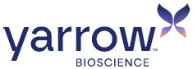

Yarrow Bioscience Reports Second Quarter 2026 Financial Results and Provides Business Update

Enrollment ongoing in Phase 2a/2b trial evaluating YB-101, a potential first-in-class anti-TSHR antibody, in patients with Graves’ disease (with or without TED); Phase 2a topline results expected in the second half of 2027

Closed previously announced private financings totaling $200 million; expected to fund operations into 2028

Completed reverse merger with VYNE Therapeutics and commenced trading on Nasdaq under the ticker symbol “YARW”

New Haven, Conn.—August 13, 2026—Yarrow Bioscience, Inc. (“Yarrow” or the “Company”) (Nasdaq: YARW), a clinical-stage biotechnology company focused on developing transformative therapies for autoimmune thyroid diseases, today announced financial results for the second quarter ended June 30, 2026 and provided business updates.

“The second quarter was highly productive for Yarrow and included the initiation of our Phase 2a/2b clinical trial of YB-101, a potential first-in-class anti-TSHR antibody that represents a highly differentiated approach to treating both Graves’ disease and thyroid eye disease. These two diseases converge on the TSHR, a single receptor that no approved therapy targets directly, giving Yarrow the unique opportunity to treat both conditions with a single molecule,” said Rebecca V. Frey, PharmD, President and Chief Executive Officer of Yarrow. “With the merger with VYNE Therapeutics now complete and cash runway expected to fund operations into 2028, we're well-positioned to advance YB-101 in GD, where dosing is underway and Phase 2a data are expected in the second half of 2027. Additionally, GenSci continues its Phase 1 MAD study in TED in China, which we expect to inform our global TED development plans.”

Second Quarter 2026 Highlights and Upcoming Milestones

YB-101: potential first-in-class anti-TSHR antibody for GD and TED

 | • | The U.S. Food and Drug Administration (FDA) granted Fast Track Designation for YB-101 in GD.

 | • | The Company initiated the Phase 2a/2b trial of YB-101 in patients with Graves’ disease (GD), with or without concurrent thyroid eye disease (TED).

 | o | The Phase 2a portion of the trial is a randomized, placebo-controlled proof-of-concept trial of 32 patients across four cohorts designed to evaluate safety, pharmacokinetics (PK), pharmacodynamics (PD), and efficacy over 24 weeks, including the percentage of patients who are euthyroid and off anti-thyroid drugs, as well as relevant measures of orbitopathy in patients with concurrent TED.
 | o | Topline results from the Phase 2a portion of the trial are expected in the second half of 2027.
 | o | The Phase 2b portion of the trial is expected to commence in the first half of 2028.

 | • | Licensing partner, Changchun GeneScience Pharmaceutical Co., Ltd. (“GenSci”), continues to advance YB-101 (also known as GenSci098) in greater China. Data from GenSci’s ongoing Phase 1 multiple ascending dose (MAD) trial in TED are anticipated in the second half of 2027 and are expected to inform the Company’s global TED development plans.

Recent Corporate Update

The Company completed the merger with VYNE Therapeutics Inc. (the “Merger”), closed the previously announced private financings that resulted in gross proceeds totaling approximately $200 million, and began trading on the Nasdaq Capital Market under the ticker symbol “YARW.” The financings were led by founding investor RTW Investments, with participation from OrbiMed, Janus Henderson Investors, venBio Partners, Logos Capital, LifeSci Venture Partners, and Perceptive Advisors.

Second Quarter 2026 Financial Results

 | • | Cash Position: As of June 30, 2026, Yarrow had cash and cash equivalents of $18.7 million. Yarrow expects its cash and cash equivalents as of June 30, 2026, together with the proceeds of $100 million received in July 2026 from the second half of the pre-Merger private financings, to fund operations into 2028.
 | • | Research & Development Expenses: R&D expenses totaled $4.9 million for the second quarter of 2026.
 | • | General & Administrative Expenses: G&A expenses totaled $1.8 million for the second quarter of 2026.
 | • | Net Loss: Net loss totaled $6.5 million for the second quarter of 2026.
 | • | Shares Outstanding: Subsequent to the Merger, Yarrow has approximately 28.6 million shares of common stock and common stock equivalents issued and outstanding.
 | • | Additional Information: The financial results presented in this release reflect those of Pre-Merger Yarrow (Yarrow Bioscience Operating Company Corp. f/k/a Yarrow Bioscience, Inc.) for the quarter ended June 30, 2026. For additional information on the Company’s financial results for the quarter ended June 30, 2026, please refer to the Company’s Current Report on Form 8-K/A expected to be filed with the SEC later today.

About the Phase 2a/2b Clinical Trial of YB-101 in Patients with GD, With or Without TED

The Phase 2a/2b clinical trial (NCT07682896) is a randomized, blinded, placebo-controlled two-part trial evaluating YB-101 in patients with GD, with or without concurrent TED. The Phase 2a portion (Part 1) is a proof-of-concept trial of YB-101 versus placebo aiming to enroll 32 patients across four cohorts. The trial will evaluate safety, PK, PD, and efficacy endpoints through 24 weeks, including the percentage of patients who are euthyroid and off anti-thyroid drugs, as well as relevant measures of orbitopathy in patients with concurrent TED. Data from the Phase 2a portion are expected in the second half of 2027.

The Phase 2b portion (Part 2) is expected to be conducted as a dose-finding trial and enroll approximately 200 patients. The selection of doses and dosing intervals for the Phase 2b is expected to be informed by the safety, efficacy, PK, and PD data generated in the Phase 2a. The Phase 2b portion is anticipated to commence in the first half of 2028.

About Yarrow Bioscience

Yarrow Bioscience, Inc. is a clinical-stage biotechnology company focused on developing transformative therapies for autoimmune thyroid diseases. The Company is developing YB-101, a potential first-in-class anti-thyroid stimulating hormone receptor (TSHR) monoclonal antibody designed to directly and rapidly disrupt the central mechanism of both Graves’ disease (GD) and thyroid eye disease (TED). For more information, visit www.yarrowbioscience.com.

Forward-looking Statements

This press release contains forward-looking statements (including within the meaning of Section 21E of the Securities Exchange Act of 1934, as amended, and Section 27A of the Securities Act of 1933, as amended) concerning the Company. These forward-looking statements include express or implied statements relating to: the therapeutic potential of YB-101 to address both GD and TED with a single product candidate; the design, initiation, enrollment, progress, timing and results of clinical trials of YB-101 conducted by the Company and by GenSci, including the expected timing of data from the Phase 2a portion of the Company’s Phase 2a/2b trial, data from the MAD portion of GenSci’s Phase 1 TED trial, and the anticipated commencement of the Phase 2b portion of the trial; the Company’s regulatory strategy and its ability to obtain and maintain regulatory approvals, including the implications of YB-101’s Fast Track Designation; the sufficiency of the Company’s capital resources and its expectation that its cash balance will fund operations into 2028; the Company’s licensing partnership with GenSci and future development plans for YB-101 in TED globally; the market opportunity for YB-101 in GD and TED; and the Company’s strategy, plans, objectives and expectations for future operations. The words “anticipate,” “believe,” “contemplate,” “continue,” “could,” “estimate,” “expect,” “intend,” “may,” “might,” “plan,” “possible,” “potential,” “predict,” “project,” “should,” “will,” “would” and similar expressions (including the negatives of these terms or variations of them) may identify forward-looking statements, but the absence of these words does not mean that a statement is not forward-looking. These forward-looking statements are based on current expectations and beliefs concerning future developments and their potential effects. There can be no assurance that future developments affecting the Company will be those that have been anticipated.

The forward-looking statements contained in this press release are based on current expectations and beliefs concerning future developments and their potential effects and therefore are subject to other risks and uncertainties. These risks and uncertainties include, but are not limited to, risks associated with the possible failure to realize certain anticipated benefits of the Merger, including with respect to future financial and operating results; the effect of the completion of the Merger on the Company’s business relationships, operating results and business generally; risks associated with the Company’s ability to manage expenses and unanticipated spending and costs that could reduce the Company’s cash resources; risks related to the Company’s ability to correctly estimate its operating expenses and other events; changes in capital resource requirements; risks related to the inability of the Company to obtain sufficient additional capital to continue to advance its product candidates or its preclinical programs; the outcome of any legal proceedings that may be instituted against the Company or any of its directors or officers; the ability of the Company to obtain, maintain and protect its intellectual property rights, in particular those related to its product candidates; the Company’s ability to advance the development of its product candidates or preclinical activities under the timelines it anticipates in planned and future clinical trials; the Company’s ability to replicate in later clinical trials positive results found in preclinical studies and early-stage clinical trials of its product candidates; the Company’s ability to realize the anticipated benefits of its research and development programs, strategic partnerships, licensing programs or other collaborations; regulatory requirements or developments and the Company’s ability to obtain necessary approvals from the FDA or other regulatory authorities; changes to clinical trial designs and regulatory pathways; competitive responses to the Merger and changes in expected or existing competition; unexpected costs, charges or expenses resulting from the Merger; potential adverse reactions or changes to business relationships resulting from the completion of the Merger; legislative, regulatory, political and economic developments; and those risks and uncertainties and other factors more fully described in filings with the Securities and Exchange Commission (the “SEC”), including reports filed on Form 10-K, 10-Q and 8-K and in other filings made by the Company with the SEC from time to time and available at www.sec.gov. These forward-looking statements are based on current expectations, management’s beliefs and certain assumptions made by the Company, all of which are subject to change. Such forward-looking statements are made as of the date of this press release, and the Company undertakes no obligation to update such statements to reflect subsequent events or circumstances, except as otherwise required by securities and other applicable law.

For More Information

Investor Contact
Joyce Allaire
LifeSci Advisors
Jallaire@lifesciadvisors.com

Media Contact
Michael Galfetti
Ten Bridge Communications
tbcyarrow@tenbridgecommunications.com

YARROW BIOSCIENCE OPERATING COMPANY CORP.
(f/k/a YARROW BIOSCIENCE, INC.)

Balance SheetS(1)
(in thousands, except share and per share data)

(Unaudited)

 |  | June 30, 2026 |  |  |  | December 31, 2025
Assets
Current assets:
Cash and cash equivalents |  | $ | 18,670 |  |  | $ | 99,994
Restricted cash |  |  | 105 |  |  |  | —
Prepaid and other current assets |  |  | 4,509 |  |  |  | 6
Total current assets |  |  | 23,284 |  |  |  | 100,000
Deferred transaction costs |  |  | 2,282 |  |  |  | 407
Total assets |  | $ | 25,566 |  |  | $ | 100,407
Liabilities, Convertible Preferred Stock and Stockholders’ Deficit
Current liabilities:
Accounts payable (related party of $610 at December 31, 2025) |  | $ | 2,206 |  |  | $ | 1,534
Accrued expenses |  |  | 2,944 |  |  |  | 70,013
Total current liabilities |  |  | 5,150 |  |  |  | 71,547
Total liabilities |  |  | 5,150 |  |  |  | 71,547
Commitments and contingencies
Series A convertible preferred stock, $0.0001 par value, 14,516,188 shares authorized, issued and outstanding at June 30, 2026 and December 31, 2025; liquidation value of $100,000 |  |  | 99,850 |  |  |  | 99,850
Stockholders’ deficit:
Common stock, $0.0001 par value, 29,672,628 shares authorized, 3,047,675 issued and outstanding at June 30, 2026 and December 31, 2025 |  |  | — |  |  |  | —
Additional paid-in capital |  |  | 817 |  |  |  | 4
Accumulated deficit |  |  | (80,251 | ) |  |  | (70,994 | )
Total stockholders’ deficit |  |  | (79,434 | ) |  |  | (70,990 | )
Total liabilities, convertible preferred stock and stockholders’ deficit |  | $ | 25,566 |  |  | $ | 100,407

 | (1) | Historical share amounts have been retroactively adjusted to reflect the exchange ratio of 0.7171.

YARROW BIOSCIENCE OPERATING COMPANY CORP.
(f/k/a YARROW BIOSCIENCE, INC.)

StatementS of Operations(1)
(in thousands, except share and per share data)

(Unaudited)

 |  | For the Three  Months Ended  June 30, 2026 |  |  |  | For the Six  Months Ended  June 30, 2026
Operating expenses:
Research and development |  | $ | 4,939 |  |  | $ | 6,185
General and administrative |  |  | 1,757 |  |  |  | 3,373
Total operating expenses |  |  | 6,696 |  |  |  | 9,558
Net loss from operations |  |  | (6,696 | ) |  |  | (9,558 | )
Other income
Interest income |  |  | 184 |  |  |  | 301
Net loss |  | $ | (6,512 | ) |  | $ | (9,257 | )
Share information:
Net loss per share of common stock, basic and diluted |  | $ | (2.14 | ) |  | $ | (3.04 | )
Weighted-average shares of common stock outstanding, basic and diluted |  |  | 3,047,675 |  |  |  | 3,047,675

 | (1) | Historical share and per share amounts have been retroactively adjusted to reflect the exchange ratio of 0.7171.

Exhibit 99.8


1 Bringing life into balance Yarrow Bioscience Overview August 13, 2026

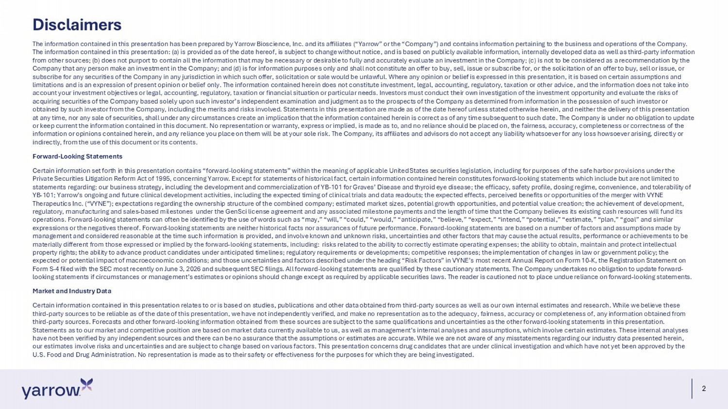
2 Disclaimers The information contained in this presentation has been prepared by Yarrow Bioscience, Inc. and its affiliates (“Yarrow” or t he “Company”) and contains information pertaining to the business and operations of the Company. The information contained in this presentation: (a) is provided as of the date hereof, is subject to change without notice, a nd is based on publicly available information, internally developed data as well as third - party information from other sources; (b) does not purport to contain all the information that may be necessary or desirable to fully and accur ate ly evaluate an investment in the Company; (c) is not to be considered as a recommendation by the Company that any person make an investment in the Company; and (d) is for information purposes only and shall not constitute an offer to buy, sell, issue or subscribe for, or the solicitation of an offer to buy, sell or issue, or subscribe for any securities of the Company in any jurisdiction in which such offer, solicitation or sale would be unlawful. Whe re any opinion or belief is expressed in this presentation, it is based on certain assumptions and limitations and is an expression of present opinion or belief only. The information contained herein does not constitute inve stm ent, legal, accounting, regulatory, taxation or other advice, and the information does not take into account your investment objectives or legal, accounting, regulatory, taxation or financial situation or particular needs. Inv est ors must conduct their own investigation of the investment opportunity and evaluate the risks of acquiring securities of the Company based solely upon such investor’s independent examination and judgment as to the prospect s o f the Company as determined from information in the possession of such investor or obtained by such investor from the Company, including the merits and risks involved. Statements in this presentation are made as of the date hereof unless stated otherwise herein, and neither the delivery of this presentation at any time, nor any sale of securities, shall under any circumstances create an implication that the information contained h ere in is correct as of any time subsequent to such date. The Company is under no obligation to update or keep current the information contained in this document. No representation or warranty, express or implied, is made as to, an d no reliance should be placed on, the fairness, accuracy, completeness or correctness of the information or opinions contained herein, and any reliance you place on them will be at your sole risk. The Company, its affi lia tes and advisors do not accept any liability whatsoever for any loss howsoever arising, directly or indirectly, from the use of this document or its contents. Forward - Looking Statements Certain information set forth in this presentation contains “forward - looking statements” within the meaning of applicable United States securities legislation, including for purposes of the safe harbor provisions under the Private Securities Litigation Reform Act of 1995, concerning Yarrow. Except for statements of historical fact, certain inform ati on contained herein constitutes forward - looking statements which include but are not limited to statements regarding: our business strategy, including the development and commercialization of YB - 101 for Graves’ Disease and t hyroid eye disease; the efficacy, safety profile, dosing regime, convenience, and tolerability of YB - 101; Yarrow’s ongoing and future clinical development activities, including the expected timing of clinical trials and data r eadouts; the expected effects, perceived benefits or opportunities of the merger with VYNE Therapeutics Inc. (“VYNE”); expectations regarding the ownership structure of the combined company; estimated market sizes, p ote ntial growth opportunities, and potential value creation; the achievement of development, regulatory, manufacturing and sales - based milestones under the GenSci license agreement and any associated milestone payments a nd the length of time that the Company believes its existing cash resources will fund its operations. Forward - looking statements can often be identified by the use of words such as “may,” “will,” “could,” “would,” “ant icipate,” “believe,” “expect,” “intend,” “potential,” “estimate,” “plan,” “goal” and similar expressions or the negatives thereof. Forward - looking statements are neither historical facts nor assurances of future performan ce. Forward - looking statements are based on a number of factors and assumptions made by management and considered reasonable at the time such information is provided, and involve known and unknown risks, uncertain tie s and other factors that may cause the actual results, performance or achievements to be materially different from those expressed or implied by the forward - looking statements, including: risks related to the ability to correctly estimate operating expenses; the ability to obtain, maintain and protect intellectual property rights; the ability to advance product candidates under anticipated timelines; regulatory requirements or developmen ts; competitive responses; the implementation of changes in law or government policy; the expected or potential impact of macroeconomic conditions; and those uncertainties and factors described under the heading “Ri sk Factors” in VYNE’s most recent Annual Report on Form 10 - K, the Registration Statement on Form S - 4 filed with the SEC most recently on June 3, 2026 and subsequent SEC filings. All forward - looking statements are qualifi ed by these cautionary statements. The Company undertakes no obligation to update forward - looking statements if circumstances or management’s estimates or opinions should change except as required by applicable secu rit ies laws. The reader is cautioned not to place undue reliance on forward - looking statements. Market and Industry Data Certain information contained in this presentation relates to or is based on studies, publications and other data obtained fr om third - party sources as well as our own internal estimates and research. While we believe these third - party sources to be reliable as of the date of this presentation, we have not independently verified, and make no represen tation as to the adequacy, fairness, accuracy or completeness of, any information obtained from third - party sources. Forecasts and other forward - looking information obtained from these sources are subject to the same qualifi cations and uncertainties as the other forward - looking statements in this presentation. Statements as to our market and competitive position are based on market data currently available to us, as well as managemen t’s internal analyses and assumptions, which involve certain estimates. These internal analyses have not been verified by any independent sources and there can be no assurance that the assumptions or estimates are accurat e. While we are not aware of any misstatements regarding our industry data presented herein, our estimates involve risks and uncertainties and are subject to change based on various factors. This presentation concerns dru g candidates that are under clinical investigation and which have not yet been approved by the U.S. Food and Drug Administration. No representation is made as to their safety or effectiveness for the purposes for which t hey are being investigated.


3 Yarrow Bioscience is seeking to bring life into balance for patients suffering with Graves’ Disease and TED

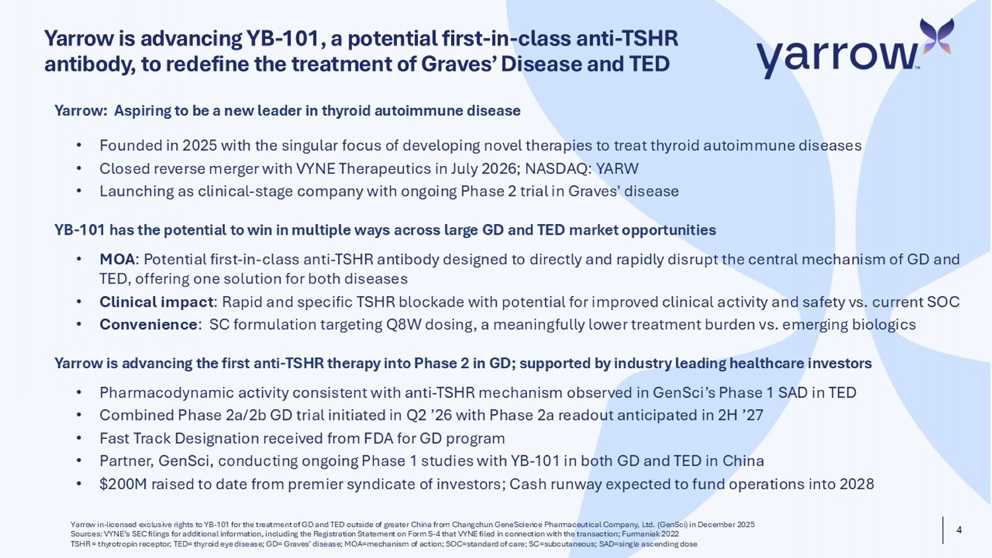
4 Yarrow is advancing YB - 101, a potential first - in - class anti - TSHR antibody, to redefine the treatment of Graves’ Disease and TED Yarrow in - licensed exclusive rights to YB - 101 for the treatment of GD and TED outside of greater China from Changchun GeneScience Pharmaceutical Company, Ltd. ( GenSci ) in December 2025 Sources: VYNE’s SEC filings for additional information, including the Registration Statement on Form S - 4 that VYNE filed in conn ection with the transaction; Furmaniak 2022 TSHR = thyrotropin receptor; TED= thyroid eye disease; GD= Graves’ disease; MOA=mechanism of action; SOC=standard of care; SC =su bcutaneous; SAD=single ascending dose Yarrow : Aspiring to be a new leader in thyroid autoimmune disease • Founded in 2025 with the singular focus of developing novel therapies to treat thyroid autoimmune diseases • Closed reverse merger with VYNE Therapeutics in July 2026; NASDAQ: YARW • Launching as clinical - stage company with ongoing Phase 2 trial in Graves' disease YB - 101 has the potential to win in multiple ways across large GD and TED market opportunities • MOA : Potential first - in - class anti - TSHR antibody designed to directly and rapidly disrupt the central mechanism of GD and TED, offering one solution for both diseases • Clinical impact : Rapid and specific TSHR blockade with potential for improved clinical activity and safety vs. current SOC • Convenience : SC formulation targeting Q8W dosing, a meaningfully lower treatment burden vs. emerging biologics Yarrow is advancing the first anti - TSHR therapy into Phase 2 in GD; supported by industry leading healthcare investors • Pharmacodynamic activity consistent with anti - TSHR mechanism observed in GenSci’s Phase 1 SAD in TED • Combined Phase 2a/2b GD trial initiated in Q2 ’26 with Phase 2a readout anticipated in 2H ’27 • Fast Track Designation received from FDA for GD program • Partner, GenSci , conducting ongoing Phase 1 studies with YB - 101 in both GD and TED in China • $200M raised to date from premier syndicate of investors; Cash runway expected to fund operations into 2028

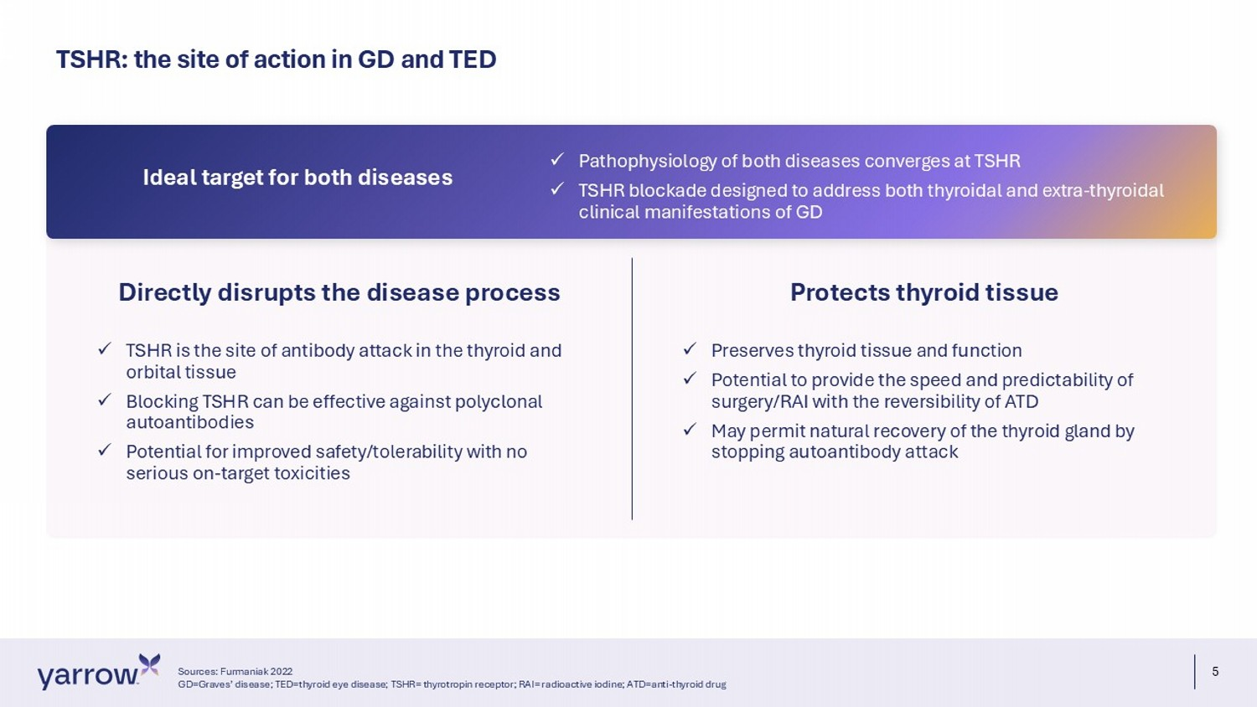
5 TSHR: the site of action in GD and TED Sources: Furmaniak 2022 GD=Graves’ disease; TED=thyroid eye disease; TSHR= thyrotropin receptor; RAI= radioactive iodine; ATD=anti - thyroid drug Directly disrupts the disease process x TSHR is the site of antibody attack in the thyroid and orbital tissue x Blocking TSHR can be effective against polyclonal autoantibodies x Potential for improved safety/tolerability with no serious on - target toxicities Protects thyroid tissue x Preserves thyroid tissue and function x Potential to provide the speed and predictability of surgery/RAI with the reversibility of ATD x May permit natural recovery of the thyroid gland by stopping autoantibody attack x Pathophysiology of both diseases converges at TSHR x TSHR blockade designed to address both thyroidal and extra - thyroidal clinical manifestations of GD Ideal target for both diseases

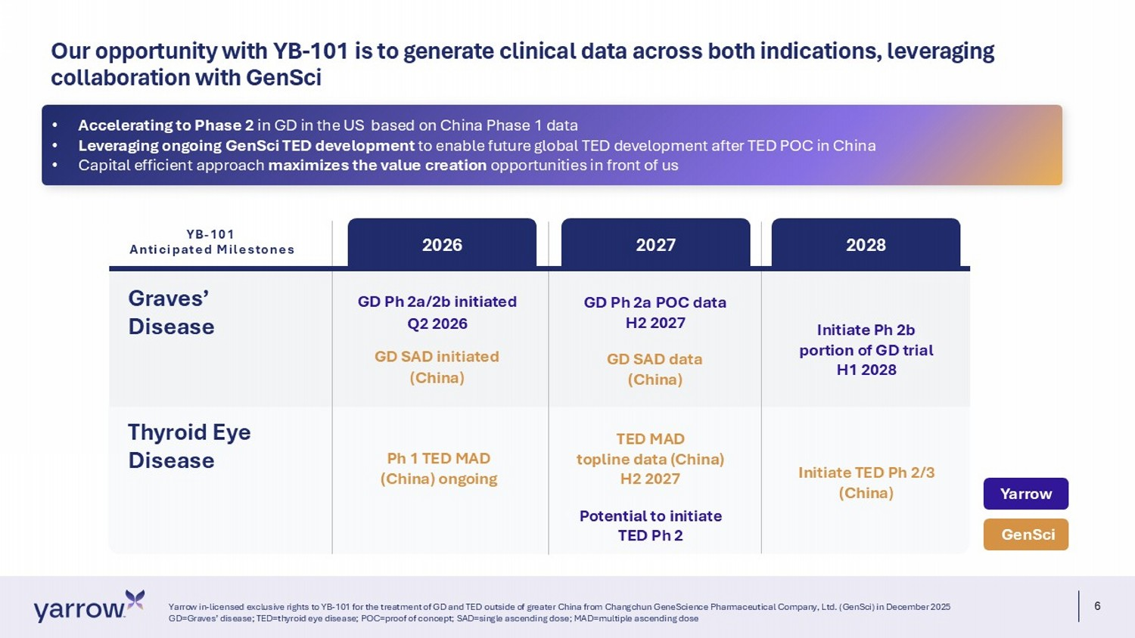
6 Our opportunity with YB - 101 is to generate clinical data across both indications, leveraging collaboration with GenSci Yarrow in - licensed exclusive rights to YB - 101 for the treatment of GD and TED outside of greater China from Changchun GeneScienc e Pharmaceutical Company, Ltd. (GenSci) in December 2025 GD=Graves’ disease; TED=thyroid eye disease; POC=proof of concept; SAD=single ascending dose; MAD=multiple ascending dose Graves’ Disease 2026 2027 2028 GD Ph 2a/2b initiated Q2 2026 GD SAD i nitiated (China) Ph 1 TED MAD (China) ongoing GD Ph 2a POC data H2 2027 GD SAD data (China) TED MAD topline data (China) H2 2027 Potential to initiate TED Ph 2 Initiate Ph 2b portion of GD trial H1 2028 Initiate TED Ph 2/3 (China) GenSci Yarrow Thyroid Eye Disease YB - 101 Anticipated Milestones • Accelerating to Phase 2 in GD in the US based on China Phase 1 data • Leveraging ongoing GenSci TED development to enable future global TED development after TED POC in China • Capital efficient approach maximizes the value creation opportunities in front of us

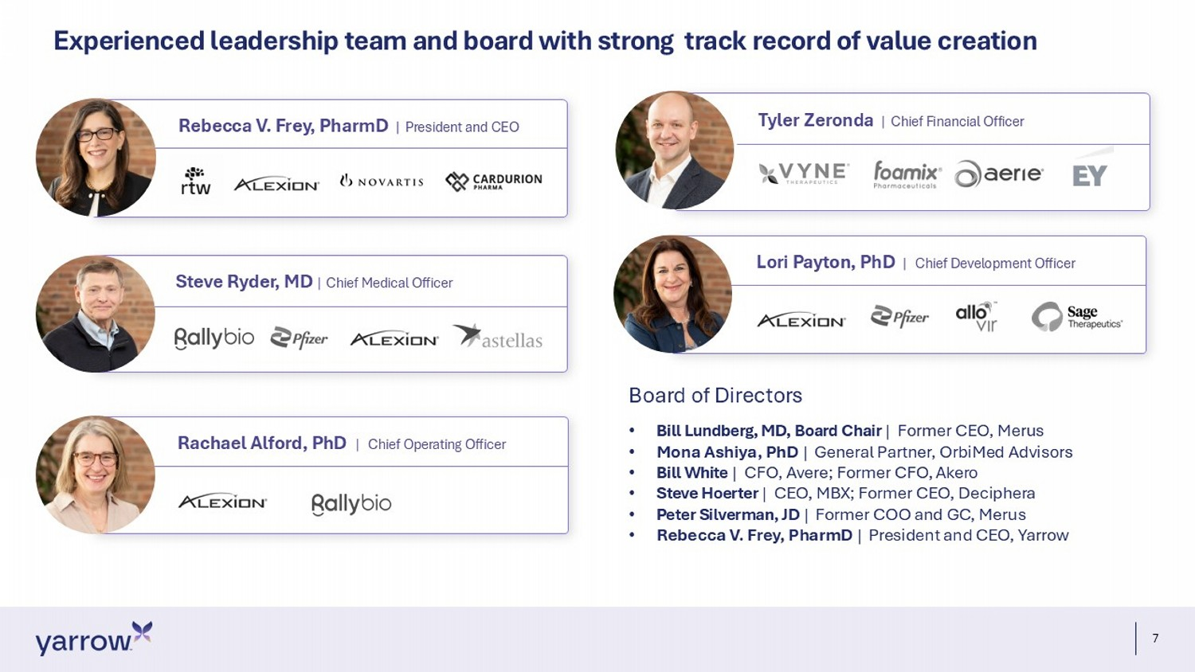
7 Experienced leadership team and board with strong track record of value creation Rebecca V. Frey, PharmD | President and CEO Lori Payton, PhD | Chief Development Officer Tyler Zeronda | Chief Financial Officer Rachael Alford, PhD | Chief Operating Officer Steve Ryder, MD | Chief Medical Officer Board of Directors • Bill Lundberg, MD, Board Chair | Former CEO, Merus • Mona Ashiya, PhD | General Partner, OrbiMed Advisors • Bill White | CFO, Avere; Former CFO, Akero • Steve Hoerter | CEO, MBX; Former CEO, Deciphera • Peter Silverman, JD | Former COO and GC, Merus • Rebecca V. Frey, PharmD | President and CEO, Yarrow

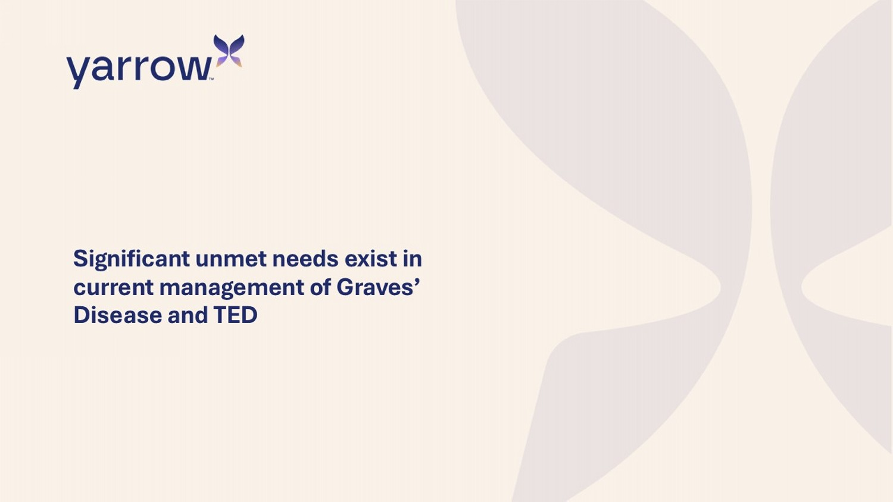
Significant unmet needs exist in current management of Graves’ Disease and TED

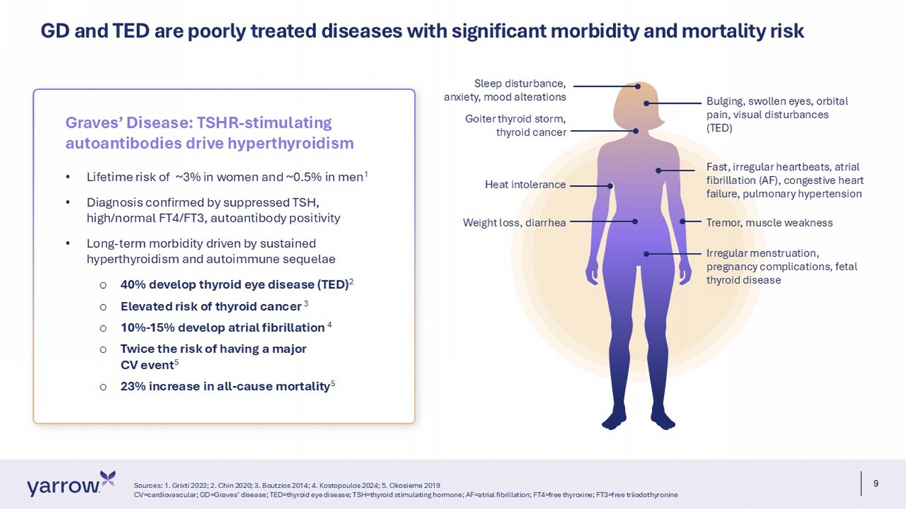
9 GD and TED are poorly treated diseases with significant morbidity and mortality risk Sources: 1. Grixti 2023; 2. Chin 2020; 3. Boutzios 2014; 4. Kostopoulos 2024; 5. Okosieme 2019 CV=cardiovascular; GD=Graves’ disease; TED=thyroid eye disease; TSH=thyroid stimulating hormone; AF=atrial fibrillation; FT4= fre e thyroxine; FT3=free triiodothyronine • Lifetime risk of ~3% in women and ~0.5% in men 1 • Diagnosis confirmed by suppressed TSH, high/normal FT4/FT3, autoantibody positivity • Long - term morbidity driven by sustained hyperthyroidism and autoimmune sequelae o 40% develop thyroid eye disease (TED) 2 o Elevated risk of thyroid cancer 3 o 10% - 15% develop atrial fibrillation 4 o Twice the risk of having a major CV event 5 o 23% increase in all - cause mortality 5 Graves’ Disease : TSHR - stimulating autoantibodies drive hyperthyroidism Goiter thyroid storm, thyroid cancer Bulging, swollen eyes, orbital pain, visual disturbances (TED) Fast, irregular heartbeats, atrial fibrillation (AF), congestive heart failure, pulmonary hypertension Tremor, muscle weakness Sleep disturbance, anxiety, mood alterations Weight loss, diarrhea Irregular menstruation, pregnancy complications, fetal thyroid disease Heat intolerance

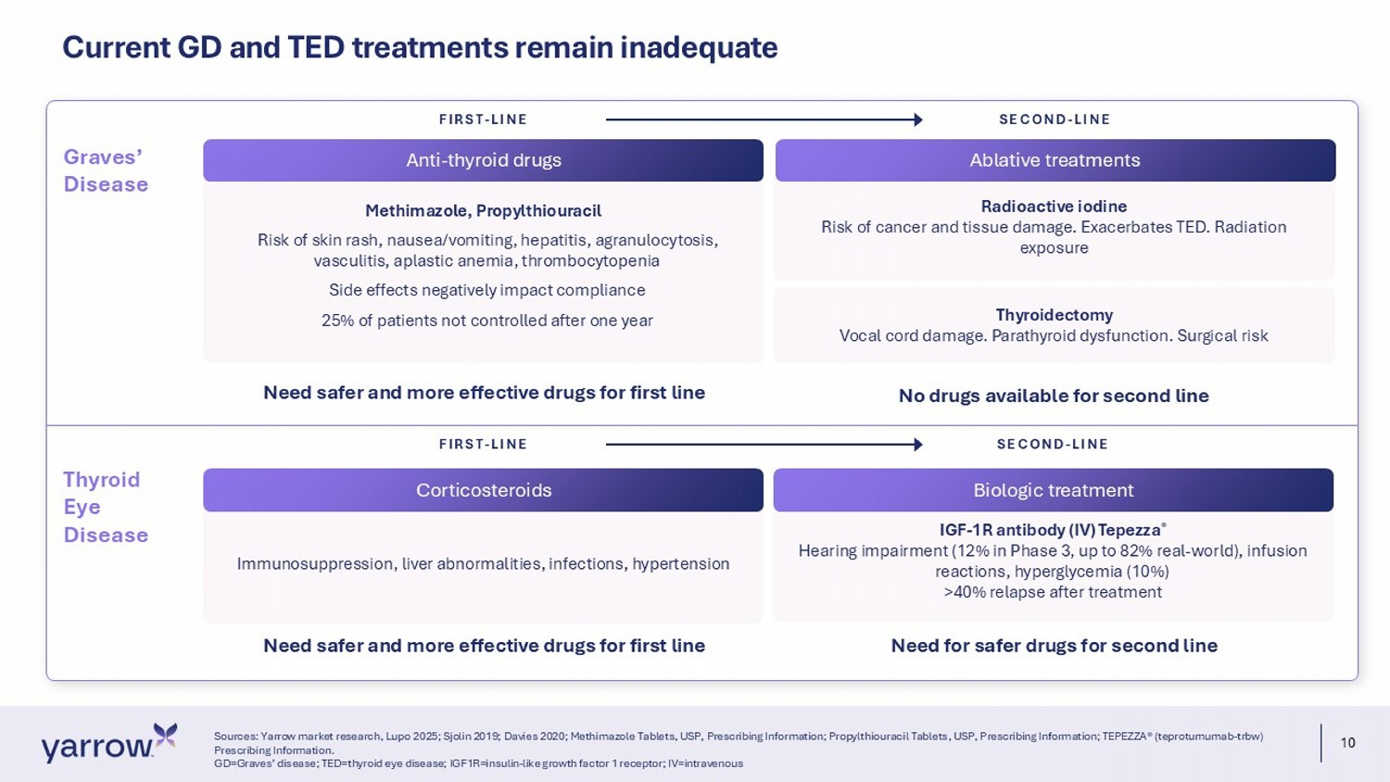
10 Radioactive iodine Risk of cancer and tissue damage. Exacerbates TED. Radiation exposure Current GD and TED treatments remain inadequate Sources: Yarrow market research, Lupo 2025; Sjolin 2019; Davies 2020; Methimazole Tablets, USP, Prescribing Information; Prop ylt hiouracil Tablets, USP, Prescribing Information; TEPEZZA® (teprotumumab - trbw ) Prescribing Information. GD=Graves’ disease; TED=thyroid eye disease; IGF1R=insulin - like growth factor 1 receptor; IV=intravenous Methimazole, Propylthiouracil Risk of skin rash, nausea/vomiting, hepatitis, agranulocytosis, vasculitis, aplastic anemia, thrombocytopenia Side effects negatively impact compliance 25% of patients not controlled after one year Thyroidectomy Vocal cord damage. Parathyroid dysfunction. Surgical risk No drugs available for second line IGF - 1R antibody (IV) Tepezza ® Hearing impairment (12% in Phase 3, up to 82% real - world), infusion reactions, hyperglycemia (10%) >40% relapse after treatment Need for safer drugs for second line Anti - thyroid drugs FIRST - LINE SECOND - LINE Graves’ Disease Thyroid Eye Disease Immunosuppression, liver abnormalities, infections, hypertension FIRST - LINE SECOND - LINE Need safer and more effective drugs for first line Need safer and more effective drugs for first line Ablative treatments Corticosteroids Biologic treatment

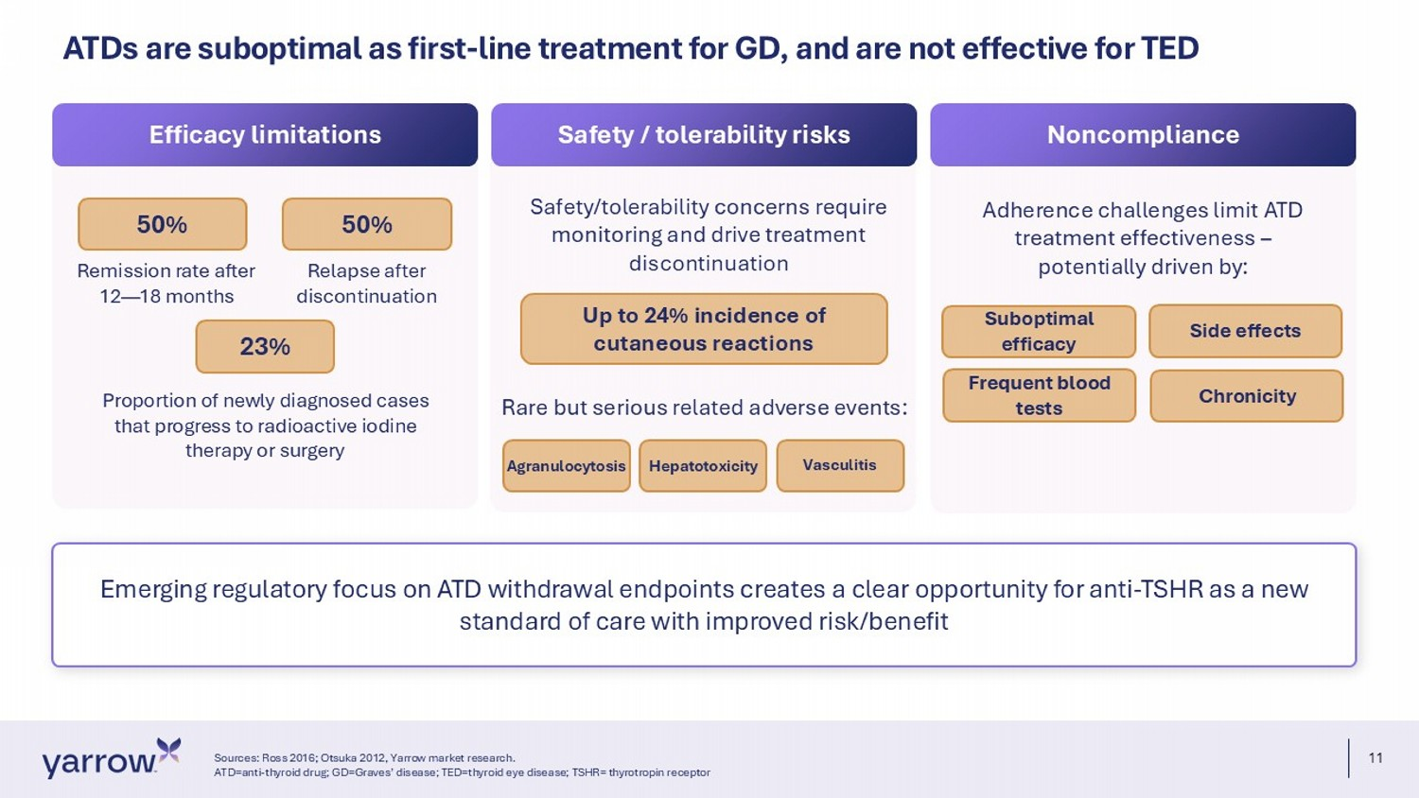
11 Emerging regulatory focus on ATD withdrawal endpoints creates a clear opportunity for anti - TSHR as a new standard of care with improved risk/benefit ATDs are suboptimal as first - line treatment for GD, and are not effective for TED Sources: Ross 2016; Otsuka 2012, Yarrow market research. ATD=anti - thyroid drug; GD=Graves’ disease; TED=thyroid eye disease; TSHR= thyrotropin receptor Efficacy limitations Safety / tolerability risks Noncompliance 50% 50% Remission rate after 12 — 18 months Relapse after discontinuation 23% Proportion of newly diagnosed cases that progress to radioactive iodine therapy or surgery Safety/ tolerability concerns require monitoring and drive treatment discontinuation Up to 24% incidence of cutaneous reactions Adherence challenges limit ATD treatment effectiveness – potentially driven by: Suboptimal efficacy Side effects Chronicity Frequent blood tests Rare but serious related adverse events: Agranulocytosis Hepatotoxicity Vasculitis

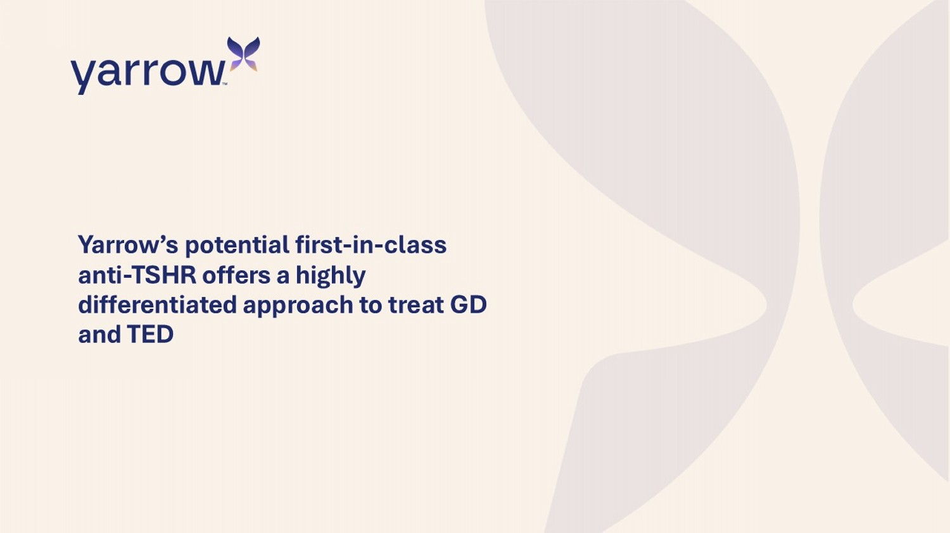
Yarrow’s potential first - in - class anti - TSHR offers a highly differentiated approach to treat GD and TED

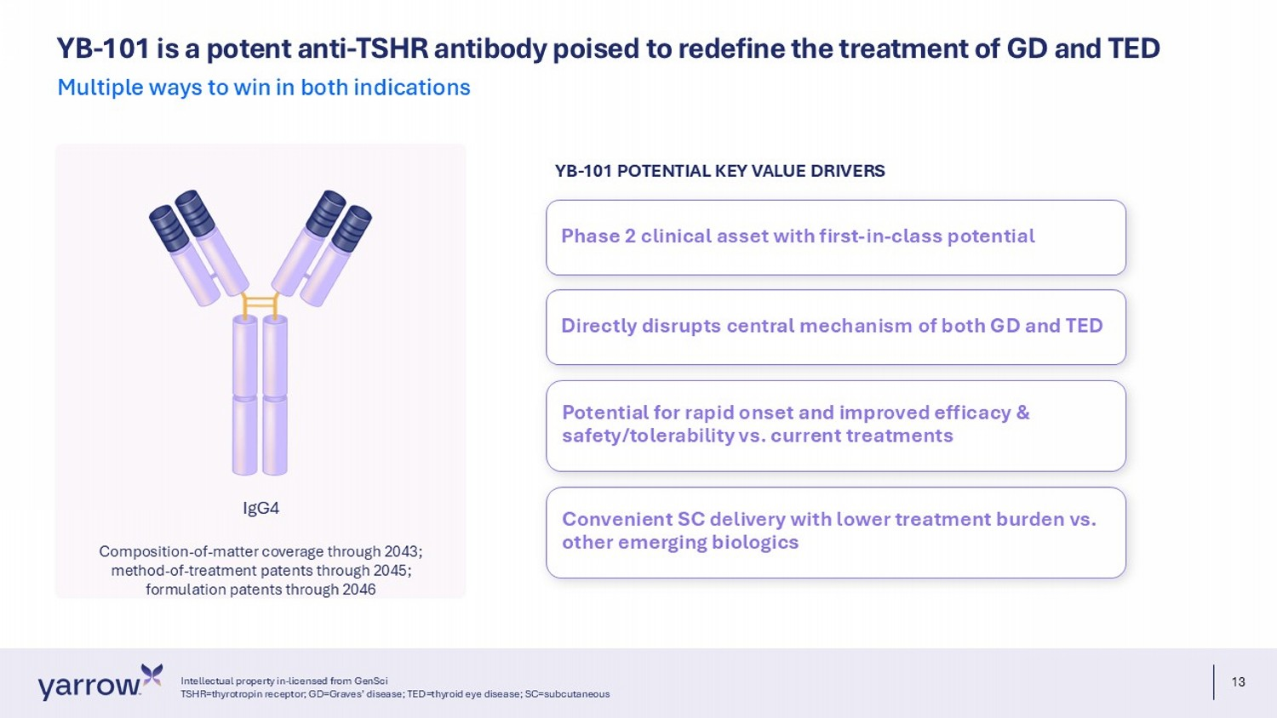
13 YB - 101 is a potent anti - TSHR antibody poised to redefine the treatment of GD and TED Multiple ways to win in both indications IgG4 Composition - of - matter coverage through 2043; method - of - treatment patents through 2045; formulation patents through 2046 Phase 2 clinical asset with first - in - class potential Directly disrupts central mechanism of both GD and TED Potential for rapid onset and improved efficacy & safety/tolerability vs. current treatments Convenient SC delivery with lower treatment burden vs. other emerging biologics YB - 101 POTENTIAL KEY VALUE DRIVERS Intellectual property in - licensed from GenSci TSHR=thyrotropin receptor; GD=Graves’ disease; TED=thyroid eye disease; SC=subcutaneous

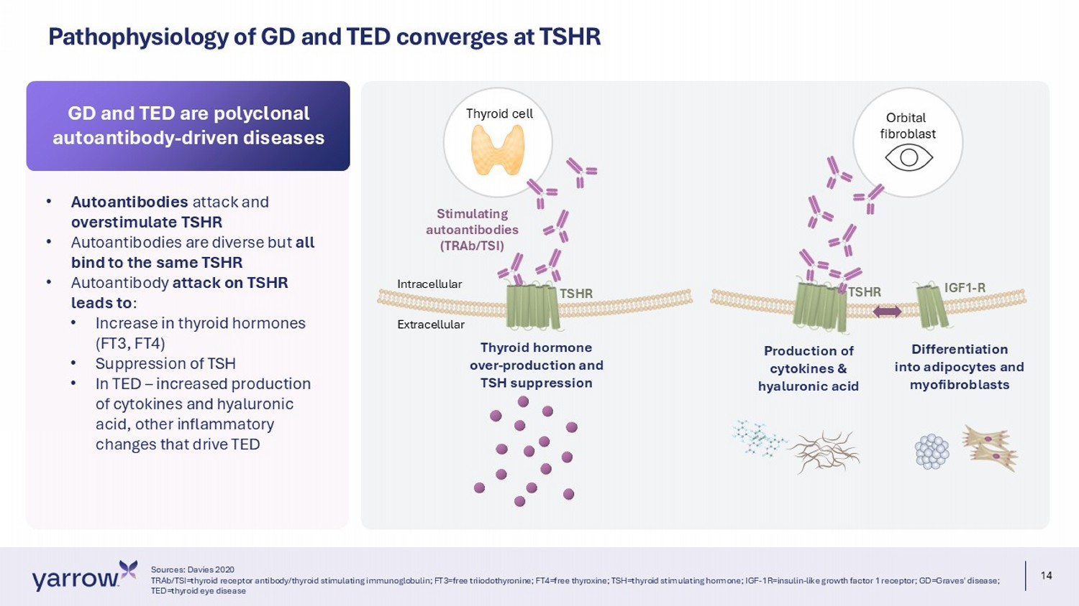
14 Pathophysiology of GD and TED converges at TSHR Thyroid cell Orbital fibroblast Stimulating autoantibodies (TRAb/TSI) TSHR Thyroid hormone over - production and TSH suppression P roduction of cytokines & hyaluronic acid Differentiation into adipocytes and myofibroblasts Intracellular Extracellular IGF1 - R TSHR • Autoantibodies attack and overstimulate TSHR • Autoantibodies are diverse but all bind to the same TSHR • Autoantibody attack on TSHR leads to : • Increase in thyroid hormones (FT3, FT4) • Suppression of TSH • In TED – increased production of cytokines and hyaluronic acid, other inflammatory changes that drive TED GD and TED are polyclonal autoantibody - driven diseases Sources: Davies 2020 TRAb/TSI=thyroid receptor antibody/thyroid stimulating immunoglobulin; FT3=free triiodothyronine; FT4=free thyroxine; TSH=thy roi d stimulating hormone; IGF - 1R=insulin - like growth factor 1 receptor; GD=Graves' disease; TED=thyroid eye disease

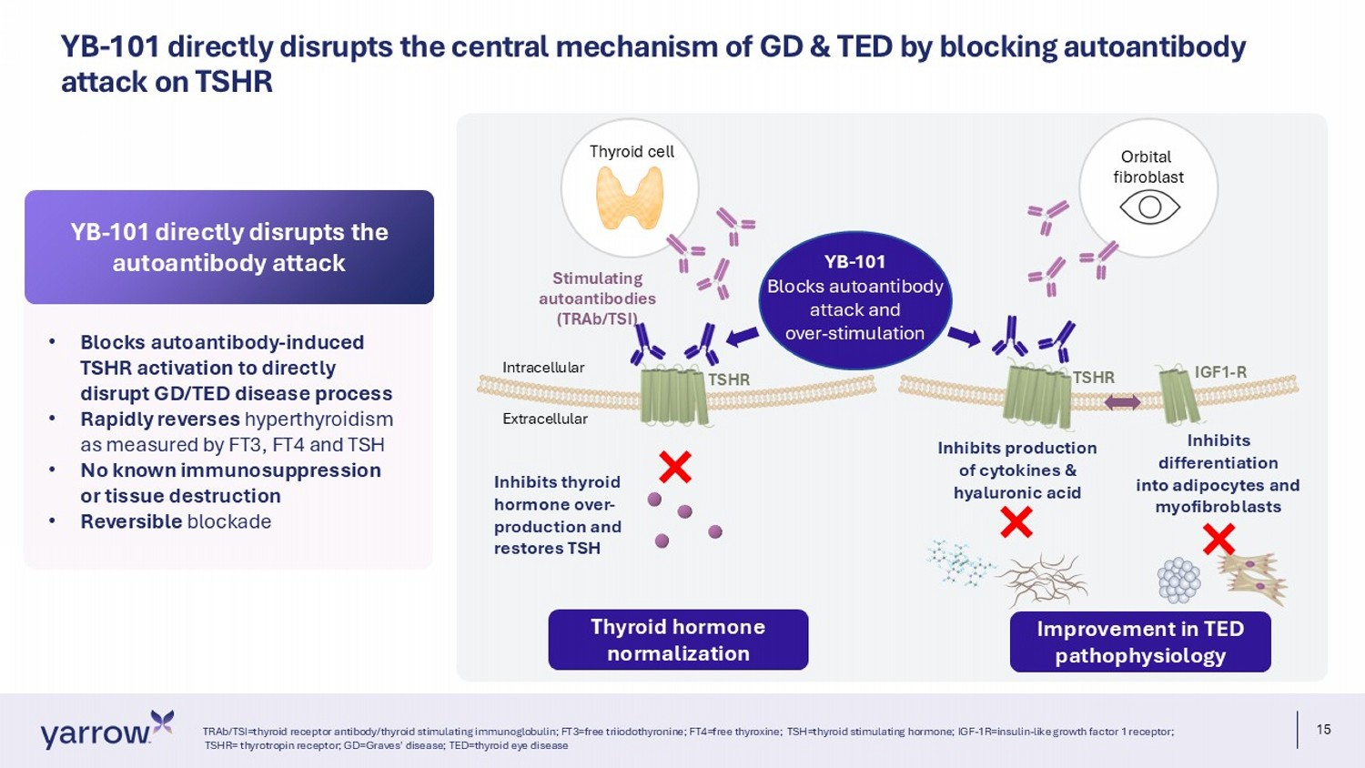
15 YB - 101 directly disrupts the central mechanism of GD & TED by blocking autoantibody attack on TSHR TRAb/TSI=thyroid receptor antibody/thyroid stimulating immunoglobulin; FT3=free triiodothyronine; FT4=free thyroxine; TSH=th yro id stimulating hormone; IGF - 1R=insulin - like growth factor 1 receptor; TSHR= thyrotropin receptor; GD=Graves' disease; TED=thyroid eye disease Thyroid cell Orbital fibroblast Stimulating autoantibodies (TRAb/TSI) TSHR Inhibits thyroid hormone over - production and restores TSH Inhibits production of cytokines & hyaluronic acid Inhibits d ifferentiation into adipocytes and myofibroblasts Intracellular Extracellular IGF1 - R TSHR YB - 101 Blocks autoantibody attack and over - stimulation Thyroid hormone normalization Improvement in TED pathophysiology • Blocks autoantibody - induced TSHR activation to directly disrupt GD/TED disease process • Rapidly reverses hyperthyroidism as measured by FT3, FT4 and TSH • No known immunosuppression or tissue destruction • Reversible blockade YB - 101 directly disrupts the autoantibody attack

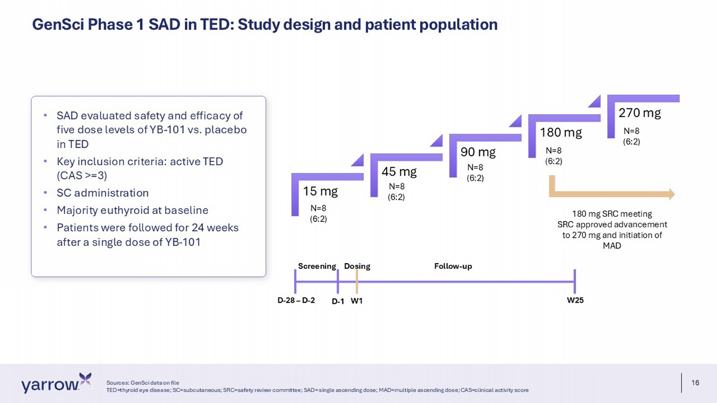
16 GenSci Phase 1 SAD in TED: Study design and patient population Sources: GenSci data on file TED=thyroid eye disease; SC=subcutaneous; SRC=safety review committee; SAD= single ascending dose; MAD=multiple ascending dos e; CAS=clinical activity score • SAD evaluated safety and efficacy of five dose levels of YB - 101 vs. placebo in TED • Key inclusion criteria: active TED (CAS >=3) • SC administration • Majority euthyroid at baseline • Patients were followed for 24 weeks after a single dose of YB - 101 Screening Dosing Follow - up D - 28 – D - 2 D - 1 W1 W25 N=8 (6:2) 15 mg 45 mg 90 mg 180 mg 270 mg N=8 (6:2) N=8 (6:2) N=8 (6:2) N=8 (6:2) 180 mg SRC meeting SRC approved advancement to 270 mg and initiation of MAD

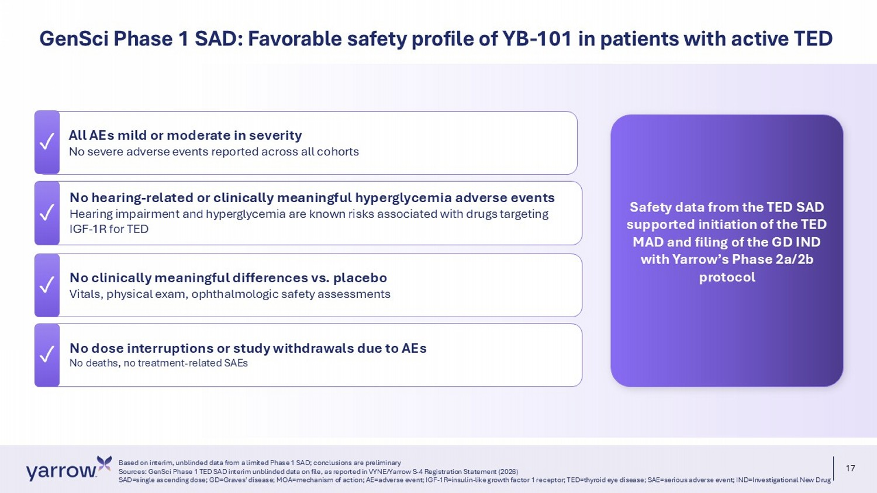
17 ✓ No dose interruptions or study withdrawals due to AEs No deaths, no treatment - related SAEs All AEs mild or moderate in severity No severe adverse events reported across all cohorts No hearing - related or clinically meaningful hyperglycemia adverse events Hearing impairment and hyperglycemia are known risks associated with drugs targeting IGF - 1R for TED ✓ No clinically meaningful differences vs. placebo Vitals, physical exam, ophthalmologic safety assessments Based on interim, unblinded data from a limited Phase 1 SAD; conclusions are preliminary Sources: GenSci Phase 1 TED SAD interim unblinded data on file, as reported in VYNE/Yarrow S - 4 Registration Statement (2026) SAD=single ascending dose; GD=Graves' disease; MOA=mechanism of action; AE=adverse event; IGF - 1R=insulin - like growth factor 1 re ceptor; TED=thyroid eye disease; SAE=serious adverse event; IND=Investigational New Drug GenSci Phase 1 SAD: Favorable safety profile of YB - 101 in patients with active TED ✓ ✓ ✓ Safety data from the TED SAD supported initiation of the TED MAD and filing of the GD IND with Yarrow’s Phase 2a/2b protocol

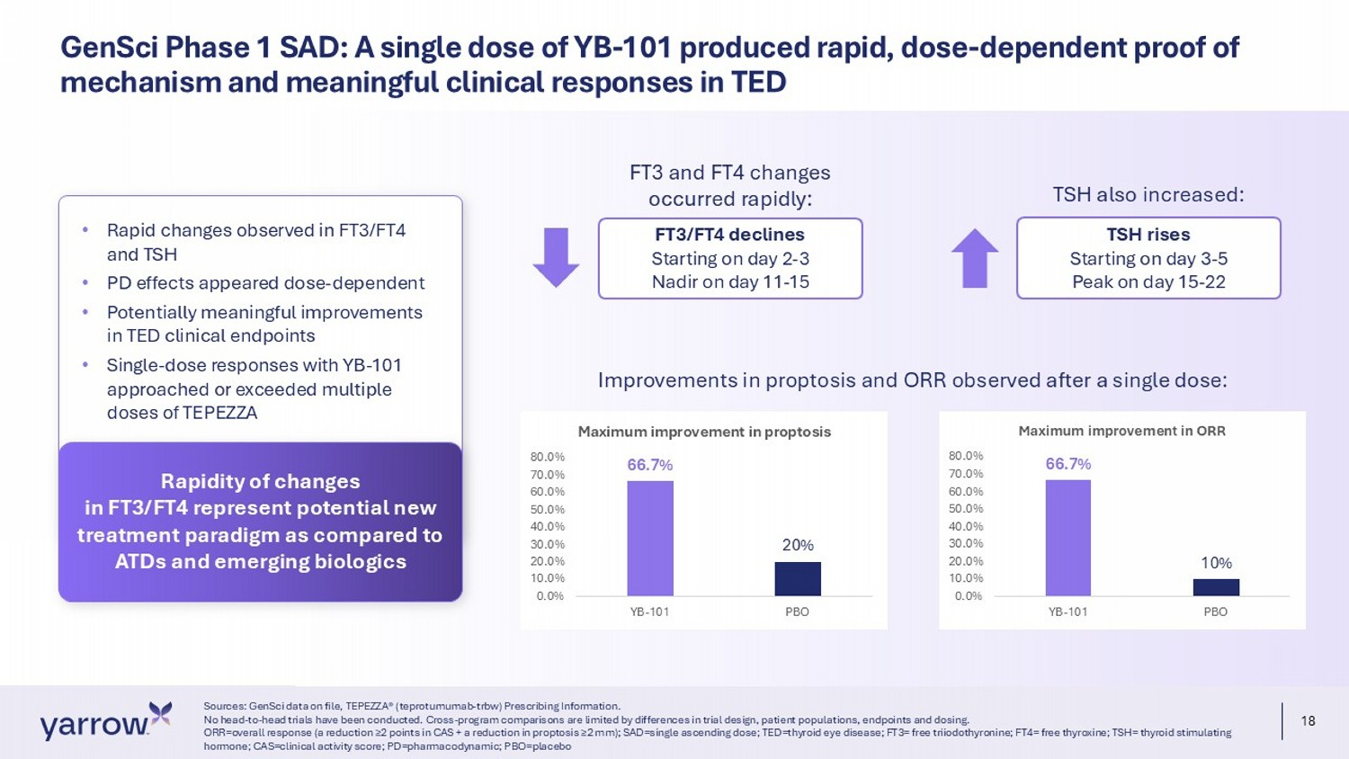
18 GenSci Phase 1 SAD: A single dose of YB - 101 produced rapid, dose - dependent proof of mechanism and meaningful clinical responses in TED Sources: GenSci data on file, TEPEZZA® (teprotumumab - trbw) Prescribing Information. No head - to - head trials have been conducted. Cross - program comparisons are limited by differences in trial design, patient popula tions, endpoints and dosing. ORR=overall response (a reduction ≥2 points in CAS + a reduction in proptosis ≥2 mm); SAD=single ascending dose; TED=thyroid eye disease; FT3= free triiodothyronine; FT4= free thyroxine; TSH= thyroid stimulating hormone; CAS=clinical activity score; PD=pharmacodynamic; PBO=placebo 66.7% 20% 0.0% 10.0% 20.0% 30.0% 40.0% 50.0% 60.0% 70.0% 80.0% YB-101 PBO Maximum improvement in proptosis 66.7% 10% 0.0% 10.0% 20.0% 30.0% 40.0% 50.0% 60.0% 70.0% 80.0% YB-101 PBO Maximum improvement in ORR FT3 and FT4 changes occurred rapidly: FT3/FT4 declines Starting on day 2 - 3 Nadir on day 11 - 15 TSH also increased: TSH rises Starting on day 3 - 5 Peak on day 15 - 22 • Rapid changes observed in FT3/FT4 and TSH • PD effects appeared dose - dependent • Potentially meaningful improvements in TED clinical endpoints • Single - dose responses with YB - 101 approached or exceeded multiple doses of TEPEZZA Rapidity of changes in FT3/FT4 represent potential new treatment paradigm as compared to ATDs and emerging biologics Improvements in proptosis and ORR observed after a single dose:

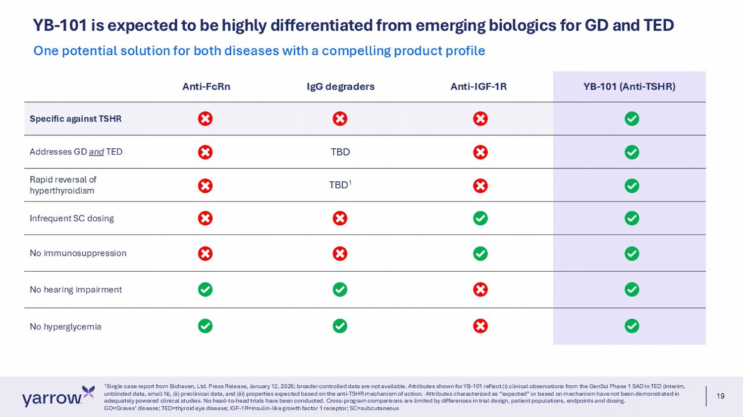
19 YB - 101 is expected to be highly differentiated from emerging biologics for GD and TED 1 Single case report from Biohaven, Ltd. Press Release, January 12, 2026; broader controlled data are not available. Attributes sh own for YB - 101 reflect (i) clinical observations from the GenSci Phase 1 SAD in TED (interim, unblinded data, small N), (ii) preclinical data, and (iii) properties expected based on the anti - TSHR mechanism of action. Attr ibutes characterized as “expected” or based on mechanism have not been demonstrated in adequately powered clinical studies. No head - to - head trials have been conducted. Cross - program comparisons are limited by differ ences in trial design, patient populations, endpoints and dosing. GD=Graves’ disease; TED=thyroid eye disease; IGF - 1R=insulin - like growth factor 1 receptor; SC=subcutaneous One potential solution for both diseases with a compelling product profile YB - 101 (Anti - TSHR) Anti - IGF - 1R IgG degraders Anti - FcRn Specific against TSHR TBD Addresses GD and TED TBD 1 Rapid reversal of hyperthyroidism Infrequent SC dosing No immunosuppression No hearing impairment No hyperglycemia

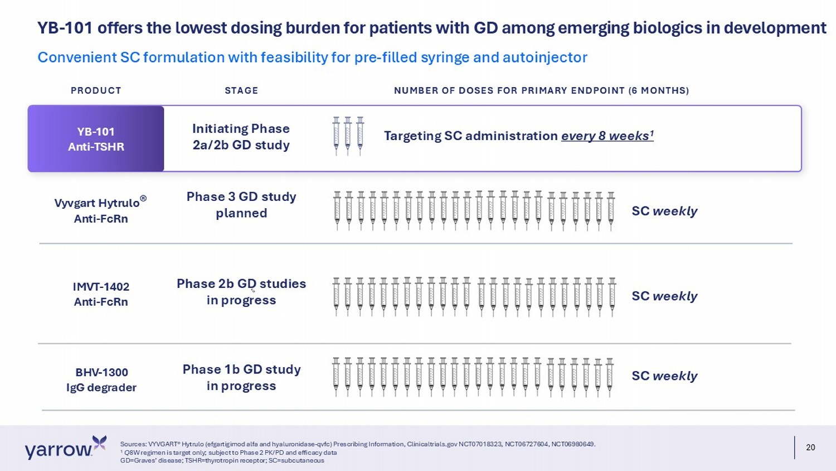
20 YB - 101 offers the lowest dosing burden for patients with GD among emerging biologics in development Sources: VYVGART® Hytrulo (efgartigimod alfa and hyaluronidase - qvfc) Prescribing Information, Clinicaltrials.gov NCT07018323, NC T06727604, NCT06980649. 1 Q 8W regimen is target only; subject to Phase 2 PK/PD and efficacy data GD=Graves’ disease; TSHR=thyrotropin receptor; SC=subcutaneous Convenient SC formulation with feasibility for pre - filled syringe and autoinjector IMVT - 1402 Anti - FcRn BHV - 1300 IgG degrader SC weekly SC weekly Phase 2b GD studies in progress Phase 1b GD study in progress Vyvgart Hytrulo ® Anti - FcRn Phase 3 GD study planned SC weekly YB - 101 Anti - TSHR Targeting SC administration every 8 weeks 1 Initiating Phase 2a/2b GD study PRODUCT STAGE NUMBER OF DOSES FOR PRIMARY ENDPOINT (6 MONTHS)

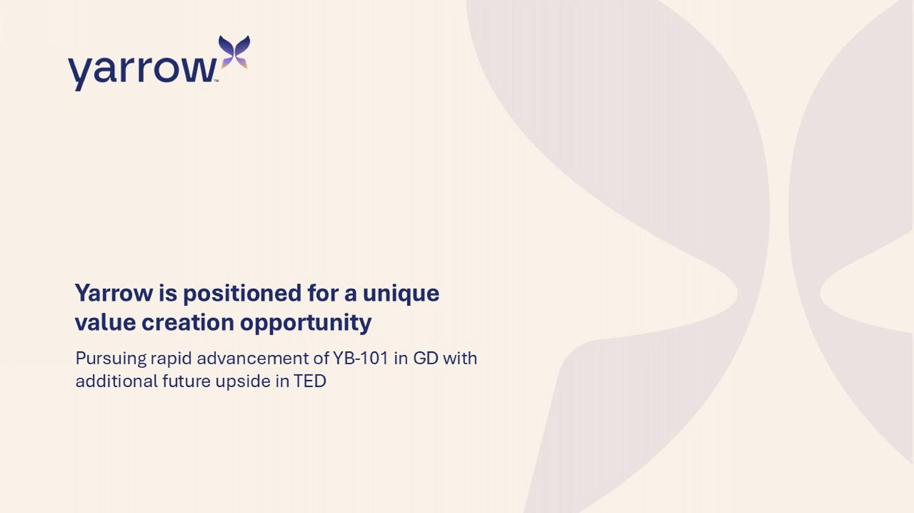
Yarrow is positioned for a unique value creation opportunity Pursuing rapid advancement of YB - 101 in GD with additional future upside in TED

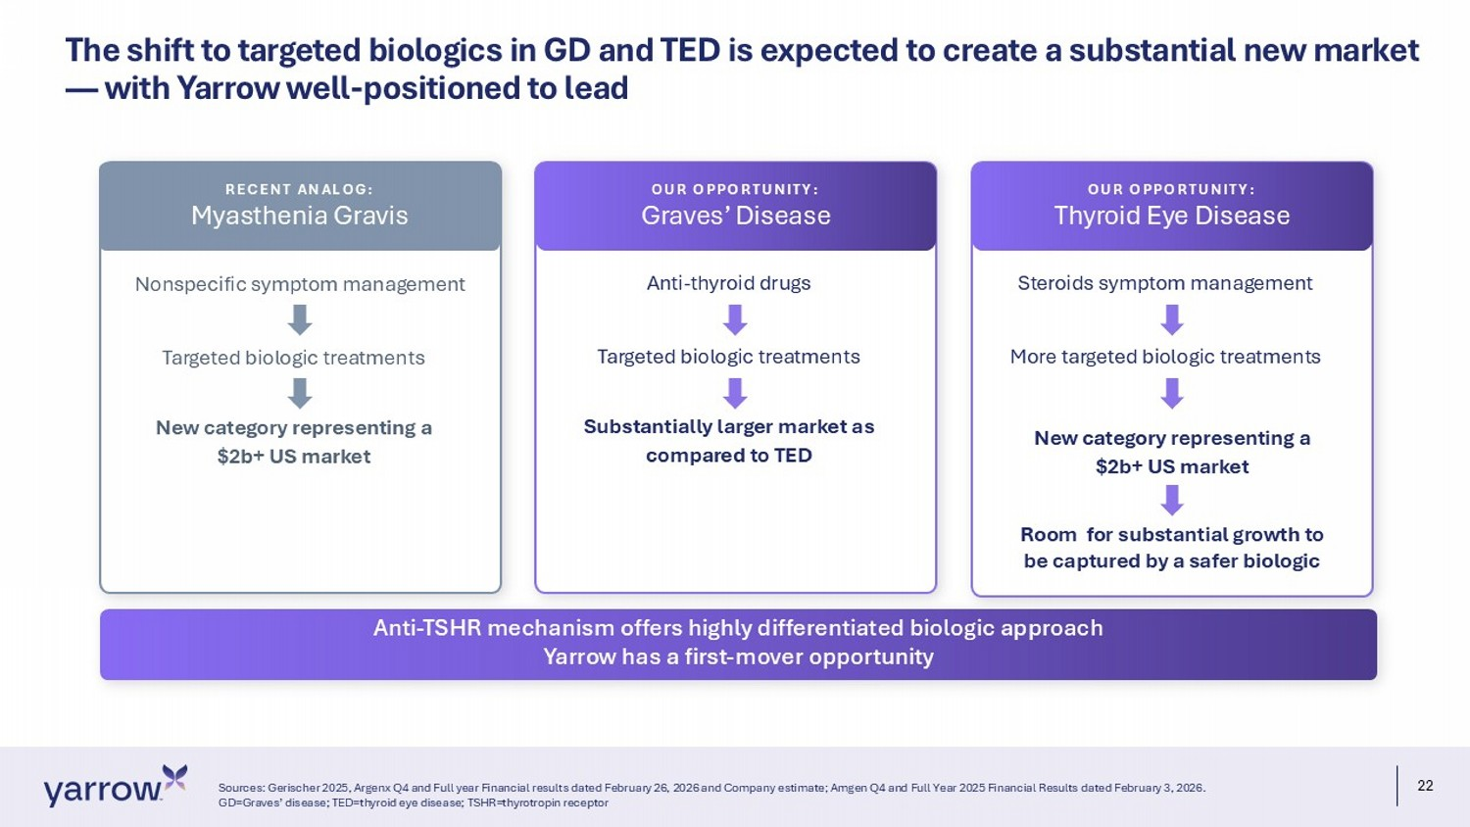
22 The shift to targeted biologics in GD and TED is expected to create a substantial new market — with Yarrow well - positioned to lead Sources: Gerischer 2025, Argenx Q4 and Full year Financial results dated February 26, 2026 and Company estimate; Amgen Q4 and Full Year 2025 Financial Result s dated February 3, 2026. GD=Graves’ disease; TED=thyroid eye disease; TSHR=thyrotropin receptor Anti - TSHR mechanism offers highly differentiated biologic approach Yarrow has a first - mover opportunity Nonspecific symptom management Targeted biologic treatments New category representing a $2b+ US market RECENT ANALOG: Myasthenia Gravis Anti - thyroid drugs Targeted biologic treatments Substantially larger market as compared to TED OUR OPPORTUNITY: Graves’ Disease Steroids symptom management More targeted biologic treatments New category representing a $2b+ US market OUR OPPORTUNITY: Thyroid Eye Disease Room for substantial growth to be captured by a safer biologic

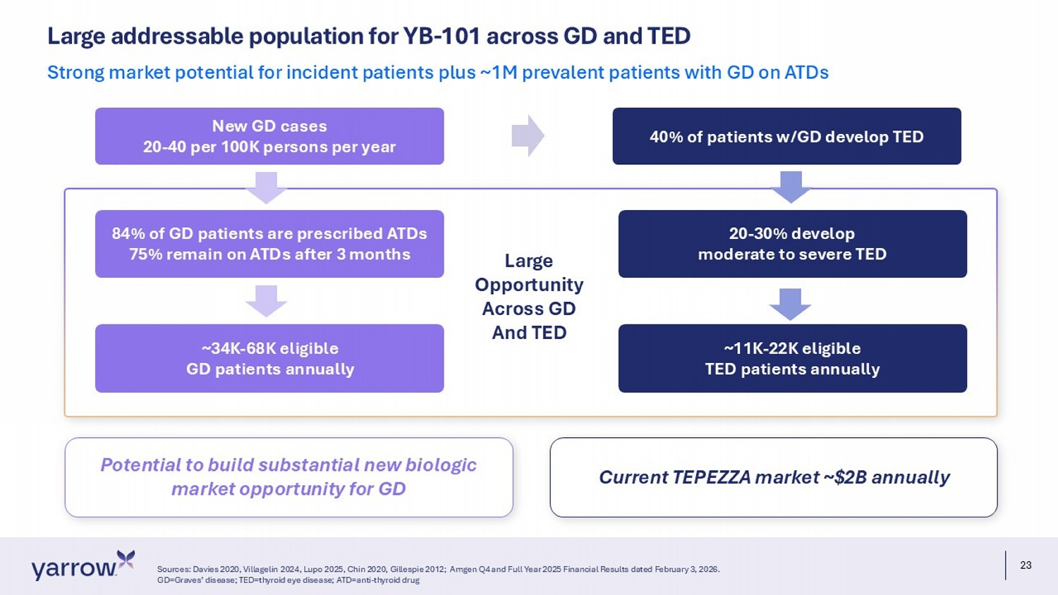
23 Potential to build substantial new biologic market opportunity for GD Large addressable population for YB - 101 across GD and TED Sources: Davies 2020, Villagelin 2024, Lupo 2025, Chin 2020, Gillespie 2012; Amgen Q4 and Full Year 2025 Financial Results dated February 3, 2026. GD=Graves’ disease; TED=thyroid eye disease; ATD=anti - thyroid drug Strong market potential for incident patients plus ~1M prevalent patients with GD on ATDs New GD cases 20 - 40 per 100K persons per year 84% of GD patients are prescribed ATDs 75% remain on ATDs after 3 months ~34K - 68K eligible GD patients annually 40% of patients w/GD develop TED 20 - 30% develop moderate to severe TED ~11K - 22K eligible TED patients annually Current TEPEZZA market ~$2B annually Large Opportunity Across GD And TED

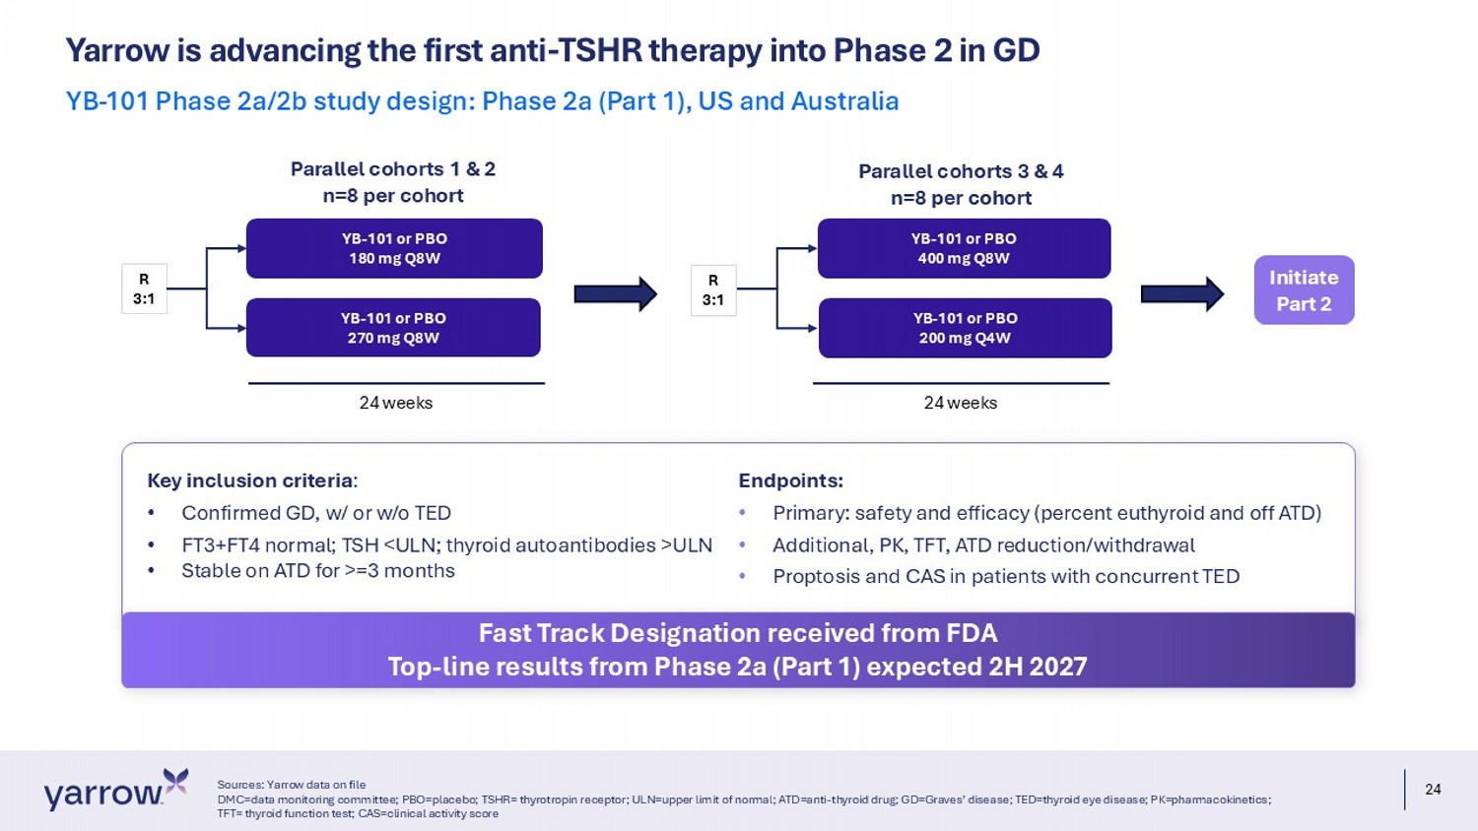
24 Yarrow is advancing the first anti - TSHR therapy into Phase 2 in GD Sources: Yarrow data on file DMC=data monitoring committee; PBO=placebo; TSHR= thyrotropin receptor; ULN=upper limit of normal; ATD=anti - thyroid drug; GD=Gra ves’ disease; TED=thyroid eye disease; PK=pharmacokinetics; TFT= thyroid function test; CAS=clinical activity score YB - 101 Phase 2a/2b study design: Phase 2a (Part 1), US and Australia YB - 101 or PBO 180 mg Q8W YB - 101 or PBO 270 mg Q8W YB - 101 or PBO 400 mg Q8W YB - 101 or PBO 200 mg Q4W R 3:1 R 3:1 Parallel cohorts 1 & 2 n=8 per cohort Parallel cohorts 3 & 4 n=8 per cohort Initiate Part 2 24 weeks 24 weeks Key inclusion criteria : • Confirmed GD, w/ or w/o TED • FT3+FT4 normal; TSH <ULN; thyroid autoantibodies >ULN • Stable on ATD for >=3 months Endpoints: • Primary: safety and efficacy (percent euthyroid and off ATD) • Additional, PK, TFT, ATD reduction/withdrawal • Proptosis and CAS in patients with concurrent TED Fast Track Designation received from FDA Top - line results from Phase 2a (Part 1) expected 2H 2027

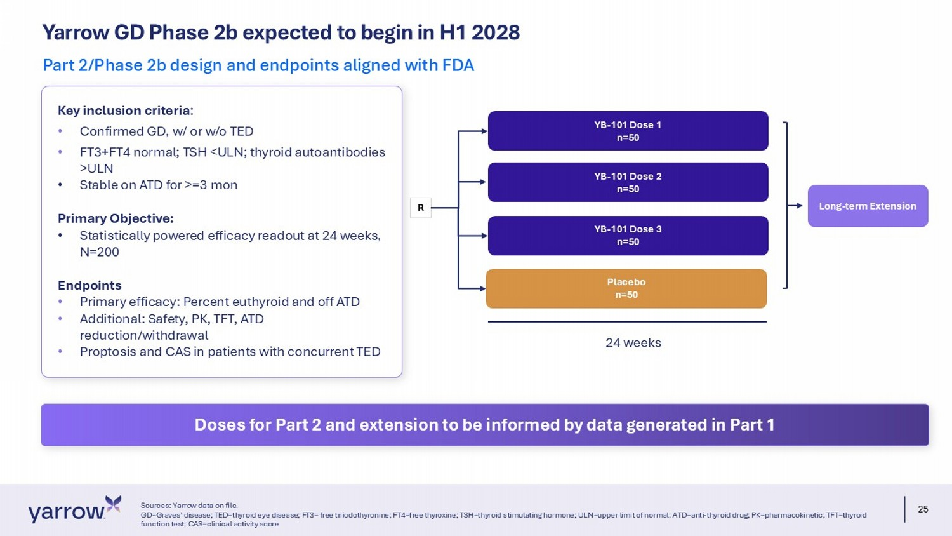
25 Yarrow GD Phase 2b expected to begin in H1 2028 Sources: Yarrow data on file. GD=Graves’ disease; TED=thyroid eye disease; FT3= free triiodothyronine; FT4=free thyroxine; TSH=thyroid stimulating hormone; UL N=upper limit of normal; ATD=anti - thyroid drug; PK=pharmacokinetic; TFT=thyroid function test; CAS=clinical activity score Part 2/Phase 2b design and endpoints aligned with FDA YB - 101 Dose 1 n=50 YB - 101 Dose 2 n=50 R Placebo n=50 YB - 101 Dose 3 n=50 24 weeks Long - term Extension Key inclusion criteria : • Confirmed GD, w/ or w/o TED • FT3+FT4 normal; TSH <ULN; thyroid autoantibodies >ULN • Stable on ATD for >=3 mon Primary Objective: • Statistically powered efficacy readout at 24 weeks, N=200 Endpoints • Primary efficacy: Percent euthyroid and off ATD • Additional: Safety, PK, TFT, ATD reduction/withdrawal • Proptosis and CAS in patients with concurrent TED Doses for Part 2 and extension to be informed by data generated in Part 1

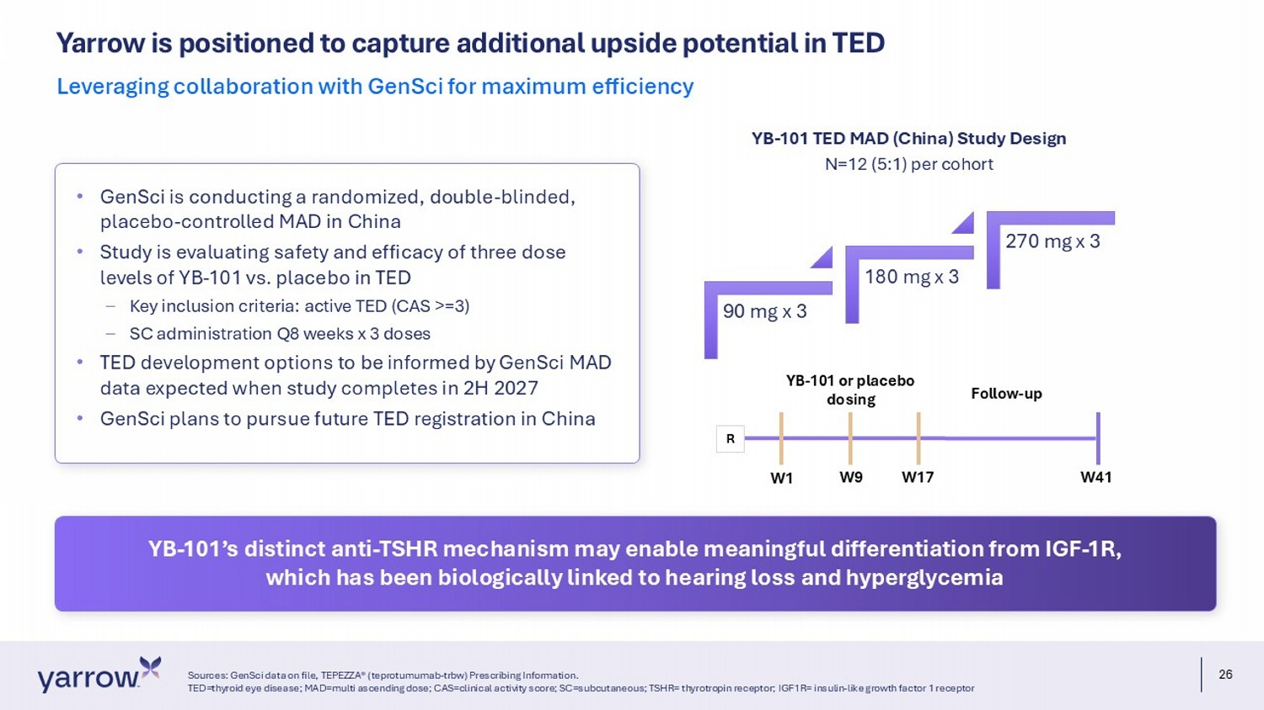
26 Yarrow is positioned to capture additional upside potential in TED Sources: GenSci data on file, TEPEZZA® (teprotumumab - trbw) Prescribing Information. TED=thyroid eye disease; MAD=multi ascending dose; CAS=clinical activity score; SC=subcutaneous; TSHR= thyrotropin receptor; IGF 1R= insulin - like growth factor 1 receptor Leveraging collaboration with GenSci for maximum efficiency 90 mg x 3 180 mg x 3 270 mg x 3 N=12 (5:1) per cohort YB - 101 TED MAD (China) Study Design YB - 101 or placebo dosing Follow - up W1 W41 W9 W17 R • GenSci is conducting a randomized, double - blinded, placebo - controlled MAD in China • Study is evaluating safety and efficacy of three dose levels of YB - 101 vs. placebo in TED – Key inclusion criteria: active TED (CAS >=3) – SC administration Q8 weeks x 3 doses • TED development options to be informed by GenSci MAD data expected when study completes in 2H 2027 • GenSci plans to pursue future TED registration in China YB - 101’s distinct anti - TSHR mechanism may enable meaningful differentiation from IGF - 1R, which has been biologically linked to hearing loss and hyperglycemia

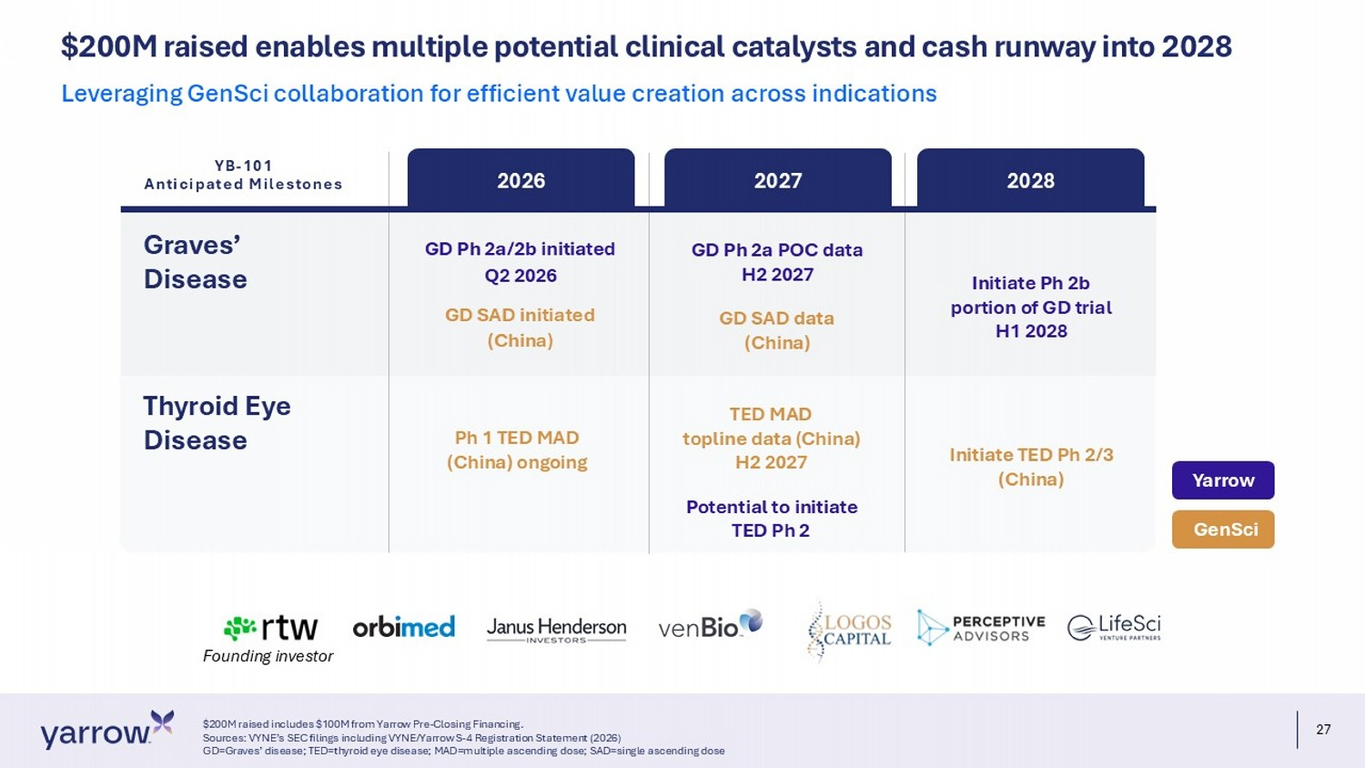
27 $ 200M raised enables multiple potential clinical catalysts and cash runway into 2028 $200M raised includes $100M from Yarrow Pre - Closing Financing. Sources: VYNE’s SEC filings including VYNE/Yarrow S - 4 Registration Statement (2026) GD=Graves’ disease; TED=thyroid eye disease; MAD=multiple ascending dose; SAD=single ascending dose Leveraging GenSci collaboration for efficient value creation across indications Founding investor Graves’ Disease 2026 2027 2028 GD Ph 2a/2b initiated Q2 2026 GD SAD initiated (China) Ph 1 TED MAD (China) ongoing GD Ph 2a POC data H2 2027 GD SAD data (China) TED MAD topline data (China) H2 2027 Potential to initiate TED Ph 2 Initiate Ph 2b portion of GD trial H1 2028 Initiate TED Ph 2/3 (China) GenSci Yarrow Thyroid Eye Disease YB - 101 Anticipated Milestones

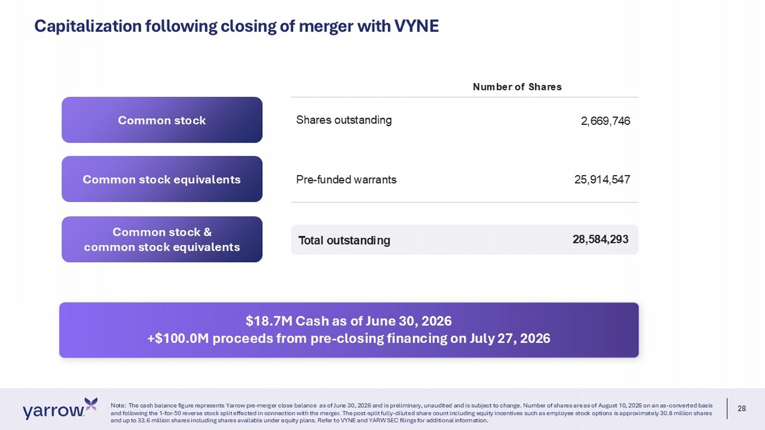
28 Note: The cash balance figure represents Yarrow pre - merger close balance as of June 30, 2026 and is preliminary, unaudited and is subject to change. Number of shares are as of August 10, 2026 on an as - converted basis and following the 1 - for - 50 reverse stock split effected in connection with the merger. The post - split fully - diluted share count including equity incentives such as employee stock options is approximately 30.8 million shares and up to 33.6 million shares including shares available under equity plans. Refer to VYNE and YARW SEC filings for additiona l i nformation. Common stock Common stock equivalents Common stock & common stock equivalents Number of Shares Shares outstanding 2,669,746 Pre - funded warrants 25,914,547 Total outstanding 28,584,293 Capitalization following closing of merger with VYNE $18.7M Cash as of June 30, 2026 +$100.0M proceeds from pre - closing financing on July 27, 2026

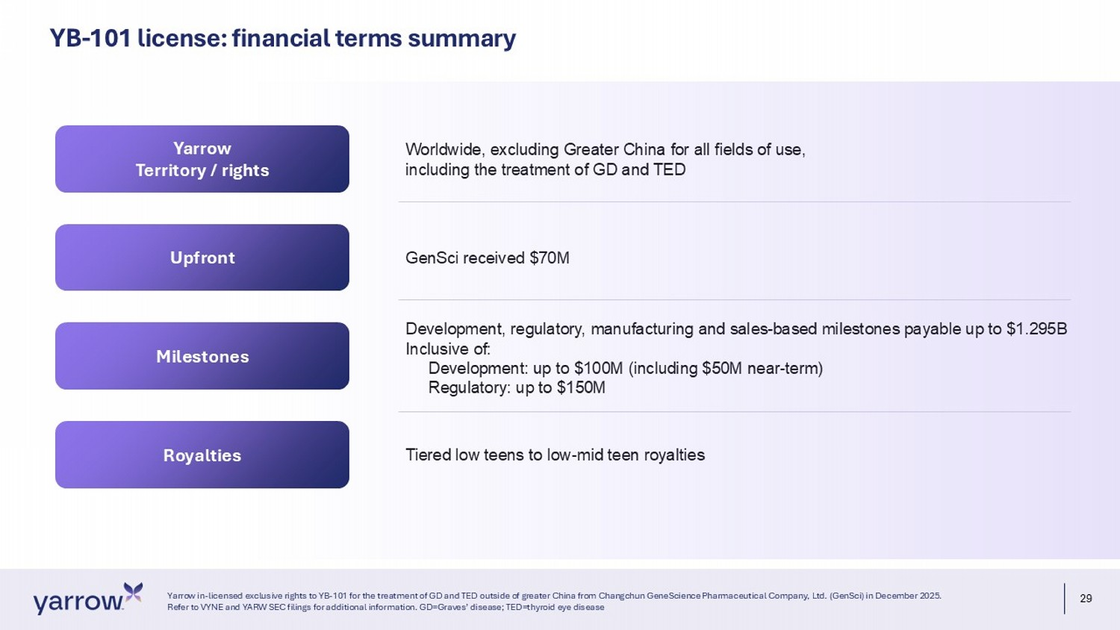
29 Yarrow in - licensed exclusive rights to YB - 101 for the treatment of GD and TED outside of greater China from Changchun GeneScience Pharmaceutical Company, Ltd. ( GenSci ) in December 2025. Refer to VYNE and YARW SEC filings for additional information. GD=Graves’ disease; TED=thyroid eye disease Yarrow Territory / rights Upfront Milestones Worldwide, excluding Greater China for all fields of use, including the treatment of GD and TED GenSci received $70M YB - 101 license: financial terms summary Royalties Development, regulatory, manufacturing and sales - based milestones payable up to $1.295B Inclusive of: Development: up to $100M (including $50M near - term) Regulatory: up to $150M Tiered low teens to low - mid teen royalties


30 yarrowbioscience.com Thank you

