UNITED STATES
SECURITIES AND EXCHANGE COMMISSION
Washington, D.C. 20549

FORM 8-K

CURRENT REPORT
Pursuant to Section 13 or 15(d) of the
Securities Exchange Act of 1934

Date of Report (Date of earliest event reported): July 14, 2026

VYNE Therapeutics Inc.
(Exact Name of Registrant as Specified in its Charter)

Delaware |  | 001-38356 |  | 45-3757789
(State or Other Jurisdiction  of Incorporation) |  | (Commission  File Number) |  | (IRS Employer  Identification No.)

P.O. Box 125, Stewartsville, NJ |  | 08886
(Address of Principal Executive Offices) |  | (Zip Code)

Registrant’s telephone number, including area code: (800) 775-7936

Check the appropriate box below if the Form 8-K filing is intended to simultaneously satisfy the filing obligation of the registrant under any of the following provisions:

☒ | Written communications pursuant to Rule 425 under the Securities Act (17 CFR 230.425)
☐ | Soliciting material pursuant to Rule 14a-12 under the Exchange Act (17 CFR 240.14a-12)
☐ | Pre-commencement communications pursuant to Rule 14d-2(b) under the Exchange Act (17 CFR 240.14d-2(b))
☐ | Pre-commencement communications pursuant to Rule 13e-4(c) under the Exchange Act (17 CFR 240.13e-4(c))

Securities registered pursuant to Section 12(b) of the Act:

Title of each class |  | Trading  symbol(s) |  | Name of each exchange  on which registered
Common Stock, $0.0001 par value |  | VYNE |  | The Nasdaq Stock Market LLC

Indicate by check mark whether the registrant is an emerging growth company as defined in Rule 405 of the Securities Act of 1933 (§230.405 of this chapter) or Rule 12b-2 of the Securities Exchange Act of 1934 (§240.12b-2 of this chapter).

Emerging growth company ☐

If an emerging growth company, indicate by check mark if the registrant has elected not to use the extended transition period for complying with any new or revised financial accounting standards provided pursuant to Section 13(a) of the Exchange Act. ☐

Item 7.01 | Regulation FD Disclosure.

On July 14, 2026, Yarrow Bioscience, Inc. (“Yarrow”) published an investor presentation (the “Presentation”) that it plans to use for investor relations and other purposes. VYNE Therapeutics Inc. (“VYNE”) has also made the Presentation available on the Investor portion of its website at https://vynetherapeutics.com/investors-media/events_presentations/. A copy of the Presentation is attached as Exhibit 99.1.

The information in this Item 7.01 and Exhibit 99.1 hereto is being furnished and shall not be deemed “filed” for purposes of Section 18 of the Securities Exchange Act of 1934, as amended (the “Exchange Act”), or otherwise subject to the liability of that section, nor shall they be deemed incorporated by reference in any of VYNE’s filings under the Securities Act of 1933, as amended, or the Exchange Act, except as expressly set forth by specific reference in such filing.

No Offer or Solicitation

This Current Report on Form 8-K and the exhibit furnished herewith are not intended to and do not constitute (i) a solicitation of a proxy, consent or approval with respect to any securities or in respect of the proposed transaction or (ii) an offer to sell or the solicitation of an offer to subscribe for or buy or an invitation to purchase or subscribe for any securities pursuant to the proposed transaction or otherwise, nor shall there be any sale, issuance or transfer of securities in any jurisdiction in contravention of applicable law. No offer of securities shall be made except by means of a prospectus meeting the requirements of the Securities Act or an exemption therefrom. Subject to certain exceptions to be approved by the relevant regulators or certain facts to be ascertained, the public offer will not be made directly or indirectly, in or into any jurisdiction where to do so would constitute a violation of the laws of such jurisdiction, or by use of the mails or by any means or instrumentality (including without limitation, facsimile transmission, telephone and the internet) of interstate or foreign commerce, or any facility of a national securities exchange, of any such jurisdiction.

NEITHER THE UNITED STATES SECURITIES AND EXCHANGE COMMISSION (THE “SEC”) NOR ANY STATE SECURITIES COMMISSION HAS APPROVED OR DISAPPROVED OF THE SECURITIES OR DETERMINED IF THIS CURRENT REPORT ON FORM 8-K AND THE EXHIBIT FURNISHED HEREWITH ARE TRUTHFUL OR COMPLETE.

Important Additional Information About the Proposed Transaction Has Been Filed with the SEC

This Current Report on Form 8-K does not substitute for the S-4 (as defined below), proxy statement/prospectus or for any other document that VYNE has filed or may file with the SEC in connection with the proposed transaction. In connection with the proposed transaction between VYNE and Yarrow, VYNE has filed relevant materials with the SEC, including a registration statement on Form S-4 (File No.: 333-294804) that contains a proxy statement/prospectus (the “S-4”). VYNE URGES INVESTORS AND STOCKHOLDERS TO READ THE S-4, INCLUDING THE PROXY STATEMENT/PROSPECTUS CONTAINED THEREIN, AND ANY OTHER RELEVANT DOCUMENTS THAT MAY BE FILED WITH THE SEC, AS WELL AS ANY AMENDMENTS OR SUPPLEMENTS TO THESE DOCUMENTS, CAREFULLY AND IN THEIR ENTIRETY BECAUSE THEY CONTAIN IMPORTANT INFORMATION ABOUT VYNE, YARROW, THE PROPOSED TRANSACTION AND RELATED MATTERS. Investors and stockholders will be able to obtain free copies of the S-4 and other documents filed by VYNE with the SEC through the website maintained by the SEC at www.sec.gov. In addition, investors and stockholders should note that VYNE communicates with investors and the public using its website (www.vynetherapeutics.com) and the investor media website (https://vynetherapeutics.com/investors-media) where anyone will be able to obtain free copies of the S-4 and included proxy statement/prospectus and other documents filed by VYNE with the SEC and stockholders are urged to read the S-4 and included proxy statement/prospectus and the other relevant materials before making any voting or investment decision with respect to the proposed transaction.

Participants in the Solicitation

VYNE, Yarrow and their respective directors and executive officers may be deemed to be participants in the solicitation of proxies from stockholders in connection with the proposed transaction. Information about VYNE’s directors and executive officers, including a description of their interests in VYNE, is included in the S-4 and VYNE’s Annual Report on Form 10-K for the year ended December 31, 2025, which was filed with the SEC on February 27, 2026. These documents are available free of charge at the SEC's website at www.sec.gov.

Item 9.01 | Financial Statements and Exhibits.

(d) Exhibits.

Exhibit  Number |  | Description
99.1 |  | Presentation, dated July 14, 2026.
104 |  | Cover Page Interactive Data File (embedded within the Inline XBRL document).

SIGNATURES

Pursuant to the requirements of the Securities Exchange Act of 1934, the registrant has duly caused this report to be signed on its behalf by the undersigned hereunto duly authorized.

 | VYNE THERAPEUTICS INC.
Date: July 14, 2026 | By: | /s/ Mutya Harsch
 |  | Mutya Harsch
 |  | Chief Legal Officer and General Counsel

Exhibit 99.1

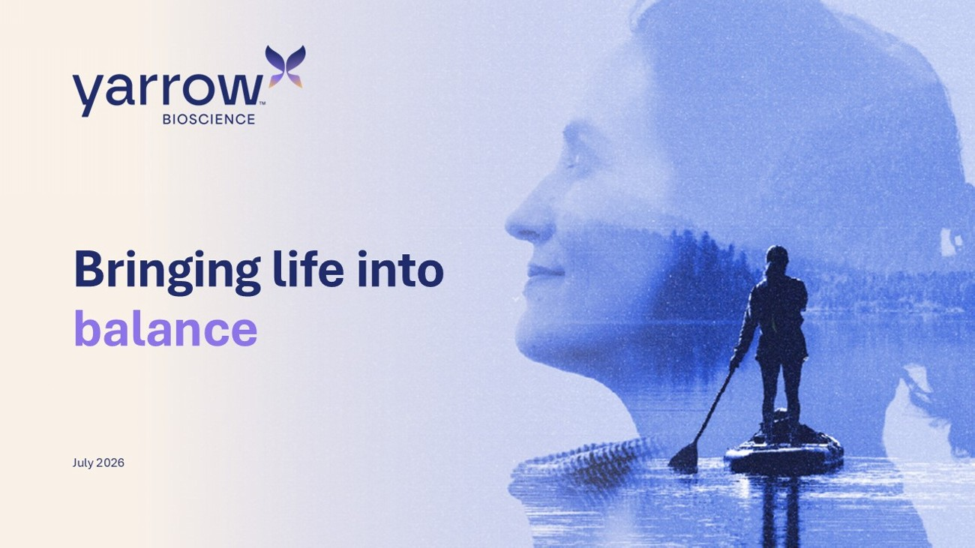
1 Bringing life into balance July 2026

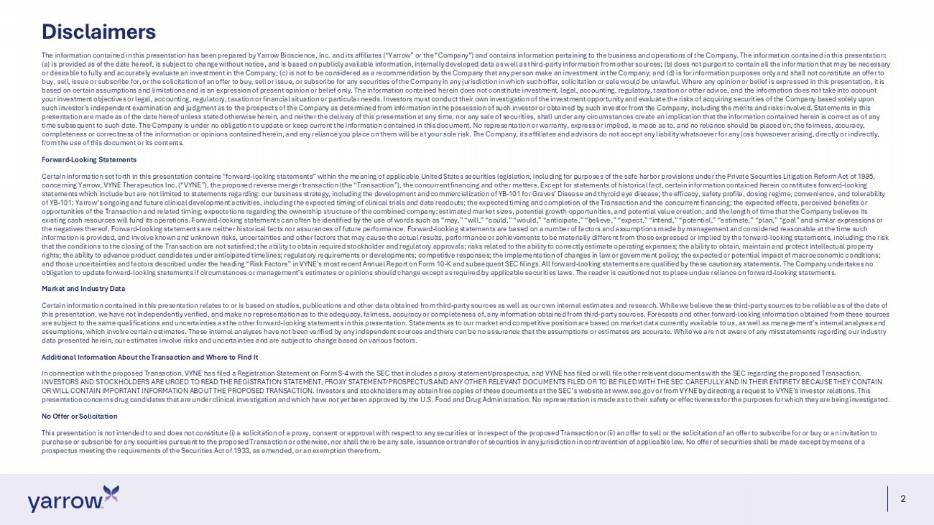
2 Disclaimers The information contained in this presentation has been prepared by Yarrow Bioscience, Inc. and its affiliates (“Yarrow” or t he “Company”) and contains information pertaining to the business and operations of the Company. The information contained in th is presentation: (a) is provided as of the date hereof, is subject to change without notice, and is based on publicly available information, i nte rnally developed data as well as third - party information from other sources; (b) does not purport to contain all the information that may be necessary or desirable to fully and accurately evaluate an investment in the Company; (c) is not to be considered as a recommendation b y t he Company that any person make an investment in the Company; and (d) is for information purposes only and shall not constitu te an offer to buy, sell, issue or subscribe for, or the solicitation of an offer to buy, sell or issue, or subscribe for any securities of the Company in any jurisdiction in which such offer, solicitation or sale would be unlawful. Where any opinion or belief is expre ss ed in this presentation, it is based on certain assumptions and limitations and is an expression of present opinion or belief only. The information containe d h erein does not constitute investment, legal, accounting, regulatory, taxation or other advice, and the information does not t ake into account your investment objectives or legal, accounting, regulatory, taxation or financial situation or particular needs. Investors m ust conduct their own investigation of the investment opportunity and evaluate the risks of acquiring securities of the Company b as ed solely upon such investor’s independent examination and judgment as to the prospects of the Company as determined from information in the po ssession of such investor or obtained by such investor from the Company, including the merits and risks involved. Statements in this presentation are made as of the date hereof unless stated otherwise herein, and neither the delivery of this presentation at any time, nor any sale of securities, shall under any circumstances create an implication that the information contained herein i s correct as of any time subsequent to such date. The Company is under no obligation to update or keep current the information contained in this doc ument. No representation or warranty, express or implied, is made as to, and no reliance should be placed on, the fairness, a ccu racy, completeness or correctness of the information or opinions contained herein, and any reliance you place on them will be at yo ur sole risk. The Company, its affiliates and advisors do not accept any liability whatsoever for any loss howsoever arising, di rec tly or indirectly, from the use of this document or its contents. Forward - Looking Statements Certain information set forth in this presentation contains “forward - looking statements” within the meaning of applicable United States securities legislation, including for purposes of the safe harbor provisions under the Private Securities Litigation R ef orm Act of 1995, concerning Yarrow, VYNE Therapeutics Inc. (“VYNE”), the proposed reverse merger transaction (the “Transaction”), the concurre nt financing and other matters. Except for statements of historical fact, certain information contained herein constitutes forwa rd - looking statements which include but are not limited to statements regarding: our business strategy, including the development and co mme rcialization of YB - 101 for Graves’ Disease and thyroid eye disease; the efficacy, safety profile, dosing regime, convenience, an d tolerability of YB - 101; Yarrow’s ongoing and future clinical development activities, including the expected timing of clinical trials and dat a readouts; the expected timing and completion of the Transaction and the concurrent financing; the expected effects, perceiv ed benefits or opportunities of the Transaction and related timing; expectations regarding the ownership structure of the combined company; est imated market sizes, potential growth opportunities, and potential value creation; and the length of time that the Company be lie ves its existing cash resources will fund its operations. Forward - looking statements can often be identified by the use of words such as “may,” “will,” “could,” “would,” “anticipate,” “believe,” “expect,” “intend,” “potential,” “estimate,” “plan,” “goal” and sim il ar expressions or the negatives thereof. Forward - looking statements are neither historical facts nor assurances of future performance. Forward - loo king statements are based on a number of factors and assumptions made by management and considered reasonable at the time suc h information is provided, and involve known and unknown risks, uncertainties and other factors that may cause the actual resul ts, performance or achievements to be materially different from those expressed or implied by the forward - looking statements, inclu ding: the risk that the conditions to the closing of the Transaction are not satisfied; the ability to obtain required stockholder and regul ato ry approvals; risks related to the ability to correctly estimate operating expenses; the ability to obtain, maintain and prot ect intellectual property rights; the ability to advance product candidates under anticipated timelines; regulatory requirements or developments; compe tit ive responses; the implementation of changes in law or government policy; the expected or potential impact of macroeconomic c ond itions; and those uncertainties and factors described under the heading “Risk Factors” in VYNE’s most recent Annual Report on Form 10 - K and subsequent SEC filings. All forward - looking statements are qualified by these cautio nary statements. The Company undertakes no obligation to update forward - looking statements if circumstances or management’s estimates or opinions should change except as r equired by applicable securities laws. The reader is cautioned not to place undue reliance on forward - looking statements. Market and Industry Data Certain information contained in this presentation relates to or is based on studies, publications and other data obtained fr om third - party sources as well as our own internal estimates and research. While we believe these third - party sources to be reliabl e as of the date of this presentation, we have not independently verified, and make no representation as to the adequacy, fairness, accuracy or c omp leteness of, any information obtained from third - party sources. Forecasts and other forward - looking information obtained from th ese sources are subject to the same qualifications and uncertainties as the other forward - looking statements in this presentation. Statement s as to our market and competitive position are based on market data currently available to us, as well as management’s inter nal analyses and assumptions, which involve certain estimates. These internal analyses have not been verified by any independent sources and t her e can be no assurance that the assumptions or estimates are accurate. While we are not aware of any misstatements regarding o ur industry data presented herein, our estimates involve risks and uncertainties and are subject to change based on various factors. Additional Information About the Transaction and Where to Find It In connection with the proposed Transaction, VYNE has filed a Registration Statement on Form S - 4 with the SEC that includes a pr oxy statement/prospectus, and VYNE has filed or will file other relevant documents with the SEC regarding the proposed Transa cti on. INVESTORS AND STOCKHOLDERS ARE URGED TO READ THE REGISTRATION STATEMENT, PROXY STATEMENT/PROSPECTUS AND ANY OTHER RELEVANT DO CUM ENTS FILED OR TO BE FILED WITH THE SEC CAREFULLY AND IN THEIR ENTIRETY BECAUSE THEY CONTAIN OR WILL CONTAIN IMPORTANT INFORMATION ABOUT THE PROPOSED TRANSACTION. Investors and stockholders may obtain free copies of th ese documents at the SEC’s website at www.sec.gov or from VYNE by directing a request to VYNE’s investor relations. This presentation concerns drug candidates that are under clinical investigation and which have not yet been approved by the U.S. Foo d and Drug Administration. No representation is made as to their safety or effectiveness for the purposes for which they are bei ng investigated. No Offer or Solicitation This presentation is not intended to and does not constitute (i) a solicitation of a proxy, consent or approval with respect to any securities or in respect of the proposed Transaction or (ii) an offer to sell or the solicitation of an offer to subscrib e f or or buy or an invitation to purchase or subscribe for any securities pursuant to the proposed Transaction or otherwise, nor shall there be any sale, issu anc e or transfer of securities in any jurisdiction in contravention of applicable law. No offer of securities shall be made exce pt by means of a prospectus meeting the requirements of the Securities Act of 1933, as amended, or an exemption therefrom.


3 Yarrow Bioscience is seeking to bring life into balance for patients suffering with Graves’ Disease and TED

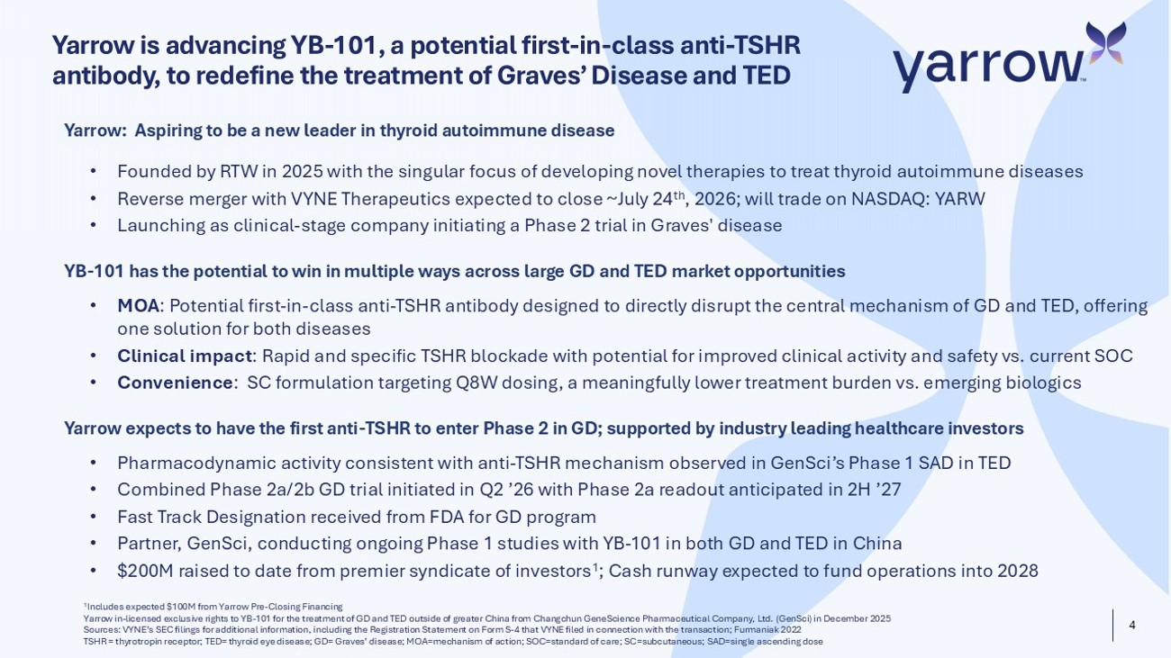
4 Yarrow is advancing YB - 101, a potential first - in - class anti - TSHR antibody, to redefine the treatment of Graves’ Disease and TED 1 Includes expected $100M from Yarrow Pre - Closing Financing Yarrow in - licensed exclusive rights to YB - 101 for the treatment of GD and TED outside of greater China from Changchun GeneScience Pharmaceutical Company, Ltd. ( GenSci ) in December 2025 Sources: VYNE’s SEC filings for additional information, including the Registration Statement on Form S - 4 that VYNE filed in conn ection with the transaction; Furmaniak 2022 TSHR = thyrotropin receptor; TED= thyroid eye disease; GD= Graves’ disease; MOA=mechanism of action; SOC=standard of care; SC =su bcutaneous; SAD=single ascending dose Yarrow : Aspiring to be a new leader in thyroid autoimmune disease • Founded by RTW in 2025 with the singular focus of developing novel therapies to treat thyroid autoimmune diseases • Reverse merger with VYNE Therapeutics expected to close ~July 24 th , 2026 ; will trade on NASDAQ: YARW • Launching as clinical - stage company initiating a Phase 2 trial in Graves' disease YB - 101 has the potential to win in multiple ways across large GD and TED market opportunities • MOA : Potential first - in - class anti - TSHR antibody designed to directly disrupt the central mechanism of GD and TED, offering one solution for both diseases • Clinical impact : Rapid and specific TSHR blockade with potential for improved clinical activity and safety vs. current SOC • Convenience : SC formulation targeting Q8W dosing, a meaningfully lower treatment burden vs. emerging biologics Yarrow expects to have the first anti - TSHR to enter Phase 2 in GD; supported by industry leading healthcare investors • Pharmacodynamic activity consistent with anti - TSHR mechanism observed in GenSci’s Phase 1 SAD in TED • Combined Phase 2a/2b GD trial initiated in Q2 ’26 with Phase 2a readout anticipated in 2H ’27 • Fast Track Designation received from FDA for GD program • Partner, GenSci , conducting ongoing Phase 1 studies with YB - 101 in both GD and TED in China • $200M raised to date from premier syndicate of investors 1 ; Cash runway expected to fund operations into 2028

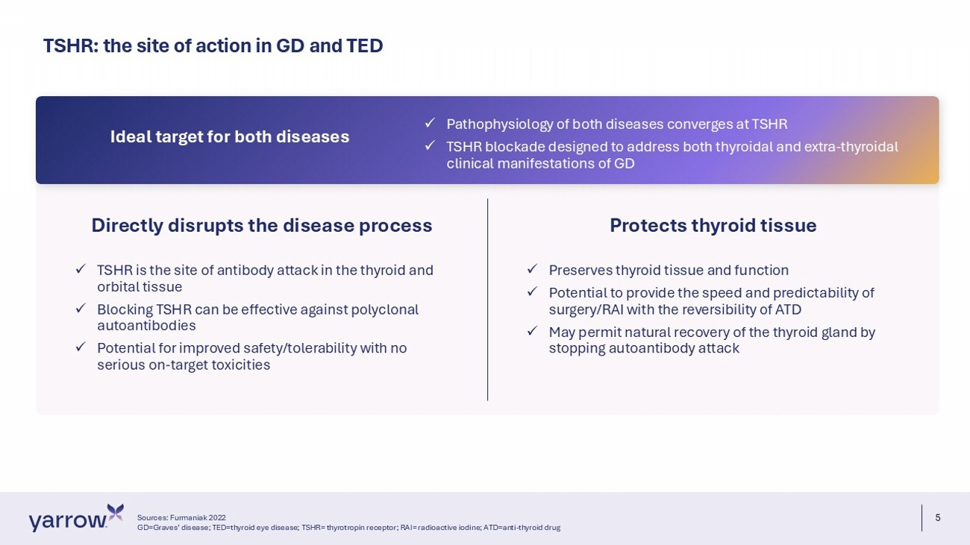
5 TSHR: the site of action in GD and TED Sources: Furmaniak 2022 GD=Graves’ disease; TED=thyroid eye disease; TSHR= thyrotropin receptor; RAI= radioactive iodine; ATD=anti - thyroid drug Directly disrupts the disease process x TSHR is the site of antibody attack in the thyroid and orbital tissue x Blocking TSHR can be effective against polyclonal autoantibodies x Potential for improved safety/tolerability with no serious on - target toxicities Protects thyroid tissue x Preserves thyroid tissue and function x Potential to provide the speed and predictability of surgery/RAI with the reversibility of ATD x May permit natural recovery of the thyroid gland by stopping autoantibody attack x Pathophysiology of both diseases converges at TSHR x TSHR blockade designed to address both thyroidal and extra - thyroidal clinical manifestations of GD Ideal target for both diseases

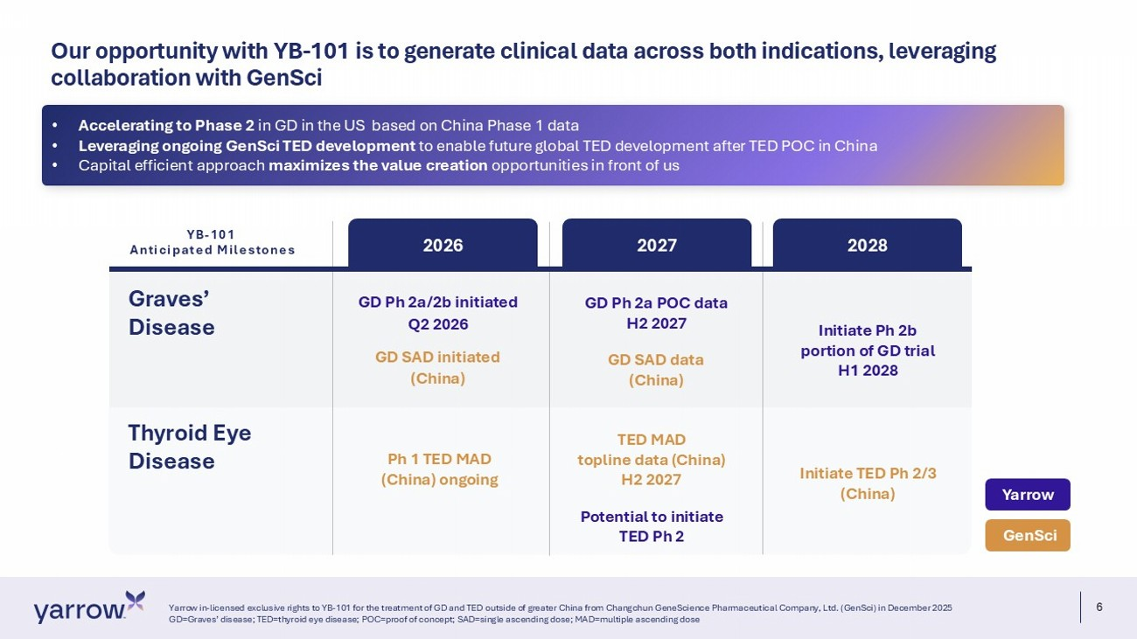
6 Our opportunity with YB - 101 is to generate clinical data across both indications, leveraging collaboration with GenSci Yarrow in - licensed exclusive rights to YB - 101 for the treatment of GD and TED outside of greater China from Changchun GeneScienc e Pharmaceutical Company, Ltd. (GenSci) in December 2025 GD=Graves’ disease; TED=thyroid eye disease; POC=proof of concept; SAD=single ascending dose; MAD=multiple ascending dose Graves’ Disease 2026 2027 2028 GD Ph 2a/2b initiated Q2 2026 GD SAD i nitiated (China) Ph 1 TED MAD (China) ongoing GD Ph 2a POC data H2 2027 GD SAD data (China) TED MAD topline data (China) H2 2027 Potential to initiate TED Ph 2 Initiate Ph 2b portion of GD trial H1 2028 Initiate TED Ph 2/3 (China) GenSci Yarrow Thyroid Eye Disease YB - 101 Anticipated Milestones • Accelerating to Phase 2 in GD in the US based on China Phase 1 data • Leveraging ongoing GenSci TED development to enable future global TED development after TED POC in China • Capital efficient approach maximizes the value creation opportunities in front of us

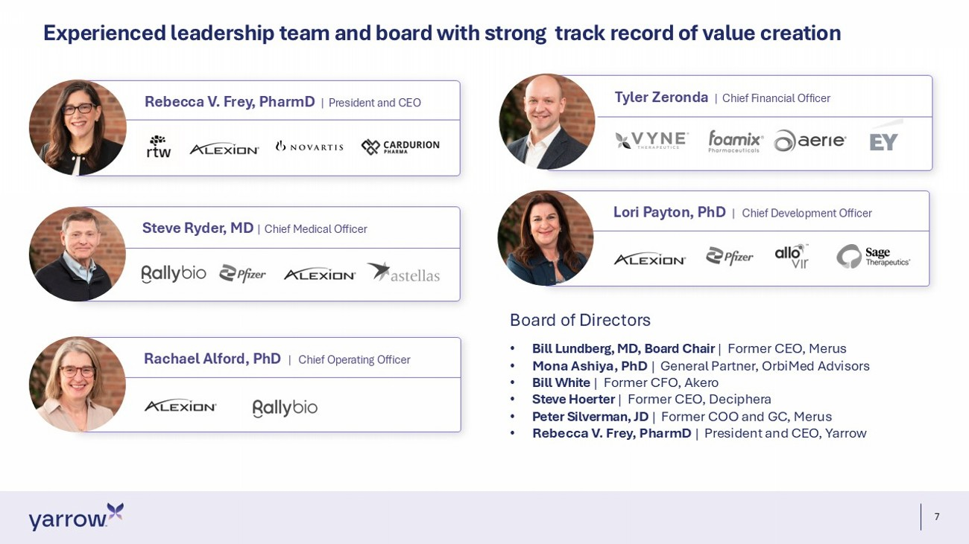
7 Experienced leadership team and board with strong track record of value creation Rebecca V. Frey, PharmD | President and CEO Lori Payton, PhD | Chief Development Officer Tyler Zeronda | Chief Financial Officer Rachael Alford, PhD | Chief Operating Officer Steve Ryder, MD | Chief Medical Officer Board of Directors • Bill Lundberg, MD, Board Chair | Former CEO, Merus • Mona Ashiya, PhD | General Partner, OrbiMed Advisors • Bill White | Former CFO, Akero • Steve Hoerter | Former CEO, Deciphera • Peter Silverman, JD | Former COO and GC, Merus • Rebecca V. Frey, PharmD | President and CEO, Yarrow

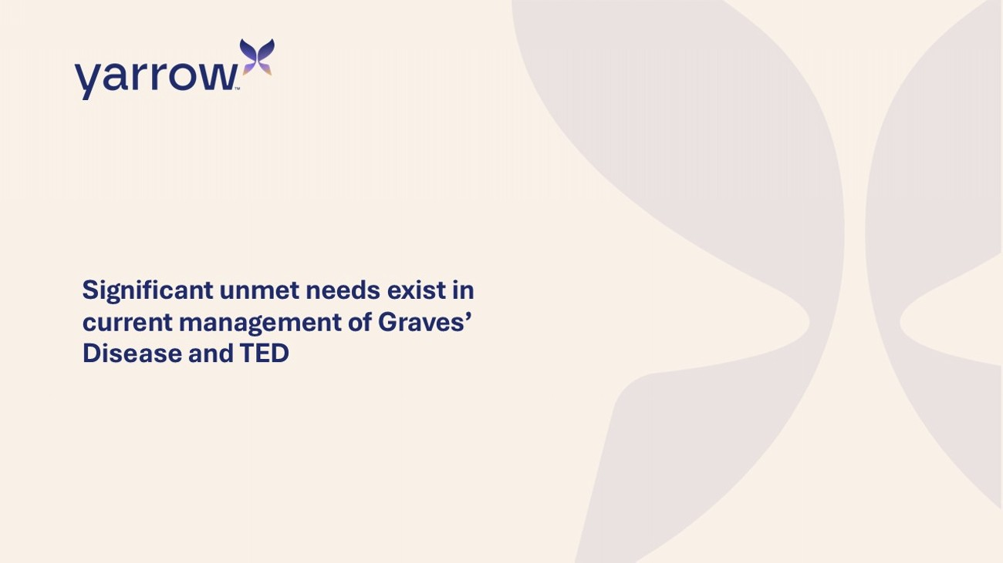
Significant unmet needs exist in current management of Graves’ Disease and TED

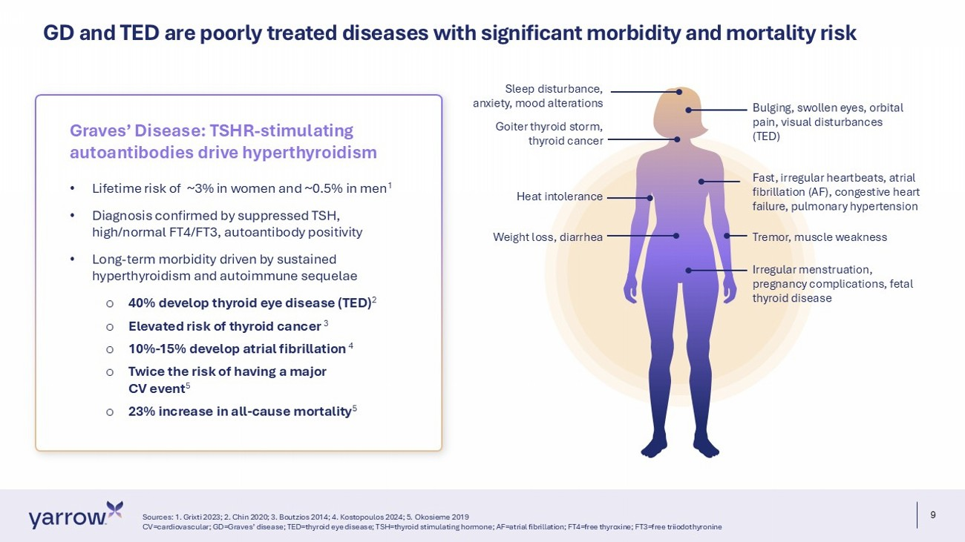
9 GD and TED are poorly treated diseases with significant morbidity and mortality risk Sources: 1. Grixti 2023; 2. Chin 2020; 3. Boutzios 2014; 4. Kostopoulos 2024; 5. Okosieme 2019 CV=cardiovascular; GD=Graves’ disease; TED=thyroid eye disease; TSH=thyroid stimulating hormone; AF=atrial fibrillation; FT4= fre e thyroxine; FT3=free triiodothyronine • Lifetime risk of ~3% in women and ~0.5% in men 1 • Diagnosis confirmed by suppressed TSH, high/normal FT4/FT3, autoantibody positivity • Long - term morbidity driven by sustained hyperthyroidism and autoimmune sequelae o 40% develop thyroid eye disease (TED) 2 o Elevated risk of thyroid cancer 3 o 10% - 15% develop atrial fibrillation 4 o Twice the risk of having a major CV event 5 o 23% increase in all - cause mortality 5 Graves’ Disease : TSHR - stimulating autoantibodies drive hyperthyroidism Goiter thyroid storm, thyroid cancer Bulging, swollen eyes, orbital pain, visual disturbances (TED) Fast, irregular heartbeats, atrial fibrillation (AF), congestive heart failure, pulmonary hypertension Tremor, muscle weakness Sleep disturbance, anxiety, mood alterations Weight loss, diarrhea Irregular menstruation, pregnancy complications, fetal thyroid disease Heat intolerance

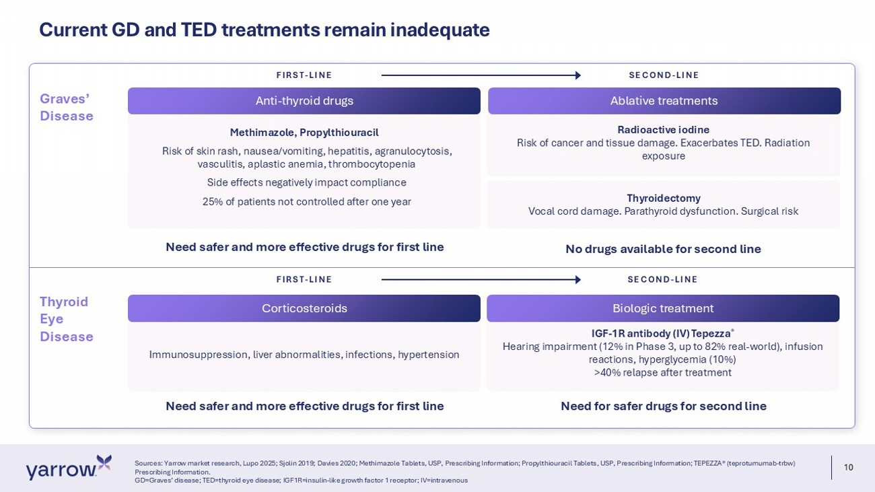
10 Radioactive iodine Risk of cancer and tissue damage. Exacerbates TED. Radiation exposure Current GD and TED treatments remain inadequate Sources: Yarrow market research, Lupo 2025; Sjolin 2019; Davies 2020; Methimazole Tablets, USP, Prescribing Information; Prop ylt hiouracil Tablets, USP, Prescribing Information; TEPEZZA® (teprotumumab - trbw ) Prescribing Information. GD=Graves’ disease; TED=thyroid eye disease; IGF1R=insulin - like growth factor 1 receptor; IV=intravenous Methimazole, Propylthiouracil Risk of skin rash, nausea/vomiting, hepatitis, agranulocytosis, vasculitis, aplastic anemia, thrombocytopenia Side effects negatively impact compliance 25% of patients not controlled after one year Thyroidectomy Vocal cord damage. Parathyroid dysfunction. Surgical risk No drugs available for second line IGF - 1R antibody (IV) Tepezza ® Hearing impairment (12% in Phase 3, up to 82% real - world), infusion reactions, hyperglycemia (10%) >40% relapse after treatment Need for safer drugs for second line Anti - thyroid drugs FIRST - LINE SECOND - LINE Graves’ Disease Thyroid Eye Disease Immunosuppression, liver abnormalities, infections, hypertension FIRST - LINE SECOND - LINE Need safer and more effective drugs for first line Need safer and more effective drugs for first line Ablative treatments Corticosteroids Biologic treatment

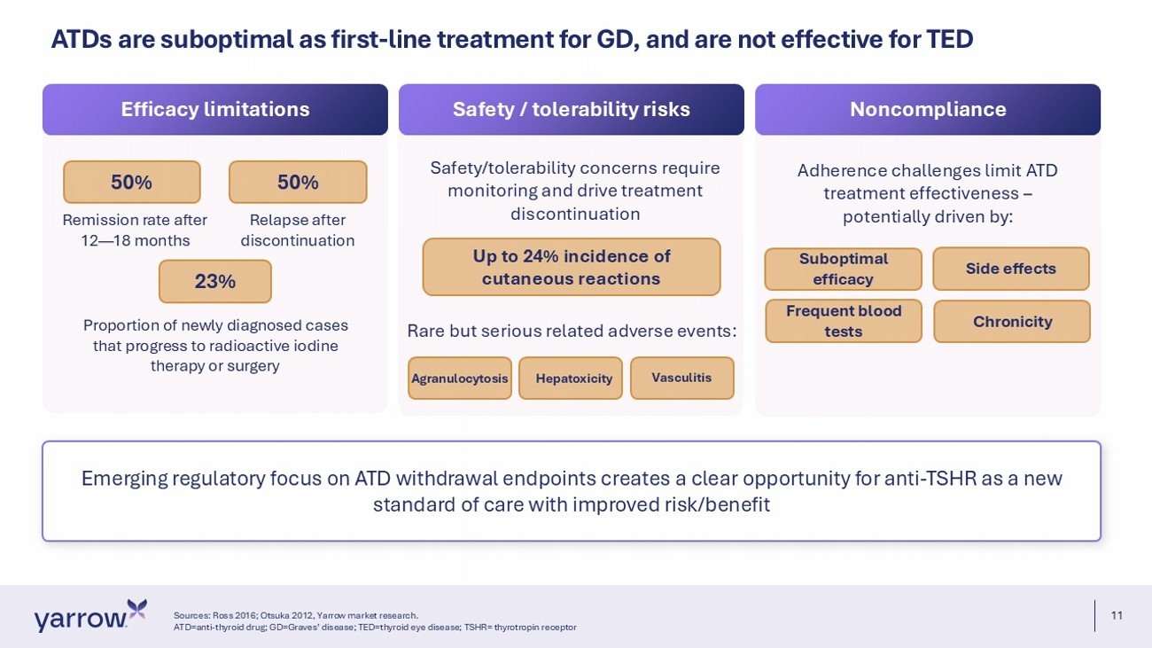
11 Emerging regulatory focus on ATD withdrawal endpoints creates a clear opportunity for anti - TSHR as a new standard of care with improved risk/benefit ATDs are suboptimal as first - line treatment for GD, and are not effective for TED Sources: Ross 2016; Otsuka 2012, Yarrow market research. ATD=anti - thyroid drug; GD=Graves’ disease; TED=thyroid eye disease; TSHR= thyrotropin receptor Efficacy limitations Safety / tolerability risks Noncompliance 50% 50% Remission rate after 12 — 18 months Relapse after discontinuation 23% Proportion of newly diagnosed cases that progress to radioactive iodine therapy or surgery Safety/ tolerability concerns require monitoring and drive treatment discontinuation Up to 24% incidence of cutaneous reactions Adherence challenges limit ATD treatment effectiveness – potentially driven by: Suboptimal efficacy Side effects Chronicity Frequent blood tests Rare but serious related adverse events: Agranulocytosis Hepatoxicity Vasculitis

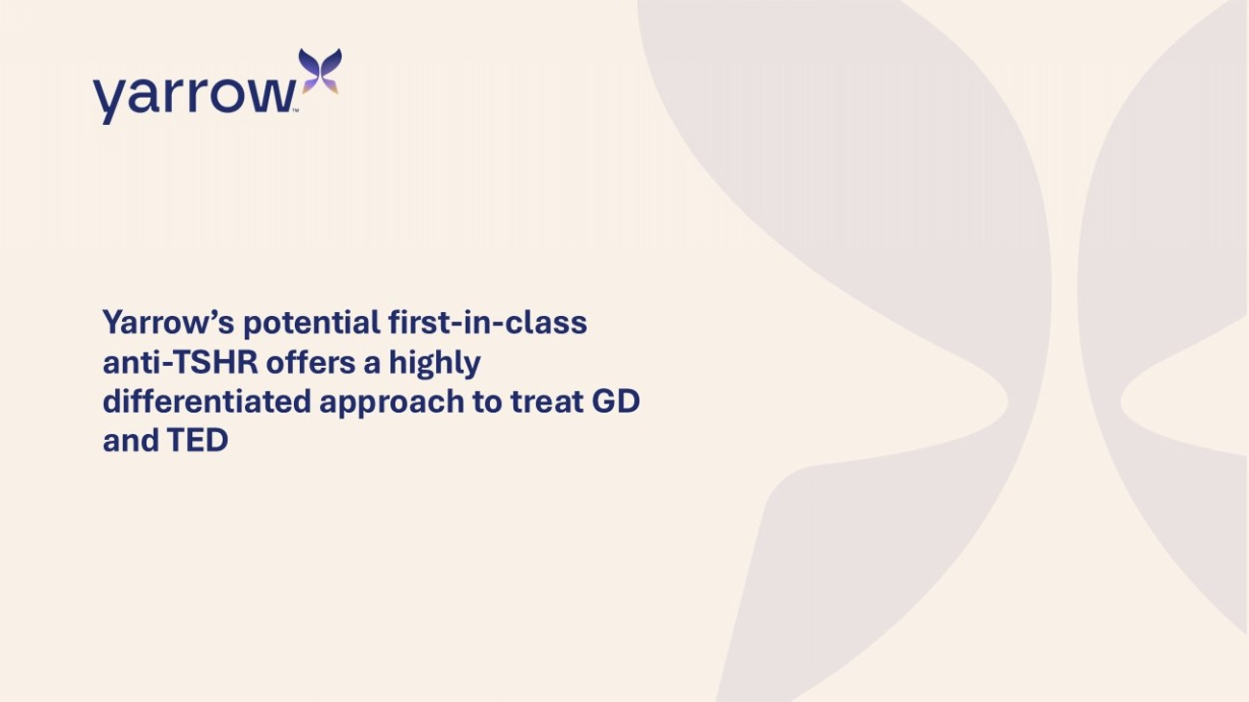
Yarrow’s potential first - in - class anti - TSHR offers a highly differentiated approach to treat GD and TED

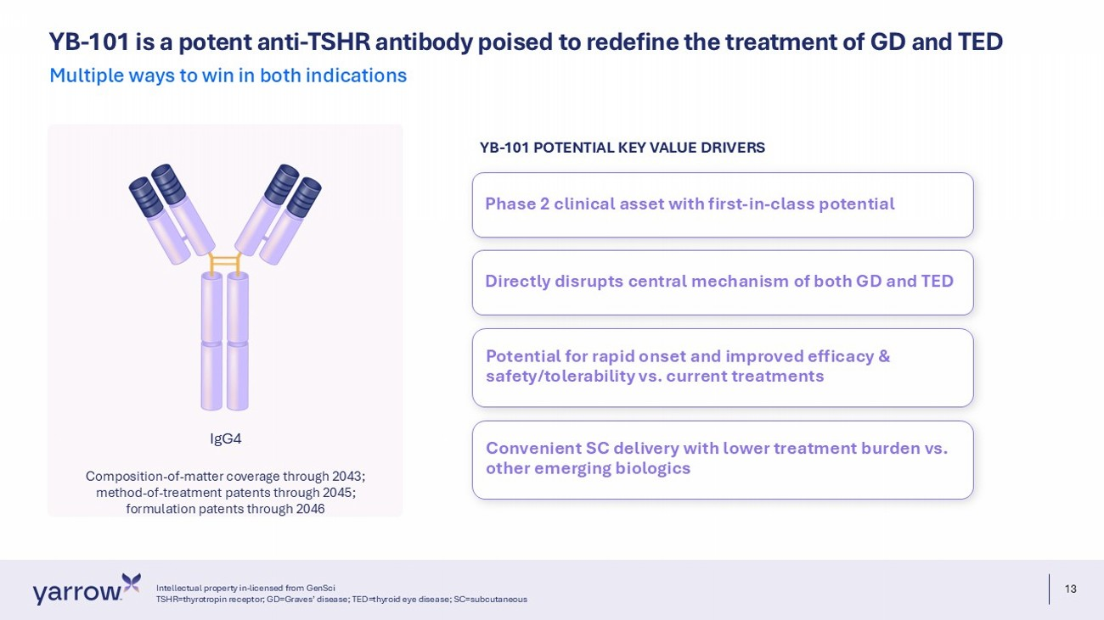
13 YB - 101 is a potent anti - TSHR antibody poised to redefine the treatment of GD and TED Multiple ways to win in both indications IgG4 Composition - of - matter coverage through 2043; method - of - treatment patents through 2045; formulation patents through 2046 Phase 2 clinical asset with first - in - class potential Directly disrupts central mechanism of both GD and TED Potential for rapid onset and improved efficacy & safety/tolerability vs. current treatments Convenient SC delivery with lower treatment burden vs. other emerging biologics YB - 101 POTENTIAL KEY VALUE DRIVERS Intellectual property in - licensed from GenSci TSHR=thyrotropin receptor; GD=Graves’ disease; TED=thyroid eye disease; SC=subcutaneous

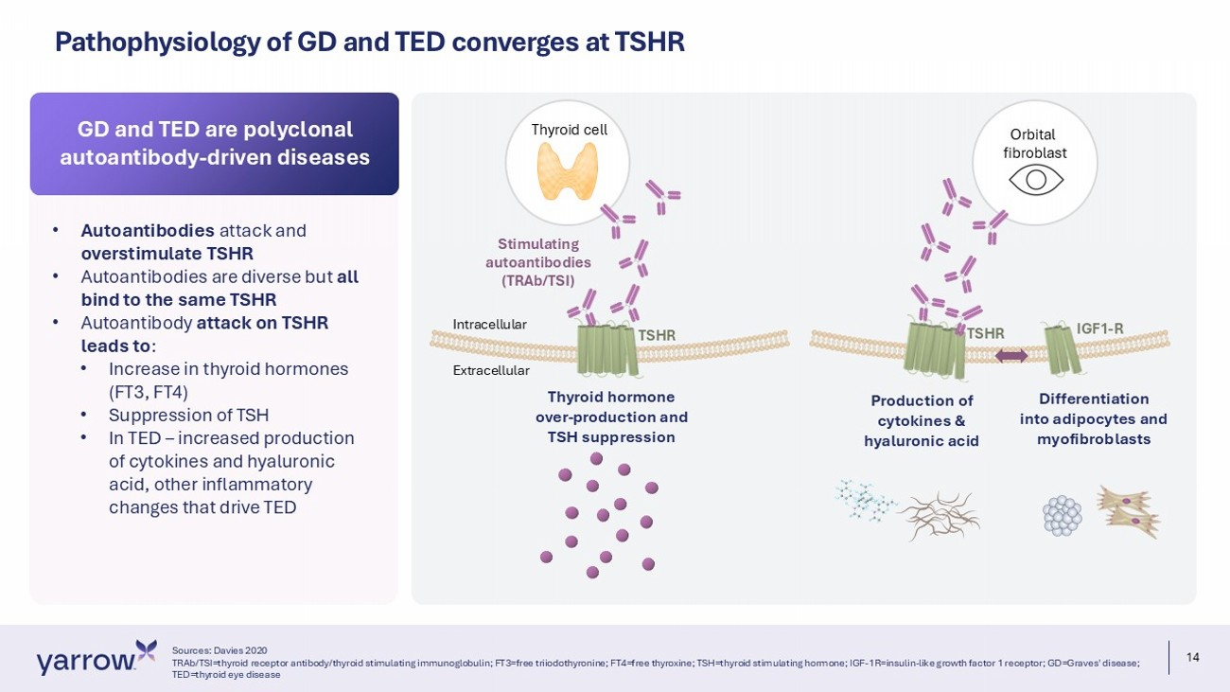
14 Pathophysiology of GD and TED converges at TSHR Thyroid cell Orbital fibroblast Stimulating autoantibodies (TRAb/TSI) TSHR Thyroid hormone over - production and TSH suppression P roduction of cytokines & hyaluronic acid Differentiation into adipocytes and myofibroblasts Intracellular Extracellular IGF1 - R TSHR • Autoantibodies attack and overstimulate TSHR • Autoantibodies are diverse but all bind to the same TSHR • Autoantibody attack on TSHR leads to : • Increase in thyroid hormones (FT3, FT4) • Suppression of TSH • In TED – increased production of cytokines and hyaluronic acid, other inflammatory changes that drive TED GD and TED are polyclonal autoantibody - driven diseases Sources: Davies 2020 TRAb/TSI=thyroid receptor antibody/thyroid stimulating immunoglobulin; FT3=free triiodothyronine; FT4=free thyroxine; TSH=thy roi d stimulating hormone; IGF - 1R=insulin - like growth factor 1 receptor; GD=Graves' disease; TED=thyroid eye disease

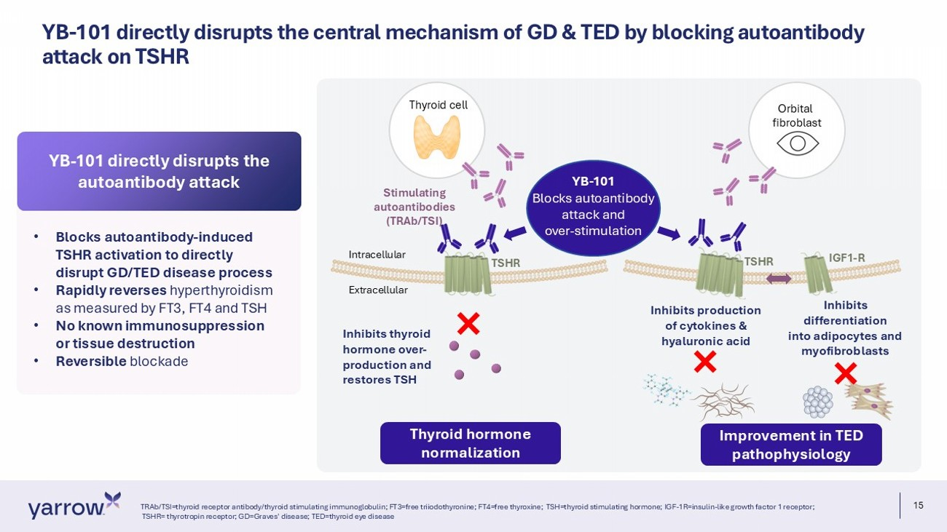
15 YB - 101 directly disrupts the central mechanism of GD & TED by blocking autoantibody attack on TSHR TRAb/TSI=thyroid receptor antibody/thyroid stimulating immunoglobulin; FT3=free triiodothyronine; FT4=free thyroxine; TSH=th yro id stimulating hormone; IGF - 1R=insulin - like growth factor 1 receptor; TSHR= thyrotropin receptor; GD=Graves' disease; TED=thyroid eye disease Thyroid cell Orbital fibroblast Stimulating autoantibodies (TRAb/TSI) TSHR Inhibits thyroid hormone over - production and restores TSH Inhibits production of cytokines & hyaluronic acid Inhibits d ifferentiation into adipocytes and myofibroblasts Intracellular Extracellular IGF1 - R TSHR YB - 101 Blocks autoantibody attack and over - stimulation Thyroid hormone normalization Improvement in TED pathophysiology • Blocks autoantibody - induced TSHR activation to directly disrupt GD/TED disease process • Rapidly reverses hyperthyroidism as measured by FT3, FT4 and TSH • No known immunosuppression or tissue destruction • Reversible blockade YB - 101 directly disrupts the autoantibody attack

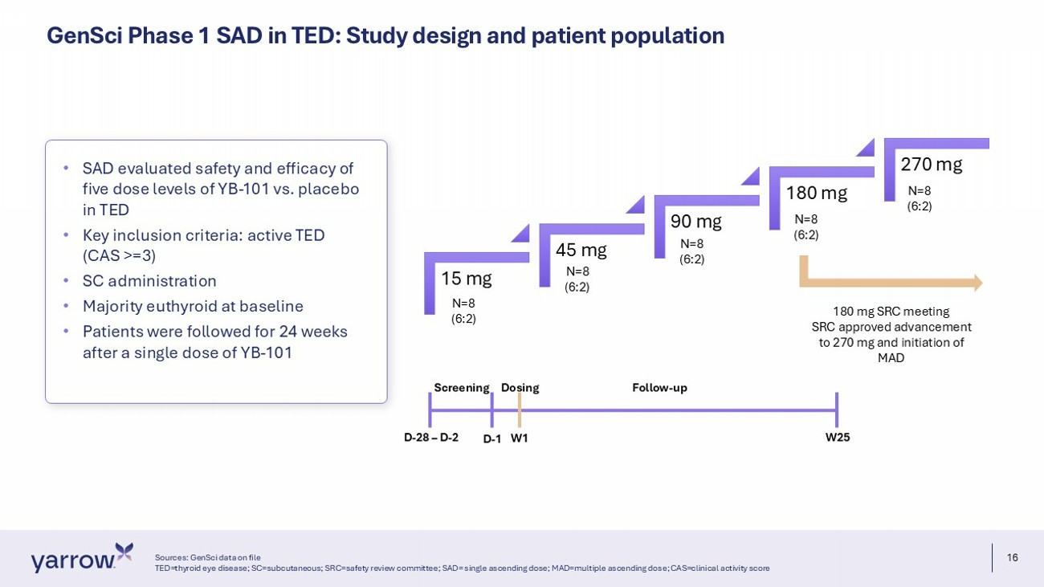
16 GenSci Phase 1 SAD in TED: Study design and patient population Sources: GenSci data on file TED=thyroid eye disease; SC=subcutaneous; SRC=safety review committee; SAD= single ascending dose; MAD=multiple ascending dos e; CAS=clinical activity score • SAD evaluated safety and efficacy of five dose levels of YB - 101 vs. placebo in TED • Key inclusion criteria: active TED (CAS >=3) • SC administration • Majority euthyroid at baseline • Patients were followed for 24 weeks after a single dose of YB - 101 Screening Dosing Follow - up D - 28 – D - 2 D - 1 W1 W25 N=8 (6:2) 15 mg 45 mg 90 mg 180 mg 270 mg N=8 (6:2) N=8 (6:2) N=8 (6:2) N=8 (6:2) 180 mg SRC meeting SRC approved advancement to 270 mg and initiation of MAD

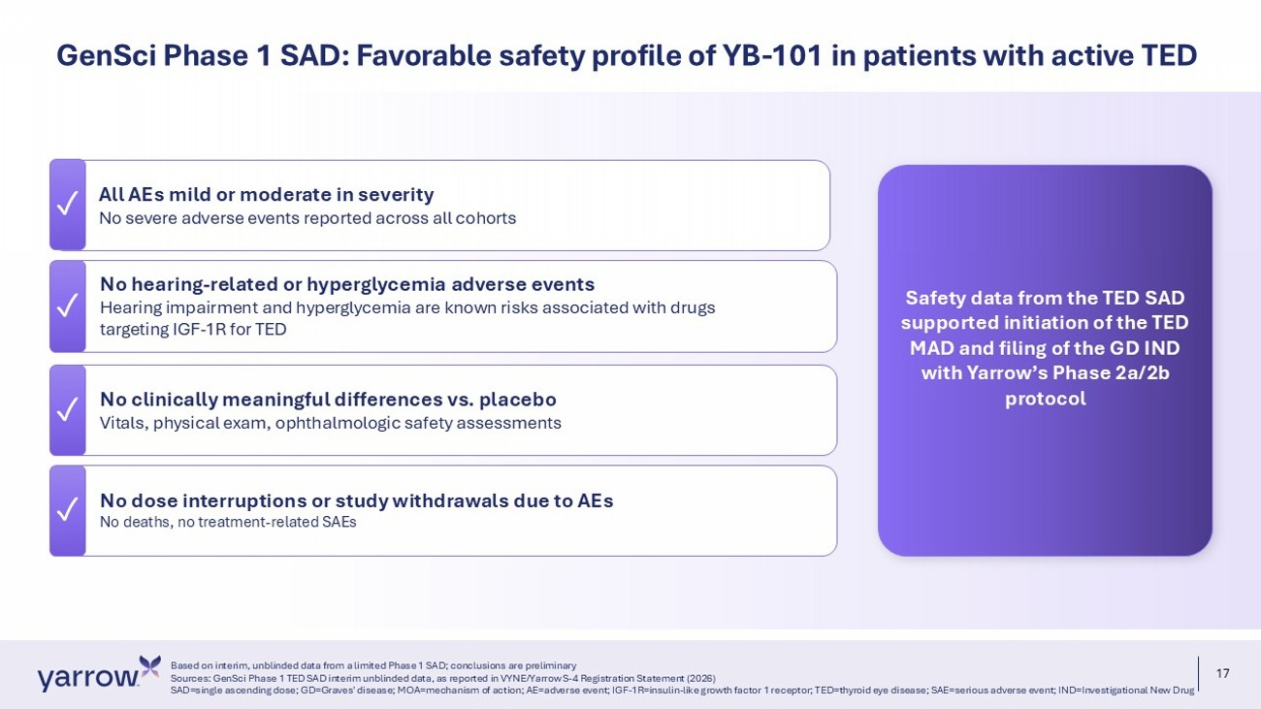
17 ✓ No dose interruptions or study withdrawals due to AEs No deaths, no treatment - related SAEs All AEs mild or moderate in severity No severe adverse events reported across all cohorts No hearing - related or hyperglycemia adverse events Hearing impairment and hyperglycemia are known risks associated with drugs targeting IGF - 1R for TED No clinically meaningful differences vs. placebo Vitals, physical exam, ophthalmologic safety assessments Based on interim, unblinded data from a limited Phase 1 SAD; conclusions are preliminary Sources: GenSci Phase 1 TED SAD interim unblinded data, as reported in VYNE/Yarrow S - 4 Registration Statement (2026) SAD=single ascending dose; GD=Graves' disease; MOA=mechanism of action; AE=adverse event; IGF - 1R=insulin - like growth factor 1 re ceptor; TED=thyroid eye disease; SAE=serious adverse event; IND=Investigational New Drug GenSci Phase 1 SAD: Favorable safety profile of YB - 101 in patients with active TED ✓ ✓ ✓ Safety data from the TED SAD supported initiation of the TED MAD and filing of the GD IND with Yarrow’s Phase 2a/2b protocol

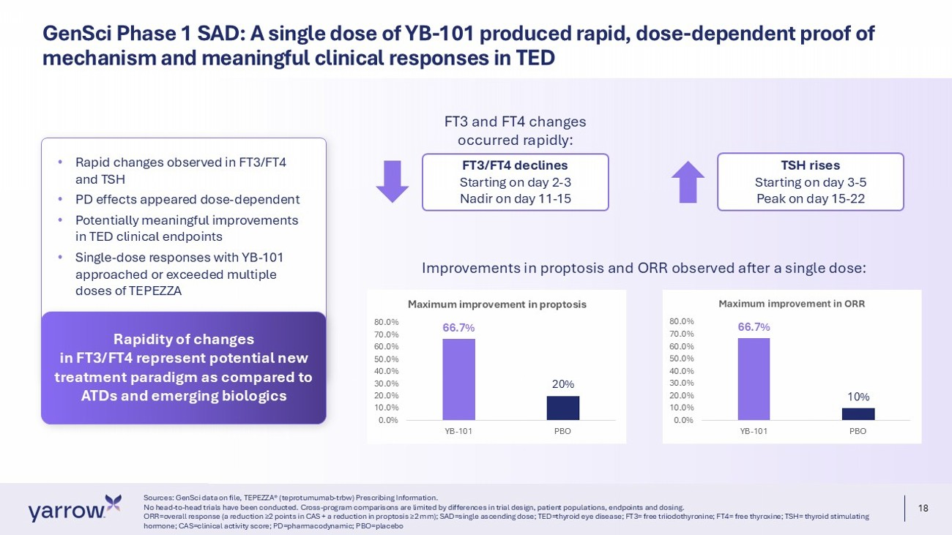
18 GenSci Phase 1 SAD: A single dose of YB - 101 produced rapid, dose - dependent proof of mechanism and meaningful clinical responses in TED Sources: GenSci data on file, TEPEZZA® (teprotumumab - trbw) Prescribing Information. No head - to - head trials have been conducted. Cross - program comparisons are limited by differences in trial design, patient popula tions, endpoints and dosing. ORR=overall response (a reduction ≥2 points in CAS + a reduction in proptosis ≥2 mm); SAD=single ascending dose; TED=thyroid eye disease; FT3= free triiodothyronine; FT4= free thyroxine; TSH= thyroid stimulating hormone; CAS=clinical activity score; PD=pharmacodynamic; PBO=placebo 66.7% 20% 0.0% 10.0% 20.0% 30.0% 40.0% 50.0% 60.0% 70.0% 80.0% YB-101 PBO Maximum improvement in proptosis 66.7% 10% 0.0% 10.0% 20.0% 30.0% 40.0% 50.0% 60.0% 70.0% 80.0% YB-101 PBO Maximum improvement in ORR FT3 and FT4 changes occurred rapidly: FT3/FT4 declines Starting on day 2 - 3 Nadir on day 11 - 15 TSH rises Starting on day 3 - 5 Peak on day 15 - 22 • Rapid changes observed in FT3/FT4 and TSH • PD effects appeared dose - dependent • Potentially meaningful improvements in TED clinical endpoints • Single - dose responses with YB - 101 approached or exceeded multiple doses of TEPEZZA Rapidity of changes in FT3/FT4 represent potential new treatment paradigm as compared to ATDs and emerging biologics Improvements in proptosis and ORR observed after a single dose:

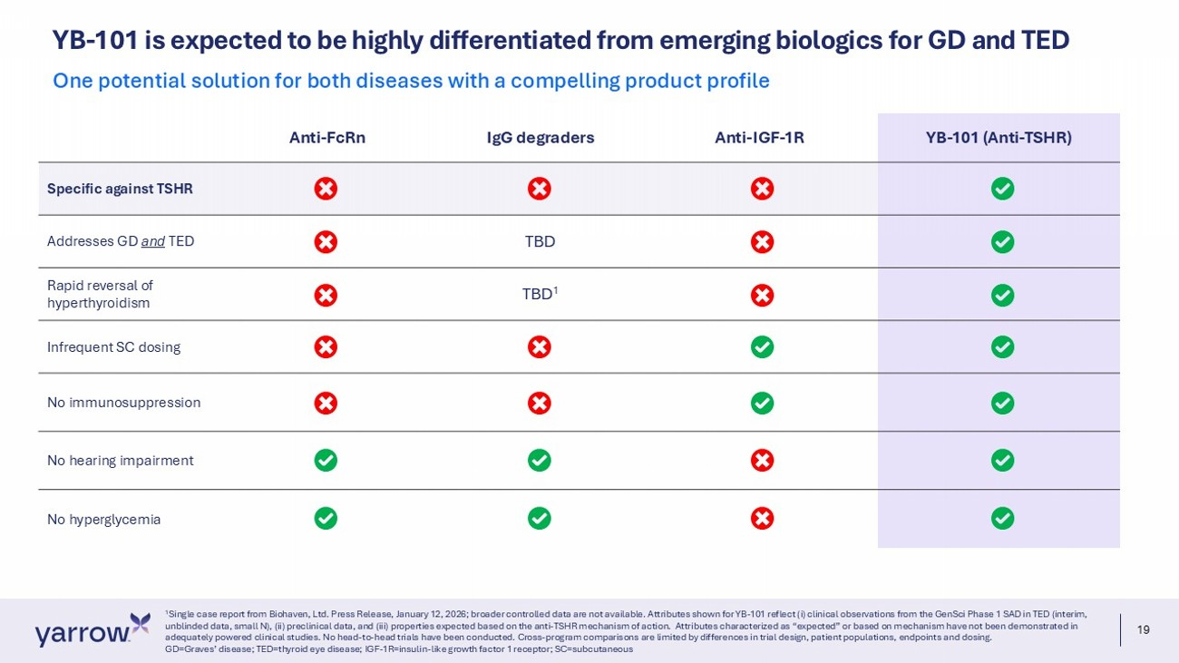
19 YB - 101 is expected to be highly differentiated from emerging biologics for GD and TED 1 Single case report from Biohaven, Ltd. Press Release, January 12, 2026; broader controlled data are not available. Attributes sh own for YB - 101 reflect (i) clinical observations from the GenSci Phase 1 SAD in TED (interim, unblinded data, small N), (ii) preclinical data, and (iii) properties expected based on the anti - TSHR mechanism of action. Attr ibutes characterized as “expected” or based on mechanism have not been demonstrated in adequately powered clinical studies. No head - to - head trials have been conducted. Cross - program comparisons are limited by differ ences in trial design, patient populations, endpoints and dosing. GD=Graves’ disease; TED=thyroid eye disease; IGF - 1R=insulin - like growth factor 1 receptor; SC=subcutaneous One potential solution for both diseases with a compelling product profile YB - 101 (Anti - TSHR) Anti - IGF - 1R IgG degraders Anti - FcRn Specific against TSHR TBD Addresses GD and TED TBD 1 Rapid reversal of hyperthyroidism Infrequent SC dosing No immunosuppression No hearing impairment No hyperglycemia

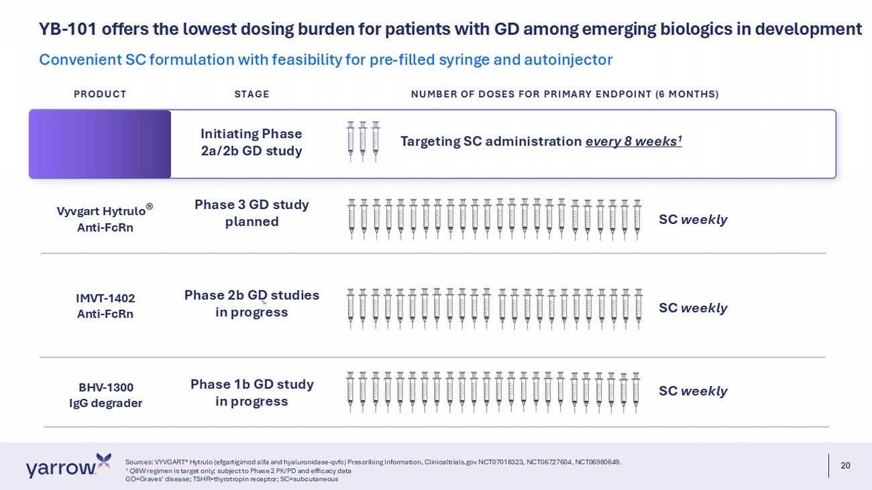
20 YB - 101 offers the lowest dosing burden for patients with GD among emerging biologics in development Sources: VYVGART® Hytrulo (efgartigimod alfa and hyaluronidase - qvfc) Prescribing Information, Clinicaltrials.gov NCT07018323, NC T06727604, NCT06980649. 1 Q 8W regimen is target only; subject to Phase 2 PK/PD and efficacy data GD=Graves’ disease; TSHR=thyrotropin receptor; SC=subcutaneous Convenient SC formulation with feasibility for pre - filled syringe and autoinjector IMVT - 1402 Anti - FcRn BHV - 1300 IgG degrader SC weekly SC weekly Phase 2b GD studies in progress Phase 1b GD study in progress Vyvgart Hytrulo ® Anti - FcRn Phase 3 GD study planned SC weekly Targeting SC administration every 8 weeks 1 Initiating Phase 2a/2b GD study PRODUCT STAGE NUMBER OF DOSES FOR PRIMARY ENDPOINT (6 MONTHS)

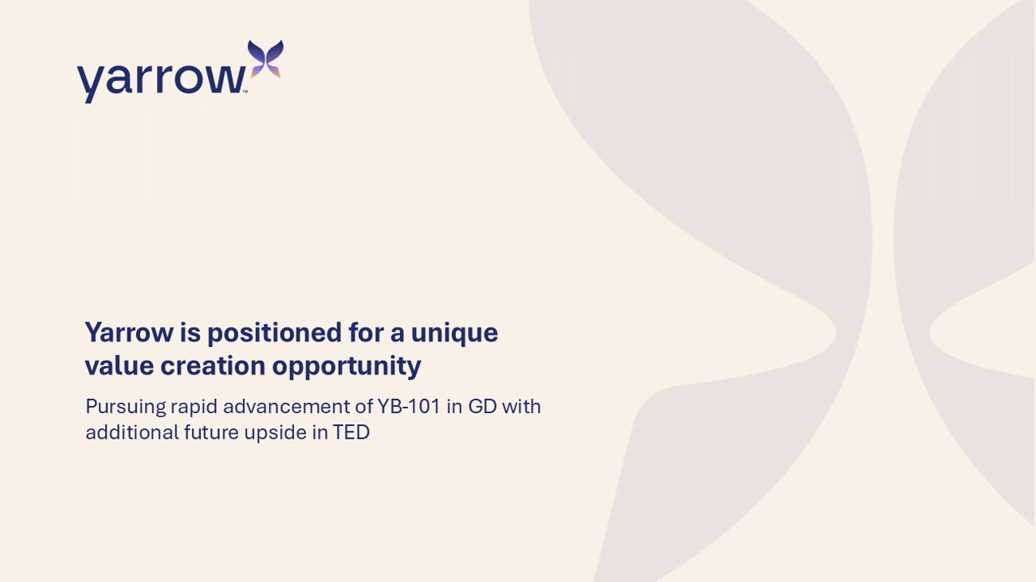
Yarrow is positioned for a unique value creation opportunity Pursuing rapid advancement of YB - 101 in GD with additional future upside in TED

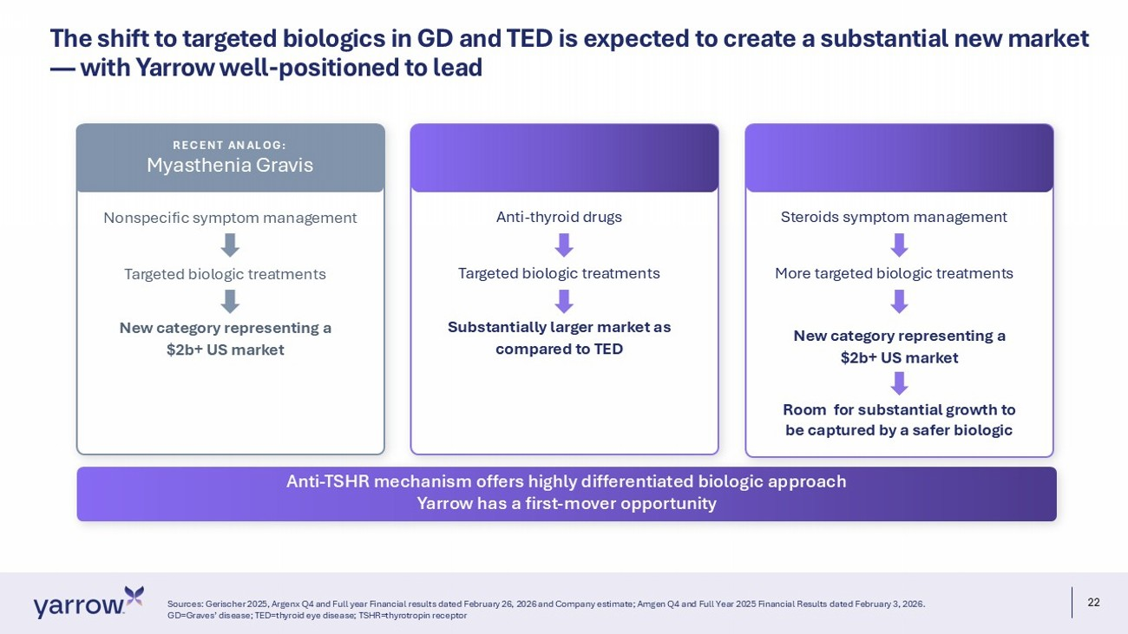
22 The shift to targeted biologics in GD and TED is expected to create a substantial new market — with Yarrow well - positioned to lead Sources: Gerischer 2025, Argenx Q4 and Full year Financial results dated February 26, 2026 and Company estimate; Amgen Q4 and Full Year 2025 Financial Result s dated February 3, 2026. GD=Graves’ disease; TED=thyroid eye disease; TSHR=thyrotropin receptor Anti - TSHR mechanism offers highly differentiated biologic approach Yarrow has a first - mover opportunity Nonspecific symptom management Targeted biologic treatments New category representing a $2b+ US market RECENT ANALOG: Myasthenia Gravis Anti - thyroid drugs Targeted biologic treatments Substantially larger market as compared to TED Steroids symptom management More targeted biologic treatments New category representing a $2b+ US market Room for substantial growth to be captured by a safer biologic

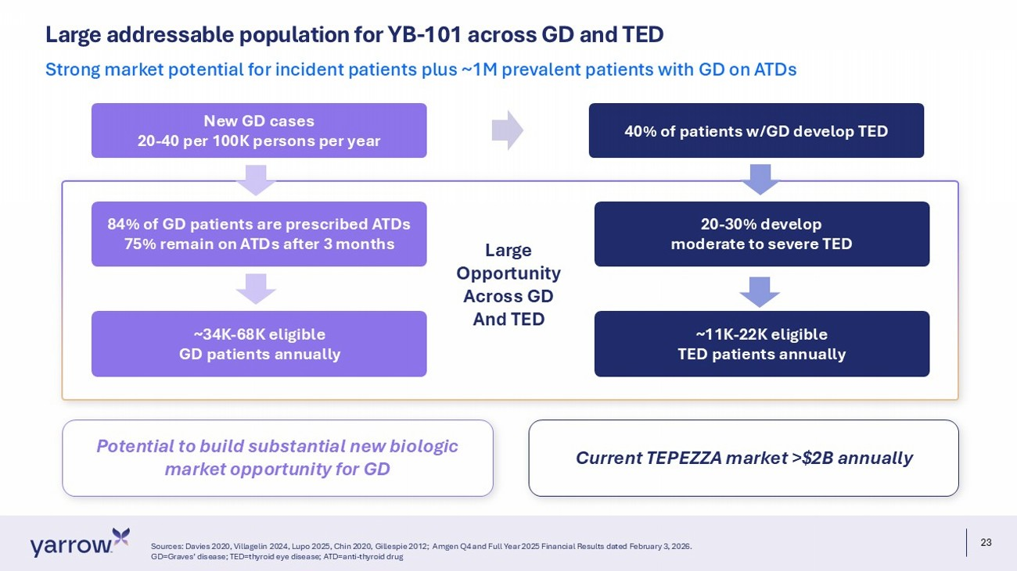
23 Potential to build substantial new biologic market opportunity for GD Large addressable population for YB - 101 across GD and TED Sources: Davies 2020, Villagelin 2024, Lupo 2025, Chin 2020, Gillespie 2012; Amgen Q4 and Full Year 2025 Financial Results dated February 3, 2026. GD=Graves’ disease; TED=thyroid eye disease; ATD=anti - thyroid drug Strong market potential for incident patients plus ~1M prevalent patients with GD on ATDs New GD cases 20 - 40 per 100K persons per year 84% of GD patients are prescribed ATDs 75% remain on ATDs after 3 months ~34K - 68K eligible GD patients annually 40% of patients w/GD develop TED 20 - 30% develop moderate to severe TED ~11K - 22K eligible TED patients annually Current TEPEZZA market >$2B annually Large Opportunity Across GD And TED

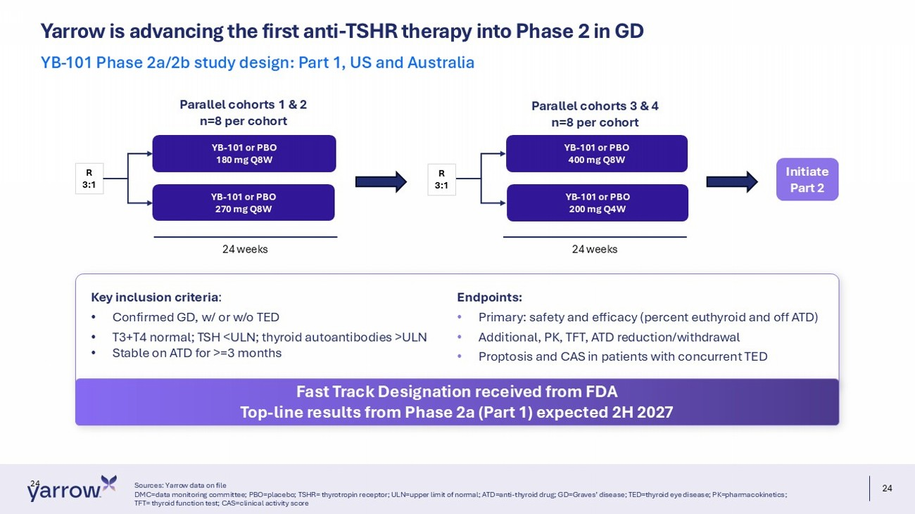
24 Yarrow is advancing the first anti - TSHR therapy into Phase 2 in GD Sources: Yarrow data on file DMC=data monitoring committee; PBO=placebo; TSHR= thyrotropin receptor; ULN=upper limit of normal; ATD=anti - thyroid drug; GD=Gra ves’ disease; TED=thyroid eye disease; PK=pharmacokinetics; TFT= thyroid function test; CAS=clinical activity score YB - 101 Phase 2a/2b study design: Part 1, US and Australia 24 YB - 101 or PBO 180 mg Q8W YB - 101 or PBO 270 mg Q8W YB - 101 or PBO 400 mg Q8W YB - 101 or PBO 200 mg Q4W R 3:1 R 3:1 Parallel cohorts 1 & 2 n=8 per cohort Parallel cohorts 3 & 4 n=8 per cohort Initiate Part 2 24 weeks 24 weeks Key inclusion criteria : • Confirmed GD, w/ or w/o TED • T3+T4 normal; TSH <ULN; thyroid autoantibodies >ULN • Stable on ATD for >=3 months Endpoints: • Primary: safety and efficacy (percent euthyroid and off ATD) • Additional, PK, TFT, ATD reduction/withdrawal • Proptosis and CAS in patients with concurrent TED Fast Track Designation received from FDA Top - line results from Phase 2a (Part 1) expected 2H 2027

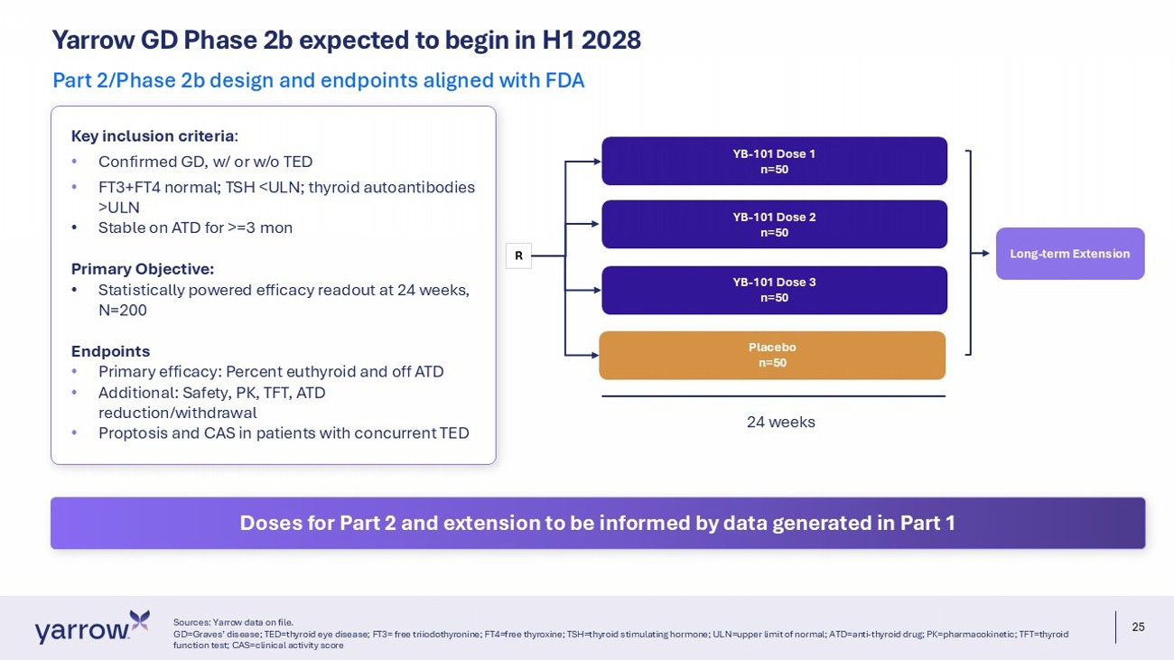
25 Yarrow GD Phase 2b expected to begin in H1 2028 Sources: Yarrow data on file. GD=Graves’ disease; TED=thyroid eye disease; FT3= free triiodothyronine; FT4=free thyroxine; TSH=thyroid stimulating hormone; UL N=upper limit of normal; ATD=anti - thyroid drug; PK=pharmacokinetic; TFT=thyroid function test; CAS=clinical activity score Part 2/Phase 2b design and endpoints aligned with FDA YB - 101 Dose 1 n=50 YB - 101 Dose 2 n=50 R Placebo n=50 YB - 101 Dose 3 n=50 24 weeks Long - term Extension Key inclusion criteria : • Confirmed GD, w/ or w/o TED • FT3+FT4 normal; TSH <ULN; thyroid autoantibodies >ULN • Stable on ATD for >=3 mon Primary Objective: • Statistically powered efficacy readout at 24 weeks, N=200 Endpoints • Primary efficacy: Percent euthyroid and off ATD • Additional: Safety, PK, TFT, ATD reduction/withdrawal • Proptosis and CAS in patients with concurrent TED Doses for Part 2 and extension to be informed by data generated in Part 1

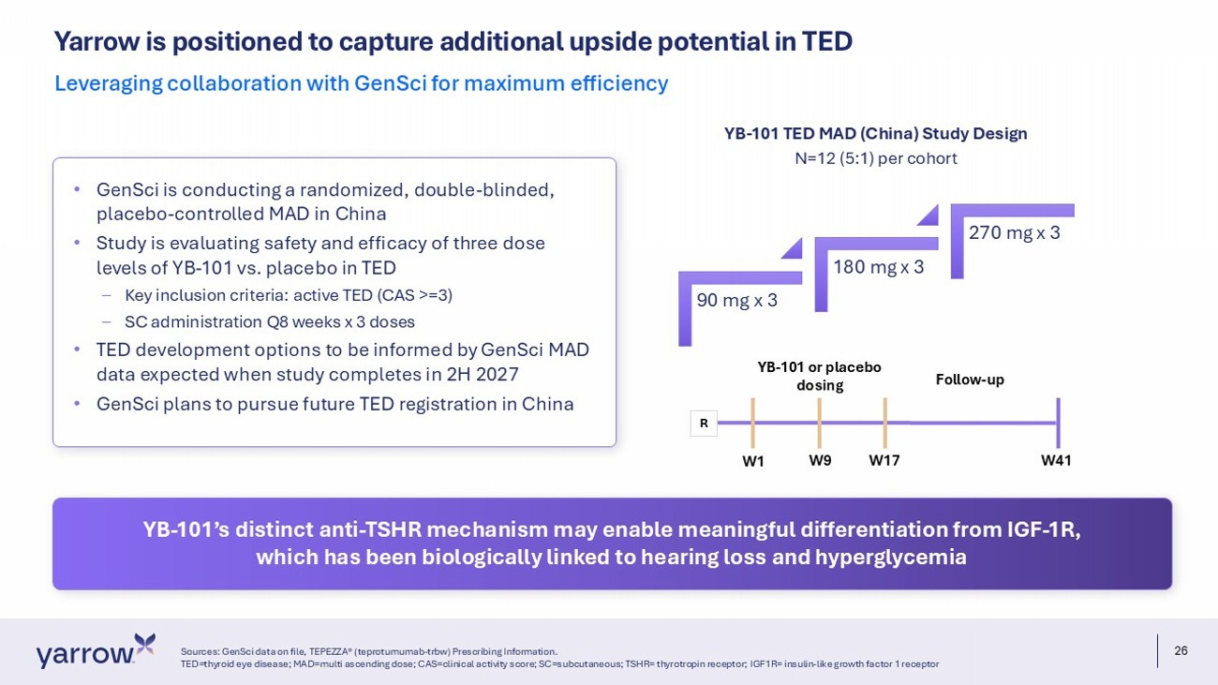
26 Yarrow is positioned to capture additional upside potential in TED Sources: GenSci data on file, TEPEZZA® (teprotumumab - trbw) Prescribing Information. TED=thyroid eye disease; MAD=multi ascending dose; CAS=clinical activity score; SC=subcutaneous; TSHR= thyrotropin receptor; IGF 1R= insulin - like growth factor 1 receptor Leveraging collaboration with GenSci for maximum efficiency 90 mg x 3 180 mg x 3 270 mg x 3 N=12 (5:1) per cohort YB - 101 TED MAD (China) Study Design YB - 101 or placebo dosing Follow - up W1 W41 W9 W17 R • GenSci is conducting a randomized, double - blinded, placebo - controlled MAD in China • Study is evaluating safety and efficacy of three dose levels of YB - 101 vs. placebo in TED – Key inclusion criteria: active TED (CAS >=3) – SC administration Q8 weeks x 3 doses • TED development options to be informed by GenSci MAD data expected when study completes in 2H 2027 • GenSci plans to pursue future TED registration in China YB - 101’s distinct anti - TSHR mechanism may enable meaningful differentiation from IGF - 1R, which has been biologically linked to hearing loss and hyperglycemia

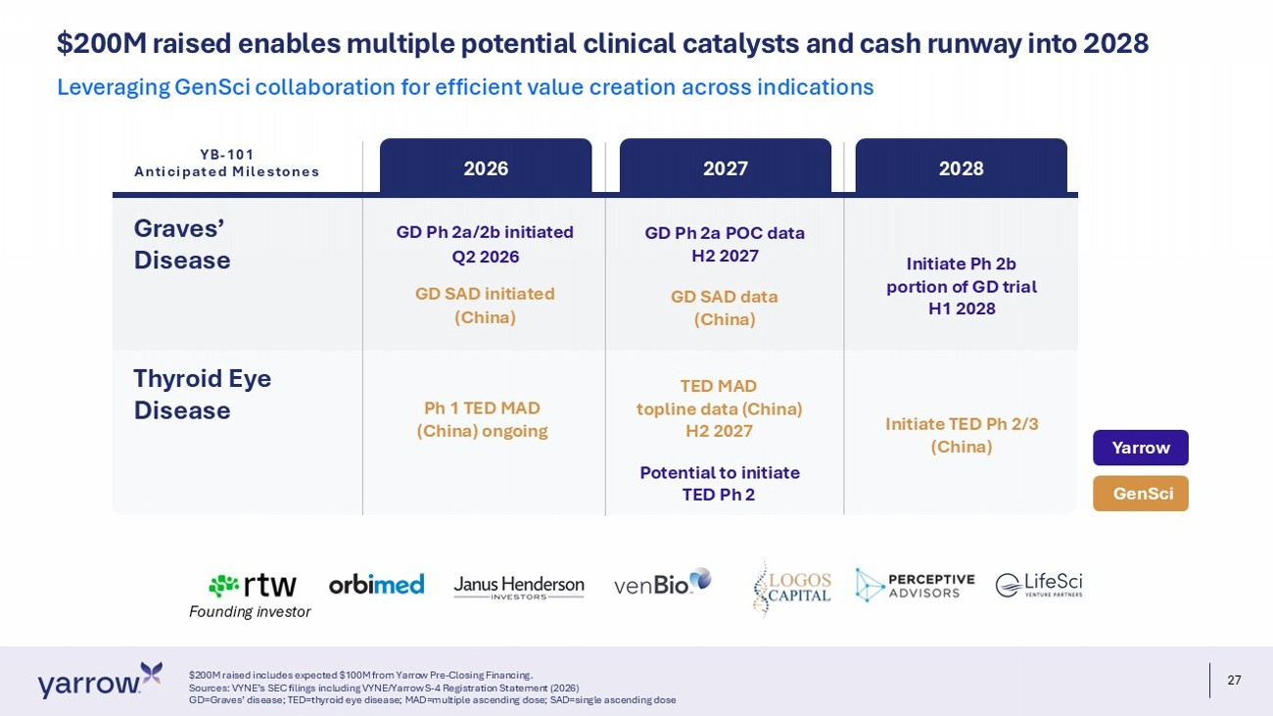
27 $ 200M raised enables multiple potential clinical catalysts and cash runway into 2028 $200M raised includes expected $100M from Yarrow Pre - Closing Financing. Sources: VYNE’s SEC filings including VYNE/Yarrow S - 4 Registration Statement (2026) GD=Graves’ disease; TED=thyroid eye disease; MAD=multiple ascending dose; SAD=single ascending dose Leveraging GenSci collaboration for efficient value creation across indications Founding investor Graves’ Disease 2026 2027 2028 GD Ph 2a/2b initiated Q2 2026 GD SAD initiated (China) Ph 1 TED MAD (China) ongoing GD Ph 2a POC data H2 2027 GD SAD data (China) TED MAD topline data (China) H2 2027 Potential to initiate TED Ph 2 Initiate Ph 2b portion of GD trial H1 2028 Initiate TED Ph 2/3 (China) GenSci Yarrow Thyroid Eye Disease YB - 101 Anticipated Milestones

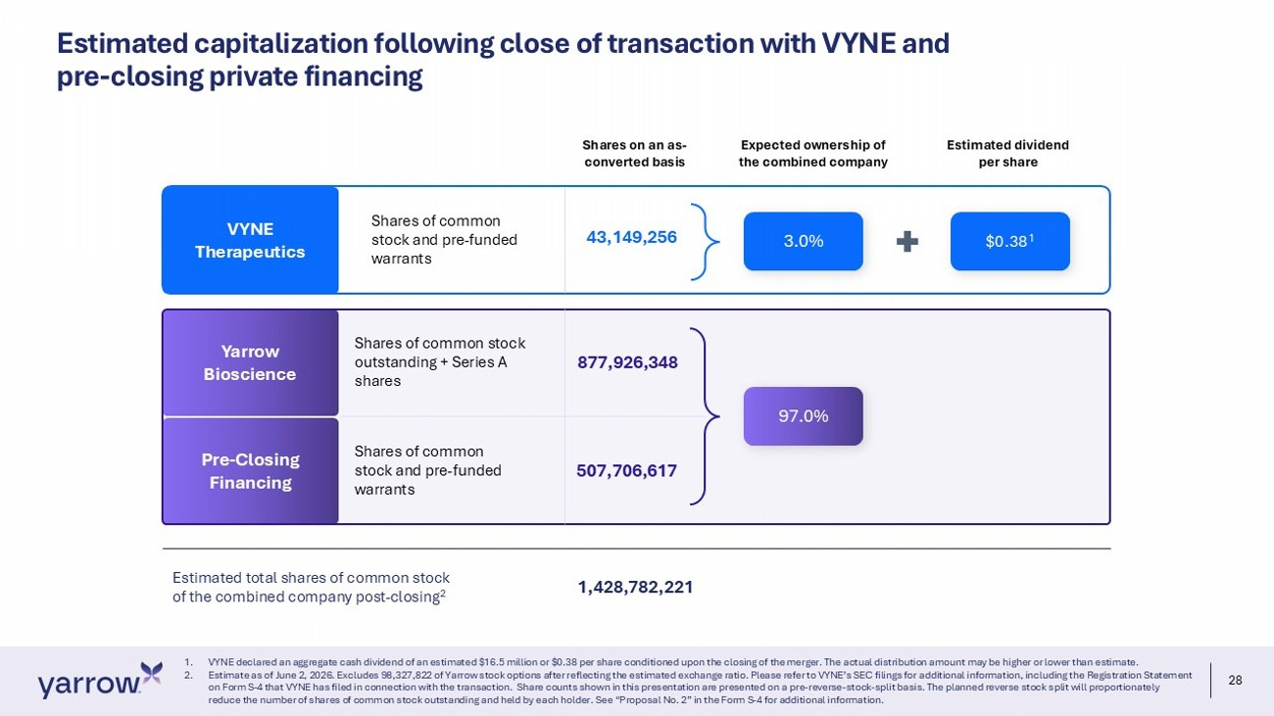
28 Estimated capitalization following close of transaction with VYNE and pre - closing private financing 1. VYNE declared an aggregate cash dividend of an estimated $16.5 million or $0.38 per share conditioned upon the closing of the me rger. The actual distribution amount may be higher or lower than estimate. 2. Estimate as of June 2, 2026. Excludes 98,327,822 of Yarrow stock options after reflecting the estimated exchange ratio. Pleas e r efer to VYNE’s SEC filings for additional information, including the Registration Statement on Form S - 4 that VYNE has filed in connection with the transaction. Share counts shown in this presentation are presented on a pre - reverse - stock - split basis. The planned reverse stock split will proportionately reduce the number of shares of common stock outstanding and held by each holder. See “Proposal No. 2” in the Form S - 4 for additi onal information. Shares of common stock and pre - funded warrants Expected ownership of the combined company Estimated dividend per share Shares on an as - converted basis 3.0% Estimated total shares of common stock of the combined company post - closing 2 Shares of common stock and pre - funded warrants 43,149,256 Shares of common stock outstanding + Series A shares 877,926,348 $0.38 1 507,706,617 1,428,782,221 VYNE Therapeutics Yarrow Bioscience Pre - Closing Financing 97.0%

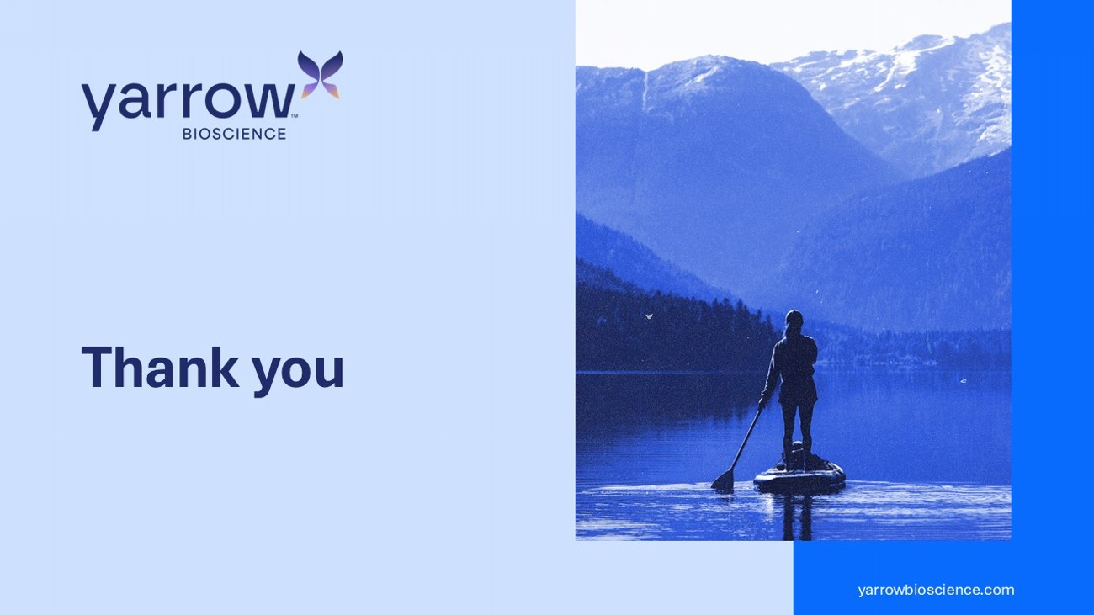
29 yarrowbioscience.com Thank you

